Приложение № 1
Сведения о границах территориальных зон
1. Территориальные зоны г.Малая Вишера
Ж1 Зона застройки индивидуальными жилыми домами и домами блокированной застройки
№№ точек | X | Y
1 | 614976.22 | 2233433.76
2 | 615037.34 | 2233363.89
3 | 615112.33 | 2233411.95
4 | 615430.01 | 2233077.26
5 | 615031.90 | 2232712.31
6 | 614975.56 | 2232771.52
7 | 614803.89 | 2232948.33
8 | 614837.69 | 2232980.27
9 | 614771.97 | 2233051.29
10 | 614727.49 | 2233027.15
11 | 614545.63 | 2233218.20
12 | 614540.05 | 2233210.94
13 | 614525.44 | 2233226.25
14 | 614531.65 | 2233232.88
15 | 614527.28 | 2233237.47
16 | 614402.67 | 2233373.39
17 | 614434.37 | 2233399.50
18 | 614473.08 | 2233372.09
19 | 614501.06 | 2233358.27
20 | 614569.49 | 2233325.91
21 | 614653.43 | 2233288.15
22 | 614719.43 | 2233256.38
23 | 614725.09 | 2233268.21
24 | 614795.66 | 2233231.93
25 | 614818.38 | 2233278.73
26 | 614788.73 | 2233292.88
27 | 614794.88 | 2233305.25
28 | 614768.51 | 2233318.29
29 | 614777.32 | 2233338.51
30 | 614788.11 | 2233359.26
31 | 614804.29 | 2233388.69
32 | 614886.44 | 2233482.47
33 | 614864.96 | 2233363.78
34 | 614907.11 | 2233346.92
35 | 614901.72 | 2233331.06
36 | 614980.30 | 2233297.15
37 | 614970.61 | 2233275.27
38 | 614983.42 | 2233268.62
39 | 614950.69 | 2233197.56
40 | 614864.40 | 2233236.20
41 | 614885.80 | 2233281.96
42 | 614842.24 | 2233304.04
43 | 613854.77 | 2233628.64
44 | 613889.44 | 2233587.23
45 | 613901.61 | 2233582.17
46 | 613904.76 | 2233571.20
47 | 613904.99 | 2233565.14
48 | 613894.74 | 2233554.10
49 | 613892.38 | 2233552.38
50 | 613875.90 | 2233536.01
51 | 613872.98 | 2233534.29
52 | 613858.69 | 2233534.31
53 | 613853.15 | 2233537.15
54 | 613849.81 | 2233534.95
55 | 613840.16 | 2233549.55
56 | 613837.71 | 2233552.00
57 | 613813.46 | 2233587.57
58 | 613836.54 | 2233608.89
59 | 613836.54 | 2233613.13
60 | 611756.36 | 2233683.44
61 | 611763.01 | 2233574.82
62 | 611839.26 | 2233579.56
63 | 611852.99 | 2233593.65
64 | 611854.82 | 2233584.07
65 | 611851.15 | 2233580.30
66 | 611884.24 | 2233582.35
67 | 611898.73 | 2233370.86
68 | 611891.03 | 2233369.86
69 | 611845.72 | 2233365.11
70 | 611839.68 | 2233359.55
71 | 611841.77 | 2233315.41
72 | 611871.79 | 2233316.81
73 | 611884.99 | 2233256.45
74 | 611794.33 | 2233247.32
75 | 611786.35 | 2233246.74
76 | 611781.47 | 2233239.14
77 | 611782.06 | 2233234.40
78 | 611786.95 | 2233194.93
79 | 611789.76 | 2233195.42
80 | 611794.90 | 2233164.34
81 | 611790.79 | 2233164.03
82 | 611791.35 | 2233159.56
83 | 611793.09 | 2233153.71
84 | 611782.18 | 2233131.78
85 | 611765.54 | 2233120.32
86 | 611742.63 | 2233111.03
87 | 611736.00 | 2233104.79
88 | 611703.81 | 2233105.62
89 | 611680.46 | 2233101.62
90 | 611661.05 | 2233116.69
91 | 611656.61 | 2233199.70
92 | 611628.75 | 2233202.70
93 | 611592.38 | 2233201.00
94 | 611589.07 | 2233223.85
95 | 611493.73 | 2233228.45
96 | 611507.01 | 2233274.75
97 | 611571.37 | 2233280.91
98 | 611552.90 | 2233667.64
99 | 611870.57 | 2233800.82
100 | 611879.48 | 2233655.48
101 | 611876.37 | 2233655.23
102 | 611785.22 | 2233649.56
103 | 611783.24 | 2233679.18
104 | 611786.98 | 2233680.50
105 | 611854.51 | 2233688.44
106 | 611851.88 | 2233710.88
107 | 611841.82 | 2233709.70
108 | 611841.20 | 2233716.30
109 | 611816.97 | 2233714.03
110 | 611817.15 | 2233712.12
111 | 611806.82 | 2233711.11
112 | 611806.64 | 2233713.01
113 | 611784.03 | 2233710.79
114 | 611777.74 | 2233794.51
115 | 611796.50 | 2233796.77
116 | 611858.69 | 2233800.37
117 | 613144.96 | 2234593.64
118 | 613151.65 | 2234587.66
119 | 613170.53 | 2234569.97
120 | 613199.69 | 2234538.93
121 | 613088.08 | 2234438.66
122 | 613108.73 | 2234416.23
123 | 613070.55 | 2234376.50
124 | 613142.43 | 2234305.59
125 | 613210.89 | 2234237.28
126 | 613345.12 | 2234382.87
127 | 613421.04 | 2234300.51
128 | 613414.08 | 2234294.40
129 | 613398.69 | 2234279.86
130 | 613395.78 | 2234276.88
131 | 613437.09 | 2234234.56
132 | 613444.77 | 2234225.57
133 | 613475.41 | 2234193.08
134 | 613511.28 | 2234155.17
135 | 613521.05 | 2234147.05
136 | 613477.39 | 2234098.88
137 | 613486.85 | 2234089.72
138 | 613522.13 | 2234059.56
139 | 613515.77 | 2234053.22
140 | 613514.96 | 2234053.94
141 | 613507.75 | 2234046.46
142 | 613509.38 | 2234044.81
143 | 613492.73 | 2234026.72
144 | 613503.13 | 2234016.43
145 | 613507.81 | 2234011.79
146 | 613518.15 | 2234001.43
147 | 613527.37 | 2233992.49
148 | 613525.27 | 2233990.24
149 | 613530.25 | 2233985.39
150 | 613533.91 | 2233981.74
151 | 613534.94 | 2233982.76
152 | 613545.19 | 2233970.89
153 | 613550.38 | 2233969.52
154 | 613560.66 | 2233979.65
155 | 613562.70 | 2233977.60
156 | 613574.58 | 2233991.41
157 | 613604.52 | 2234024.95
158 | 613631.17 | 2233997.75
159 | 613666.84 | 2234033.32
160 | 613684.34 | 2234014.87
161 | 613714.85 | 2233982.17
162 | 613716.23 | 2233980.50
163 | 613740.07 | 2233951.62
164 | 613796.61 | 2233891.64
165 | 613728.28 | 2233819.94
166 | 613719.15 | 2233809.21
167 | 613711.58 | 2233802.13
168 | 613695.87 | 2233786.94
169 | 613664.72 | 2233760.79
170 | 613680.98 | 2233733.70
171 | 613743.40 | 2233686.26
172 | 613676.80 | 2233665.20
173 | 613600.32 | 2233615.51
174 | 613580.72 | 2233628.81
175 | 613551.86 | 2233623.37
176 | 613473.55 | 2233517.22
177 | 613571.68 | 2233442.77
178 | 613470.25 | 2233320.44
179 | 613353.08 | 2233316.84
180 | 613287.80 | 2233314.56
181 | 613236.02 | 2233310.28
182 | 612982.64 | 2233298.41
183 | 612796.79 | 2233289.08
184 | 612463.56 | 2233273.29
185 | 612063.13 | 2233254.22
186 | 611947.49 | 2233248.47
187 | 611916.10 | 2233246.99
188 | 611914.36 | 2233246.95
189 | 611913.81 | 2233256.09
190 | 611911.45 | 2233302.73
191 | 611911.67 | 2233319.33
192 | 611914.40 | 2233328.02
193 | 611918.89 | 2233335.99
194 | 612042.13 | 2233461.46
195 | 612198.78 | 2233622.41
196 | 612470.28 | 2233897.20
197 | 612870.57 | 2234301.86
198 | 613145.47 | 2234581.47
199 | 613299.40 | 2234789.29
200 | 613343.78 | 2234749.58
201 | 613308.98 | 2234711.05
202 | 613302.53 | 2234703.93
203 | 613279.34 | 2234725.69
204 | 613280.00 | 2234728.04
205 | 613259.65 | 2234745.78
206 | 612963.96 | 2235137.94
207 | 613013.44 | 2235114.59
208 | 613032.53 | 2235097.27
209 | 613097.96 | 2235031.08
210 | 613202.53 | 2234916.43
211 | 613184.33 | 2234892.10
212 | 613192.63 | 2234884.67
213 | 613094.68 | 2234782.23
214 | 613054.83 | 2234827.81
215 | 613003.55 | 2234882.10
216 | 613044.78 | 2234924.29
217 | 613007.76 | 2234962.10
218 | 613022.20 | 2234976.71
219 | 613022.14 | 2234980.61
220 | 613019.17 | 2234983.48
221 | 613022.04 | 2234986.21
222 | 613020.54 | 2234987.85
223 | 613021.43 | 2234988.60
224 | 613020.33 | 2234990.02
225 | 613019.26 | 2234989.31
226 | 613018.01 | 2234990.65
227 | 613014.94 | 2234988.10
228 | 613011.12 | 2234987.59
229 | 612985.91 | 2235013.24
230 | 612973.62 | 2235027.96
231 | 612980.73 | 2235033.68
232 | 613007.20 | 2235057.62
233 | 613008.60 | 2235060.21
234 | 613007.47 | 2235063.29
235 | 612956.02 | 2235119.13
236 | 612954.91 | 2235121.24
237 | 612409.70 | 2235394.07
238 | 612450.68 | 2235356.75
239 | 612488.68 | 2235312.17
240 | 612493.18 | 2235307.38
241 | 612524.96 | 2235272.46
242 | 612550.55 | 2235236.31
243 | 612556.26 | 2235229.86
244 | 612582.76 | 2235194.72
245 | 612551.74 | 2235165.28
246 | 612549.65 | 2235167.54
247 | 612508.55 | 2235225.58
248 | 612483.70 | 2235251.69
249 | 612470.36 | 2235261.30
250 | 612404.87 | 2235297.19
251 | 612376.90 | 2235316.38
252 | 612373.71 | 2235322.02
253 | 612363.22 | 2235364.13
254 | 611312.14 | 2236518.90
255 | 611407.78 | 2236422.78
256 | 611608.93 | 2236208.61
257 | 611768.70 | 2236035.56
258 | 611777.54 | 2236043.53
259 | 611798.13 | 2236020.80
260 | 611786.92 | 2236009.63
261 | 611757.82 | 2235985.04
262 | 611752.96 | 2235980.90
263 | 611750.22 | 2235979.43
264 | 611738.93 | 2235975.91
265 | 611733.60 | 2235973.22
266 | 611731.21 | 2235971.53
267 | 611729.06 | 2235969.50
268 | 611725.69 | 2235964.54
269 | 611724.49 | 2235962.01
270 | 611731.36 | 2235908.94
271 | 611745.18 | 2235897.60
272 | 611756.80 | 2235888.28
273 | 611757.22 | 2235887.86
274 | 611735.80 | 2235866.84
275 | 611770.83 | 2235831.16
276 | 611792.24 | 2235852.17
277 | 611813.03 | 2235852.59
278 | 611815.62 | 2235854.15
279 | 611841.46 | 2235878.80
280 | 611856.67 | 2235892.99
281 | 611845.17 | 2235905.70
282 | 611877.69 | 2235932.98
283 | 611889.66 | 2235919.77
284 | 611892.43 | 2235922.38
285 | 611901.43 | 2235928.04
286 | 611903.89 | 2235925.12
287 | 611904.11 | 2235925.32
288 | 611911.12 | 2235917.03
289 | 611910.37 | 2235916.39
290 | 611913.81 | 2235912.32
291 | 611908.45 | 2235907.70
292 | 611906.65 | 2235906.44
293 | 612006.80 | 2235794.14
294 | 612026.87 | 2235811.60
295 | 612046.64 | 2235791.41
296 | 612050.20 | 2235791.23
297 | 612067.85 | 2235772.15
298 | 612103.38 | 2235733.17
299 | 612097.72 | 2235727.26
300 | 612081.82 | 2235710.93
301 | 612123.95 | 2235666.80
302 | 612242.30 | 2235542.86
303 | 612267.65 | 2235517.90
304 | 612260.31 | 2235513.67
305 | 612253.36 | 2235507.95
306 | 612249.64 | 2235512.02
307 | 612247.24 | 2235512.31
308 | 612234.63 | 2235501.88
309 | 612259.93 | 2235461.56
310 | 612320.12 | 2235463.49
311 | 612326.25 | 2235470.57
312 | 612396.95 | 2235405.73
313 | 612357.19 | 2235380.74
314 | 612348.57 | 2235360.19
315 | 612358.10 | 2235322.52
316 | 612369.53 | 2235308.36
317 | 612404.97 | 2235285.15
318 | 612464.78 | 2235252.03
319 | 612476.81 | 2235243.33
320 | 612500.71 | 2235219.13
321 | 612542.14 | 2235161.41
322 | 612411.16 | 2235046.10
323 | 612395.48 | 2235073.31
324 | 612245.98 | 2234934.23
325 | 612371.90 | 2234806.05
326 | 612365.19 | 2234799.32
327 | 612353.02 | 2234788.00
328 | 612308.11 | 2234743.60
329 | 612303.54 | 2234739.08
330 | 612297.55 | 2234732.17
331 | 612295.61 | 2234730.31
332 | 612294.59 | 2234731.38
333 | 612293.83 | 2234732.18
334 | 612282.34 | 2234720.70
335 | 612282.14 | 2234716.33
336 | 612282.82 | 2234714.47
337 | 612281.02 | 2234712.95
338 | 612285.11 | 2234707.28
339 | 612287.55 | 2234709.90
340 | 612291.10 | 2234704.23
341 | 612293.32 | 2234700.84
342 | 612295.25 | 2234697.45
343 | 612299.70 | 2234693.31
344 | 612303.68 | 2234697.37
345 | 612311.30 | 2234691.40
346 | 612313.39 | 2234689.90
347 | 612314.44 | 2234691.91
348 | 612316.40 | 2234690.86
349 | 612324.37 | 2234688.66
350 | 612326.94 | 2234691.28
351 | 612335.99 | 2234699.64
352 | 612341.70 | 2234704.72
353 | 612368.88 | 2234728.90
354 | 612371.12 | 2234730.75
355 | 612376.07 | 2234734.86
356 | 612403.37 | 2234762.82
357 | 612409.25 | 2234768.78
358 | 612502.11 | 2234680.31
359 | 612571.95 | 2234746.75
360 | 612605.35 | 2234711.80
361 | 612663.91 | 2234764.46
362 | 612683.62 | 2234745.12
363 | 612695.58 | 2234757.14
364 | 612639.99 | 2234812.73
365 | 612759.44 | 2234928.96
366 | 612885.24 | 2234796.96
367 | 612928.98 | 2234752.00
368 | 612947.49 | 2234736.24
369 | 613078.90 | 2234641.32
370 | 613123.05 | 2234603.91
371 | 613127.96 | 2234591.72
372 | 613125.29 | 2234579.36
373 | 613118.92 | 2234569.85
374 | 613094.13 | 2234543.38
375 | 612867.89 | 2234314.85
376 | 612462.56 | 2233905.04
377 | 612190.93 | 2233629.66
378 | 611918.54 | 2233351.58
379 | 611910.74 | 2233341.77
380 | 611891.46 | 2233623.50
381 | 611862.98 | 2234090.02
382 | 611863.01 | 2234102.05
383 | 611865.59 | 2234114.08
384 | 611870.36 | 2234124.12
385 | 611894.21 | 2234153.26
386 | 611913.36 | 2234173.77
387 | 611910.87 | 2234176.20
388 | 611909.78 | 2234177.30
389 | 611906.28 | 2234180.89
390 | 611886.78 | 2234159.96
391 | 611886.57 | 2234159.72
392 | 611862.23 | 2234129.99
393 | 611861.77 | 2234129.32
394 | 611861.58 | 2234128.96
395 | 611856.30 | 2234117.84
396 | 611855.93 | 2234116.75
397 | 611853.12 | 2234103.64
398 | 611853.01 | 2234102.60
399 | 611852.98 | 2234089.88
400 | 611852.99 | 2234089.57
401 | 611854.51 | 2234063.46
402 | 611851.90 | 2234063.33
403 | 611829.44 | 2234062.72
404 | 611829.55 | 2234076.01
405 | 611833.18 | 2234094.14
406 | 611839.49 | 2234094.84
407 | 611846.17 | 2234095.41
408 | 611846.02 | 2234099.50
409 | 611845.57 | 2234103.54
410 | 611845.47 | 2234104.45
411 | 611833.47 | 2234104.63
412 | 611830.37 | 2234131.94
413 | 611828.54 | 2234133.92
414 | 611765.36 | 2234128.91
415 | 611740.99 | 2234126.94
416 | 611747.43 | 2234071.37
417 | 611750.25 | 2234037.30
418 | 611778.49 | 2234036.49
419 | 611781.24 | 2234033.66
420 | 611783.88 | 2234036.23
421 | 611791.59 | 2234036.26
422 | 611812.82 | 2234038.92
423 | 611813.35 | 2234038.99
424 | 611813.20 | 2234043.44
425 | 611852.89 | 2234046.97
426 | 611855.51 | 2234047.26
427 | 611861.02 | 2233957.63
428 | 611817.60 | 2233934.73
429 | 611770.84 | 2233905.93
430 | 611728.68 | 2233879.96
431 | 611719.21 | 2233874.13
432 | 611596.87 | 2233802.95
433 | 611430.14 | 2233742.08
434 | 611278.30 | 2233908.28
435 | 611196.47 | 2233853.10
436 | 611130.32 | 2233940.72
437 | 611056.58 | 2233879.95
438 | 610829.82 | 2234157.83
439 | 610916.88 | 2234216.52
440 | 610824.79 | 2234418.92
441 | 610812.59 | 2234451.82
442 | 610809.62 | 2234466.64
443 | 610803.79 | 2234484.48
444 | 610802.75 | 2234487.67
445 | 610839.36 | 2234482.89
446 | 610839.72 | 2234481.18
447 | 610878.62 | 2234476.62
448 | 610879.28 | 2234474.80
449 | 610898.46 | 2234472.03
450 | 610898.15 | 2234472.84
451 | 610897.56 | 2234476.30
452 | 610914.42 | 2234475.06
453 | 610932.43 | 2234473.28
454 | 610935.33 | 2234466.60
455 | 610951.32 | 2234466.60
456 | 610949.36 | 2234471.22
457 | 610969.86 | 2234474.10
458 | 610970.00 | 2234473.75
459 | 610974.08 | 2234474.89
460 | 610976.33 | 2234470.22
461 | 610983.14 | 2234471.50
462 | 610985.14 | 2234472.10
463 | 611000.30 | 2234478.43
464 | 610998.38 | 2234482.43
465 | 611018.93 | 2234489.85
466 | 611037.30 | 2234496.19
467 | 611040.67 | 2234491.95
468 | 611051.28 | 2234495.53
469 | 611045.22 | 2234503.88
470 | 611042.41 | 2234511.08
471 | 611022.75 | 2234503.80
472 | 611022.16 | 2234505.02
473 | 611003.18 | 2234498.11
474 | 611001.91 | 2234500.65
475 | 610978.41 | 2234490.96
476 | 610955.22 | 2234486.60
477 | 610933.59 | 2234486.60
478 | 610891.93 | 2234493.35
479 | 610770.56 | 2234508.82
480 | 610759.62 | 2234506.62
481 | 610760.44 | 2234509.17
482 | 610773.38 | 2234601.06
483 | 610883.50 | 2234612.88
484 | 611199.82 | 2234779.17
485 | 611185.52 | 2234889.93
486 | 611495.45 | 2234911.29
487 | 611517.66 | 2234848.78
488 | 611558.59 | 2234841.67
489 | 611644.23 | 2234819.13
490 | 611687.23 | 2234846.52
491 | 611679.84 | 2234920.05
492 | 611724.61 | 2234989.68
493 | 611828.81 | 2235113.33
494 | 611877.40 | 2235054.81
495 | 611980.03 | 2235137.83
496 | 611985.82 | 2235141.77
497 | 611934.09 | 2235218.20
498 | 611941.98 | 2235223.30
499 | 611971.46 | 2235238.16
500 | 612000.34 | 2235246.76
501 | 612003.23 | 2235243.44
502 | 612011.75 | 2235234.65
503 | 612018.06 | 2235227.86
504 | 612024.13 | 2235220.68
505 | 612030.78 | 2235211.93
506 | 612037.56 | 2235201.26
507 | 612045.12 | 2235190.00
508 | 612053.58 | 2235178.62
509 | 612058.58 | 2235171.06
510 | 612062.68 | 2235164.50
511 | 612071.53 | 2235169.46
512 | 612107.56 | 2235190.11
513 | 612117.95 | 2235189.01
514 | 612139.53 | 2235200.31
515 | 612142.99 | 2235220.29
516 | 612160.51 | 2235234.54
517 | 612134.34 | 2235266.73
518 | 612116.98 | 2235252.62
519 | 612082.46 | 2235236.42
520 | 612057.56 | 2235289.48
521 | 612035.20 | 2235337.13
522 | 611984.65 | 2235314.11
523 | 611952.21 | 2235303.84
524 | 611893.67 | 2235282.78
525 | 611863.23 | 2235353.52
526 | 611849.43 | 2235352.52
527 | 611819.34 | 2235341.92
528 | 611859.59 | 2235279.18
529 | 611876.42 | 2235248.35
530 | 611859.25 | 2235231.83
531 | 611850.27 | 2235242.43
532 | 611841.73 | 2235235.96
533 | 611838.11 | 2235239.81
534 | 611804.68 | 2235208.39
535 | 611799.12 | 2235203.17
536 | 611736.63 | 2235283.53
537 | 611717.80 | 2235311.83
538 | 611709.84 | 2235325.33
539 | 611699.45 | 2235341.58
540 | 611679.72 | 2235334.11
541 | 611675.59 | 2235333.26
542 | 611667.82 | 2235332.49
543 | 611662.38 | 2235332.15
544 | 611659.60 | 2235331.63
545 | 611647.23 | 2235323.22
546 | 611633.65 | 2235295.09
547 | 611636.60 | 2235290.36
548 | 611613.71 | 2235277.51
549 | 611599.49 | 2235303.19
550 | 611594.42 | 2235300.88
551 | 611591.22 | 2235307.13
552 | 611536.89 | 2235277.62
553 | 611515.77 | 2235313.72
554 | 611520.61 | 2235335.82
555 | 611521.14 | 2235337.14
556 | 611536.23 | 2235394.80
557 | 611496.52 | 2235404.48
558 | 611501.90 | 2235447.83
559 | 611508.15 | 2235471.52
560 | 611501.49 | 2235472.89
561 | 611407.58 | 2235461.72
562 | 611358.72 | 2235315.55
563 | 611426.18 | 2235285.41
564 | 611285.08 | 2235205.18
565 | 611100.61 | 2235448.55
566 | 611052.68 | 2235502.53
567 | 610903.76 | 2235627.63
568 | 610822.91 | 2235738.93
569 | 610702.22 | 2235898.55
570 | 610723.51 | 2235907.01
571 | 610849.15 | 2236004.06
572 | 610931.67 | 2236054.93
573 | 610990.14 | 2236075.01
574 | 611027.13 | 2236084.05
575 | 611007.72 | 2236194.02
576 | 611013.46 | 2236207.15
577 | 611045.72 | 2236203.37
578 | 611047.21 | 2236166.83
579 | 611105.89 | 2236144.30
580 | 611156.21 | 2236312.45
581 | 611211.06 | 2236418.51
582 | 611213.91 | 2236423.64
583 | 611283.33 | 2236438.20
584 | 611287.06 | 2236439.03
585 | 611801.67 | 2234921.24
586 | 611812.03 | 2234907.95
587 | 611823.20 | 2234893.68
588 | 611816.84 | 2234888.70
589 | 611803.10 | 2234880.09
590 | 611782.94 | 2234901.20
591 | 611779.07 | 2234905.96
592 | 611989.85 | 2234248.42
593 | 612000.77 | 2234239.39
594 | 612011.93 | 2234233.41
595 | 612018.96 | 2234226.97
596 | 612020.67 | 2234224.75
597 | 612033.05 | 2234221.04
598 | 612094.76 | 2234159.86
599 | 612082.81 | 2234129.34
600 | 612114.47 | 2234101.20
601 | 612051.54 | 2234038.15
602 | 611938.40 | 2234149.31
603 | 611975.40 | 2234183.91
604 | 611962.85 | 2234196.70
605 | 611975.77 | 2234210.16
606 | 611964.42 | 2234221.24
607 | 612001.09 | 2235118.98
608 | 612028.15 | 2235079.03
609 | 611953.19 | 2235024.40
610 | 611934.93 | 2235011.91
611 | 611928.85 | 2235020.25
612 | 611920.26 | 2235033.78
613 | 611917.59 | 2235038.39
614 | 611916.75 | 2235039.34
615 | 611914.00 | 2235043.20
616 | 611912.58 | 2235045.55
617 | 611909.35 | 2235047.98
618 | 611908.49 | 2235047.31
619 | 611908.02 | 2235048.35
620 | 611905.60 | 2235051.84
621 | 611920.10 | 2235062.37
622 | 611929.10 | 2235068.72
623 | 611933.30 | 2235062.75
624 | 611958.72 | 2235079.43
625 | 611951.52 | 2235090.27
626 | 611956.24 | 2235089.06
627 | 611989.84 | 2235111.02
628 | 612220.51 | 2235264.85
629 | 612235.67 | 2235226.97
630 | 612238.10 | 2235220.93
631 | 612193.72 | 2235200.95
632 | 612172.11 | 2235238.58
633 | 612185.07 | 2235251.84
634 | 612211.04 | 2235261.13
635 | 612213.46 | 2235262.08
636 | 610808.50 | 2235880.17
637 | 610833.35 | 2235869.82
638 | 610799.27 | 2235836.96
639 | 610782.78 | 2235855.53
640 | 611191.61 | 2236064.81
641 | 611230.66 | 2236048.15
642 | 611296.45 | 2236032.26
643 | 611304.03 | 2235952.07
644 | 611292.39 | 2235878.16
645 | 611273.92 | 2235848.29
646 | 611246.96 | 2235734.38
647 | 611235.23 | 2235660.62
648 | 611263.70 | 2235638.47
649 | 611231.58 | 2235608.61
650 | 611214.25 | 2235596.78
651 | 611210.09 | 2235582.31
652 | 611106.46 | 2235612.77
653 | 611116.38 | 2235653.31
654 | 611081.84 | 2235663.45
655 | 611089.68 | 2235692.78
656 | 611095.59 | 2235727.90
657 | 611106.33 | 2235763.42
658 | 611135.34 | 2235758.06
659 | 611176.54 | 2235899.41
660 | 611148.78 | 2235908.51
661 | 611184.24 | 2236037.83
662 | 611867.16 | 2236522.16
663 | 611908.57 | 2236431.13
664 | 611999.59 | 2236472.52
665 | 612064.68 | 2236333.17
666 | 612072.90 | 2236334.20
667 | 612085.23 | 2236339.85
668 | 612111.27 | 2236351.72
669 | 612262.21 | 2236029.55
670 | 612369.74 | 2235805.91
671 | 612442.54 | 2235653.74
672 | 612448.45 | 2235637.61
673 | 612456.23 | 2235611.94
674 | 612475.95 | 2235534.43
675 | 612479.65 | 2235514.09
676 | 612481.50 | 2235493.60
677 | 612481.10 | 2235481.93
678 | 612476.68 | 2235462.23
679 | 612467.98 | 2235451.03
680 | 612444.46 | 2235436.05
681 | 612389.30 | 2235483.68
682 | 612376.42 | 2235490.54
683 | 612367.96 | 2235488.87
684 | 612364.21 | 2235488.73
685 | 612354.41 | 2235496.42
686 | 612387.43 | 2235519.65
687 | 612463.18 | 2235476.48
688 | 612463.09 | 2235490.79
689 | 612463.06 | 2235494.37
690 | 612459.66 | 2235507.45
691 | 612458.04 | 2235513.90
692 | 612455.66 | 2235523.35
693 | 612448.30 | 2235545.90
694 | 612449.46 | 2235546.62
695 | 612442.83 | 2235563.79
696 | 612415.81 | 2235617.89
697 | 612388.15 | 2235649.13
698 | 612369.08 | 2235669.47
699 | 612347.66 | 2235699.85
700 | 612322.79 | 2235726.25
701 | 612277.24 | 2235774.13
702 | 612236.69 | 2235816.52
703 | 612225.42 | 2235827.95
704 | 612187.87 | 2235853.68
705 | 612186.40 | 2235859.31
706 | 612184.32 | 2235866.28
707 | 612169.47 | 2235883.23
708 | 612142.07 | 2235911.37
709 | 612107.01 | 2235949.05
710 | 612098.36 | 2235956.63
711 | 612091.01 | 2235952.16
712 | 612053.25 | 2235929.14
713 | 612037.42 | 2235920.49
714 | 612034.65 | 2235917.97
715 | 612013.14 | 2235896.32
716 | 611933.80 | 2235973.57
717 | 611920.69 | 2235986.33
718 | 611742.34 | 2236178.50
719 | 611666.37 | 2236262.85
720 | 611558.60 | 2236380.32
721 | 611607.57 | 2236403.85
722 | 615045.86 | 2236523.38
723 | 615012.81 | 2236478.02
724 | 615016.96 | 2236464.15
725 | 615046.77 | 2236468.39
726 | 615040.44 | 2236452.67
727 | 615031.57 | 2236426.49
728 | 614786.86 | 2236368.48
729 | 614675.76 | 2236301.55
730 | 614679.44 | 2236305.31
731 | 614687.40 | 2236317.99
732 | 614696.71 | 2236335.82
733 | 614712.66 | 2236365.46
734 | 614721.01 | 2236380.49
735 | 614726.97 | 2236390.30
736 | 614734.32 | 2236400.07
737 | 614746.79 | 2236411.40
738 | 614751.93 | 2236414.72
739 | 614769.29 | 2236424.52
740 | 614793.12 | 2236435.92
741 | 614819.06 | 2236445.67
742 | 614848.00 | 2236455.39
743 | 614871.17 | 2236462.69
744 | 614936.45 | 2236485.82
745 | 615239.29 | 2236582.95
746 | 615203.48 | 2236569.08
747 | 615178.40 | 2236553.87
748 | 615175.43 | 2236564.48
749 | 615478.93 | 2236633.31
750 | 615491.03 | 2236520.22
751 | 615351.85 | 2236496.89
752 | 615311.64 | 2236487.31
753 | 615251.27 | 2236586.01
754 | 615314.82 | 2236603.18
755 | 615457.99 | 2236629.52
756 | 612698.83 | 2237830.90
757 | 612723.80 | 2237803.61
758 | 612914.54 | 2237447.44
759 | 613412.52 | 2236517.66
760 | 613538.69 | 2237218.92
761 | 613972.12 | 2237251.32
762 | 614089.52 | 2237064.23
763 | 614355.44 | 2236642.49
764 | 614419.75 | 2236540.51
765 | 614551.89 | 2236330.94
766 | 614555.62 | 2236338.61
767 | 614563.11 | 2236339.43
768 | 614569.76 | 2236341.10
769 | 614575.18 | 2236344.43
770 | 614583.50 | 2236354.42
771 | 614591.82 | 2236363.99
772 | 614598.07 | 2236370.65
773 | 614600.57 | 2236375.22
774 | 614609.30 | 2236381.88
775 | 614615.97 | 2236386.87
776 | 614623.87 | 2236398.52
777 | 614629.69 | 2236413.50
778 | 614633.43 | 2236423.91
779 | 614637.60 | 2236434.32
780 | 614643.01 | 2236440.98
781 | 614650.49 | 2236445.97
782 | 614667.98 | 2236455.54
783 | 614685.46 | 2236465.11
784 | 614702.93 | 2236478.01
785 | 614722.07 | 2236495.90
786 | 614743.31 | 2236513.80
787 | 614772.01 | 2236536.27
788 | 614797.39 | 2236554.16
789 | 614813.62 | 2236566.23
790 | 614826.52 | 2236571.23
791 | 614832.36 | 2236574.56
792 | 614835.26 | 2236577.89
793 | 614837.36 | 2236587.46
794 | 614841.92 | 2236597.03
795 | 614850.25 | 2236604.52
796 | 614861.91 | 2236608.26
797 | 614867.31 | 2236613.26
798 | 614876.05 | 2236620.33
799 | 614883.95 | 2236624.91
800 | 614897.27 | 2236631.15
801 | 614928.07 | 2236642.80
802 | 614941.80 | 2236650.29
803 | 614953.86 | 2236651.54
804 | 614970.09 | 2236656.95
805 | 614985.91 | 2236662.77
806 | 615002.97 | 2236666.94
807 | 615149.41 | 2236678.48
808 | 615218.85 | 2236678.67
809 | 615353.11 | 2236690.21
810 | 615393.58 | 2236696.04
811 | 615468.68 | 2236729.06
812 | 615478.43 | 2236638.30
813 | 615457.09 | 2236634.44
814 | 615313.82 | 2236608.08
815 | 615313.62 | 2236608.03
816 | 615249.64 | 2236590.75
817 | 615238.24 | 2236587.85
818 | 615126.83 | 2236556.72
819 | 615110.09 | 2236551.64
820 | 615095.18 | 2236546.71
821 | 614934.46 | 2236491.53
822 | 614869.25 | 2236468.43
823 | 614846.13 | 2236461.14
824 | 614817.03 | 2236451.37
825 | 614790.75 | 2236441.49
826 | 614766.49 | 2236429.89
827 | 614748.80 | 2236419.90
828 | 614743.09 | 2236416.21
829 | 614729.83 | 2236404.16
830 | 614721.96 | 2236393.69
831 | 614715.78 | 2236383.54
832 | 614707.36 | 2236368.37
833 | 614691.36 | 2236338.66
834 | 614682.14 | 2236321.00
835 | 614674.83 | 2236308.59
836 | 614666.15 | 2236297.21
837 | 614655.97 | 2236288.65
838 | 614635.76 | 2236277.74
839 | 614616.41 | 2236270.53
840 | 614604.66 | 2236267.10
841 | 614605.55 | 2236263.30
842 | 614479.66 | 2236234.55
843 | 614542.16 | 2236106.43
844 | 614547.64 | 2236096.80
845 | 614627.64 | 2235906.02
846 | 614350.29 | 2235623.91
847 | 614314.41 | 2235589.09
848 | 614322.43 | 2235580.83
849 | 614347.94 | 2235552.67
850 | 614327.93 | 2235534.55
851 | 614322.55 | 2235540.47
852 | 614285.50 | 2235506.91
853 | 614275.22 | 2235502.70
854 | 614286.31 | 2235475.39
855 | 614288.11 | 2235448.61
856 | 614287.27 | 2235385.63
857 | 614285.29 | 2235289.51
858 | 614281.21 | 2235152.71
859 | 614275.88 | 2235120.86
860 | 614300.90 | 2235119.08
861 | 614518.27 | 2235113.10
862 | 614502.61 | 2234988.72
863 | 614496.33 | 2234939.01
864 | 614484.55 | 2234894.48
865 | 614484.77 | 2234815.54
866 | 614189.03 | 2234801.20
867 | 614125.10 | 2234742.05
868 | 614081.58 | 2234708.29
869 | 614131.77 | 2234634.01
870 | 613948.81 | 2234584.51
871 | 613991.55 | 2234446.85
872 | 613942.95 | 2234430.45
873 | 613931.21 | 2234454.79
874 | 613942.41 | 2234465.01
875 | 613855.41 | 2234565.58
876 | 613815.16 | 2234530.82
877 | 613756.70 | 2234594.64
878 | 613547.60 | 2234396.65
879 | 613505.94 | 2234440.87
880 | 613463.29 | 2234490.93
881 | 613496.54 | 2234520.86
882 | 613445.69 | 2234572.70
883 | 613437.93 | 2234580.49
884 | 613433.22 | 2234576.00
885 | 613406.92 | 2234606.50
886 | 613449.20 | 2234652.08
887 | 613414.58 | 2234682.31
888 | 613416.61 | 2234684.55
889 | 613476.81 | 2234753.42
890 | 613441.23 | 2234784.23
891 | 613472.02 | 2234818.37
892 | 613471.68 | 2234822.82
893 | 613477.23 | 2234829.41
894 | 613401.17 | 2234940.35
895 | 613361.26 | 2234985.31
896 | 613278.51 | 2235007.20
897 | 613245.57 | 2235014.05
898 | 613245.55 | 2235020.08
899 | 613240.07 | 2235020.12
900 | 613167.41 | 2235060.56
901 | 613157.32 | 2235071.02
902 | 613148.27 | 2235064.39
903 | 613112.30 | 2235112.36
904 | 613052.52 | 2235180.12
905 | 613063.06 | 2235189.76
906 | 613056.96 | 2235197.41
907 | 613078.19 | 2235218.70
908 | 613077.76 | 2235226.70
909 | 613072.28 | 2235230.98
910 | 613083.53 | 2235243.90
911 | 613040.43 | 2235271.04
912 | 612979.20 | 2235212.40
913 | 612967.07 | 2235202.68
914 | 612940.29 | 2235188.49
915 | 612908.53 | 2235179.51
916 | 612899.52 | 2235180.48
917 | 612799.58 | 2235287.38
918 | 612796.75 | 2235290.41
919 | 612787.88 | 2235299.23
920 | 612709.05 | 2235229.74
921 | 612691.39 | 2235247.45
922 | 612665.69 | 2235224.84
923 | 612655.07 | 2235238.15
924 | 612647.59 | 2235246.36
925 | 612641.81 | 2235254.26
926 | 612633.47 | 2235262.16
927 | 612609.04 | 2235276.09
928 | 612566.38 | 2235326.40
929 | 612537.54 | 2235355.64
930 | 612457.51 | 2235424.77
931 | 612488.41 | 2235444.63
932 | 612494.98 | 2235472.42
933 | 612495.69 | 2235476.36
934 | 612493.22 | 2235481.71
935 | 612491.40 | 2235507.38
936 | 612486.06 | 2235534.25
937 | 612466.41 | 2235614.91
938 | 612458.12 | 2235641.59
939 | 612451.93 | 2235658.28
940 | 612378.91 | 2235810.75
941 | 612271.89 | 2236034.90
942 | 612143.15 | 2236309.63
943 | 612136.38 | 2236327.33
944 | 612123.88 | 2236353.81
945 | 612118.11 | 2236363.02
946 | 612101.67 | 2236397.99
947 | 612263.21 | 2236472.98
948 | 612264.10 | 2236525.63
949 | 612350.72 | 2236548.13
950 | 612377.02 | 2236557.36
951 | 612392.67 | 2236509.24
952 | 612422.88 | 2236520.65
953 | 612421.13 | 2236527.42
954 | 612468.55 | 2236541.47
955 | 612509.11 | 2236549.98
956 | 612545.35 | 2236560.51
957 | 612595.95 | 2236581.99
958 | 612682.48 | 2236592.48
959 | 612682.40 | 2236721.93
960 | 612810.63 | 2236718.52
961 | 612854.57 | 2237126.18
962 | 612726.27 | 2237184.51
963 | 612714.72 | 2237136.65
964 | 612698.08 | 2237082.83
965 | 612634.67 | 2236951.97
966 | 612622.59 | 2236934.86
967 | 612615.54 | 2236907.67
968 | 612612.28 | 2236856.36
969 | 612603.75 | 2236711.78
970 | 612450.89 | 2236686.44
971 | 612427.11 | 2236827.37
972 | 612479.38 | 2236836.57
973 | 612500.41 | 2237221.22
975 | 612726.27 | 2237261.02
976 | 612717.21 | 2237377.79
977 | 612989.14 | 2235426.10
978 | 612996.14 | 2235423.42
979 | 613005.43 | 2235299.06
980 | 613003.58 | 2235288.64
981 | 612993.60 | 2235291.38
982 | 612956.26 | 2235292.77
983 | 612925.07 | 2235295.95
984 | 612914.37 | 2235301.85
985 | 612901.19 | 2235311.02
986 | 612891.64 | 2235327.06
987 | 612888.01 | 2235347.12
988 | 612890.53 | 2235375.52
989 | 612933.84 | 2235405.69
990 | 612944.74 | 2235415.41
991 | 612959.45 | 2235425.11
992 | 612961.91 | 2235425.73
993 | 612755.50 | 2235903.81
994 | 612770.75 | 2235824.69
995 | 612734.31 | 2235818.01
996 | 612703.85 | 2235813.93
997 | 612690.38 | 2235896.51
998 | 612701.65 | 2235897.90
999 | 612708.54 | 2235898.64
1000 | 612750.15 | 2235903.17
1001 | 612752.06 | 2235903.40
1002 | 612731.08 | 2236122.30
1003 | 612762.08 | 2236120.53
1004 | 612770.68 | 2236063.51
1005 | 612777.76 | 2236014.26
1006 | 612760.89 | 2236017.49
1007 | 612749.80 | 2236018.59
1008 | 612739.57 | 2236017.65
1009 | 612738.96 | 2236026.63
1010 | 612737.42 | 2236049.83
1011 | 613616.85 | 2235527.30
1012 | 613655.63 | 2235492.06
1013 | 613642.48 | 2235476.92
1014 | 613686.45 | 2235435.13
1015 | 613682.63 | 2235431.37
1016 | 613635.29 | 2235475.31
1017 | 613620.66 | 2235459.74
1018 | 613598.02 | 2235480.81
1019 | 613368.30 | 2236410.74
1020 | 613400.99 | 2236193.18
1021 | 613477.78 | 2236154.37
1022 | 613775.19 | 2235784.76
1023 | 613783.99 | 2235773.86
1024 | 613758.36 | 2235753.17
1025 | 613721.16 | 2235705.39
1026 | 613688.26 | 2235626.58
1027 | 613626.49 | 2235590.42
1028 | 613595.20 | 2235563.90
1029 | 613577.11 | 2235528.76
1030 | 613561.19 | 2235473.27
1031 | 613496.35 | 2235388.93
1032 | 613479.14 | 2235376.30
1033 | 613465.37 | 2235376.30
1034 | 613313.32 | 2235406.14
1035 | 613261.50 | 2235406.91
1036 | 613197.42 | 2235407.86
1037 | 613106.77 | 2235413.60
1038 | 613085.52 | 2235418.18
1039 | 613089.08 | 2235475.00
1040 | 613090.76 | 2235501.74
1041 | 613079.17 | 2235511.21
1042 | 613076.07 | 2235518.96
1043 | 613081.04 | 2235521.04
1044 | 613055.71 | 2235545.11
1045 | 613060.41 | 2235563.01
1046 | 613050.90 | 2235560.98
1047 | 612986.37 | 2235550.00
1048 | 612873.04 | 2235527.89
1049 | 612859.48 | 2235529.36
1050 | 612841.83 | 2235526.31
1051 | 612821.68 | 2235601.55
1052 | 612803.93 | 2235598.11
1053 | 612804.20 | 2235597.01
1054 | 612798.37 | 2235595.81
1055 | 612793.90 | 2235613.60
1056 | 612788.32 | 2235630.35
1057 | 612809.14 | 2235635.68
1058 | 612795.53 | 2235697.19
1059 | 612792.65 | 2235711.55
1060 | 612789.87 | 2235724.15
1061 | 612832.22 | 2235729.05
1062 | 612810.91 | 2235831.94
1063 | 612797.91 | 2235911.52
1064 | 612788.38 | 2235966.07
1066 | 612957.63 | 2236045.72
1067 | 612952.17 | 2236077.69
1068 | 613037.58 | 2236103.02
1069 | 613083.24 | 2236111.84
1070 | 613081.97 | 2236118.89
1071 | 613128.63 | 2236124.05
1072 | 613185.14 | 2236120.17
1073 | 613251.53 | 2236115.61
1074 | 613272.44 | 2236173.87
1075 | 613239.74 | 2236391.42
1076 | 612715.38 | 2236496.53
1077 | 612727.20 | 2236417.96
1078 | 612737.35 | 2236342.62
1079 | 612745.24 | 2236263.58
1080 | 612752.28 | 2236206.49
1081 | 612759.36 | 2236145.57
1082 | 612723.43 | 2236144.05
1083 | 612713.19 | 2236151.75
1084 | 612712.33 | 2236173.17
1085 | 612711.84 | 2236204.80
1086 | 612707.43 | 2236258.41
1087 | 612693.18 | 2236429.54
1088 | 612641.91 | 2236427.50
1089 | 612640.75 | 2236446.50
1090 | 612637.29 | 2236455.10
1091 | 612634.35 | 2236482.71
1092 | 612999.34 | 2235274.90
1093 | 613000.76 | 2235234.88
1094 | 612976.48 | 2235221.90
1095 | 612959.58 | 2235272.73

Площадь = 9244255.58 кв.м

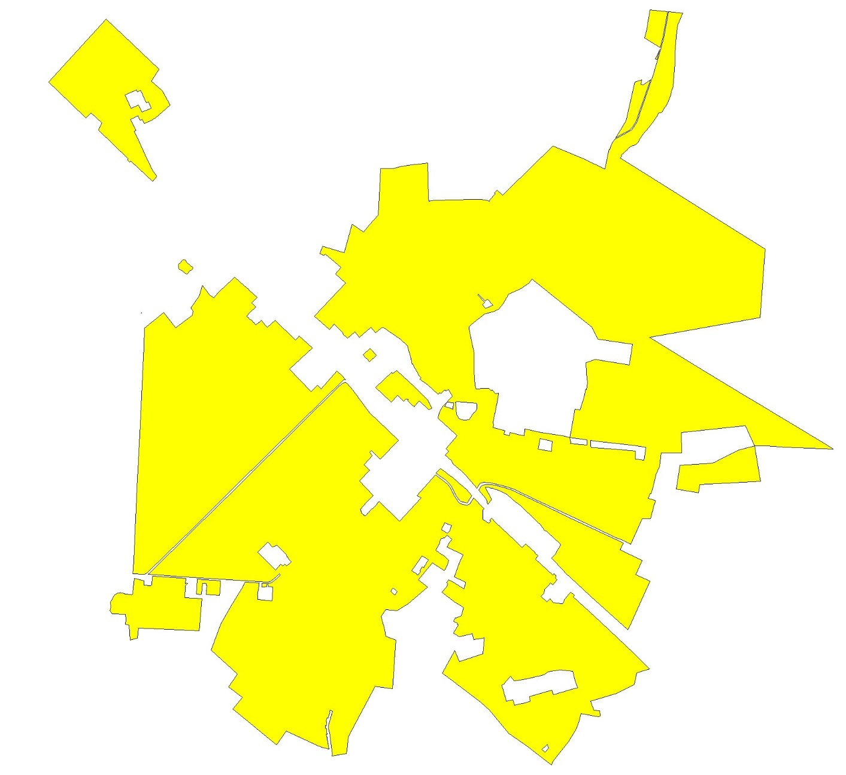

Ж2 Зона застройки среднеэтажными многоквартирными домами
№ точек | X | Y
1 | 614864.96 | 2233363.78
2 | 614907.11 | 2233346.92
3 | 614901.72 | 2233331.06
4 | 614980.30 | 2233297.15
5 | 614970.61 | 2233275.27
6 | 614983.42 | 2233268.62
7 | 614950.69 | 2233197.56
8 | 614864.40 | 2233236.20
9 | 614885.80 | 2233281.96
10 | 614842.24 | 2233304.04
11 | 613343.78 | 2234749.58
12 | 613416.61 | 2234684.55
13 | 613414.58 | 2234682.31
14 | 613449.20 | 2234652.08
15 | 613406.92 | 2234606.50
16 | 613433.22 | 2234576.00
17 | 613437.93 | 2234580.49
18 | 613445.69 | 2234572.70
19 | 613496.54 | 2234520.86
20 | 613463.29 | 2234490.93
21 | 613505.94 | 2234440.87
22 | 613547.60 | 2234396.65
23 | 613494.76 | 2234347.69
24 | 613483.99 | 2234359.35
25 | 613508.71 | 2234385.08
26 | 613488.60 | 2234407.26
27 | 613457.01 | 2234375.84
28 | 613372.02 | 2234455.30
29 | 613367.67 | 2234463.06
30 | 613378.57 | 2234473.62
31 | 613427.84 | 2234521.91
32 | 613369.07 | 2234582.81
33 | 613316.98 | 2234636.97
34 | 613329.59 | 2234649.10
35 | 613322.22 | 2234657.07
36 | 613343.30 | 2234677.36
37 | 613335.53 | 2234684.20
38 | 613308.98 | 2234711.05
39 | 614484.77 | 2234815.54
40 | 614472.06 | 2234783.97
41 | 614473.90 | 2234693.25
42 | 614451.38 | 2234685.33
43 | 614452.85 | 2234561.34
44 | 614442.82 | 2234549.47
45 | 614430.30 | 2234412.51
46 | 614428.18 | 2234378.96
47 | 614402.92 | 2234378.12
48 | 614399.69 | 2234294.73
49 | 614361.36 | 2234231.92
50 | 614304.63 | 2234231.73
51 | 614261.94 | 2234218.52
52 | 614193.69 | 2234198.10
53 | 614219.43 | 2234117.32
54 | 614109.57 | 2234046.16
55 | 614086.75 | 2234130.92
56 | 613991.55 | 2234446.85
57 | 613948.81 | 2234584.51
58 | 614131.77 | 2234634.01
59 | 614081.58 | 2234708.29
60 | 614125.10 | 2234742.05
61 | 614189.03 | 2234801.20
62 | 613245.70 | 2234836.98
63 | 613299.40 | 2234789.29
64 | 613259.65 | 2234745.78
65 | 613189.85 | 2234675.80
66 | 613155.15 | 2234713.97
67 | 613180.28 | 2234738.05
68 | 613185.34 | 2234755.65
69 | 613231.04 | 2234799.58
70 | 613220.34 | 2234809.63
71 | 611501.49 | 2235472.89
72 | 611508.15 | 2235471.52
73 | 611501.90 | 2235447.83
74 | 611496.52 | 2235404.48
75 | 611493.98 | 2235392.27
76 | 611464.76 | 2235398.40
77 | 611439.73 | 2235313.88
78 | 611426.18 | 2235285.41
79 | 611358.72 | 2235315.55
80 | 611407.58 | 2235461.72
81 | 611106.33 | 2235763.42
82 | 611135.34 | 2235758.06
83 | 611246.96 | 2235734.38
84 | 611235.23 | 2235660.62
85 | 611263.70 | 2235638.47
86 | 611231.58 | 2235608.61
87 | 611214.25 | 2235596.78
88 | 611210.09 | 2235582.31
89 | 611106.46 | 2235612.77
90 | 611116.38 | 2235653.31
91 | 611081.84 | 2235663.45
92 | 611089.68 | 2235692.78
93 | 611095.59 | 2235727.90
94 | 613128.63 | 2236124.05
95 | 613185.14 | 2236120.17
96 | 613251.53 | 2236115.61
97 | 613297.09 | 2236045.26
98 | 613301.61 | 2235988.54
99 | 613310.66 | 2235877.15
100 | 613227.57 | 2235862.59
101 | 613227.08 | 2235862.50
102 | 613227.71 | 2235858.50
103 | 613206.49 | 2235855.46
104 | 613205.32 | 2235863.32
105 | 613109.74 | 2235853.82
106 | 613109.25 | 2235858.81
107 | 613097.49 | 2235857.66
108 | 613040.40 | 2235855.68
109 | 613040.69 | 2235847.19
110 | 613047.65 | 2235785.05
111 | 613055.58 | 2235711.21
112 | 613064.52 | 2235615.98
113 | 613065.61 | 2235592.40
114 | 613064.51 | 2235578.19
115 | 613060.41 | 2235563.01
116 | 613050.90 | 2235560.98
117 | 612986.37 | 2235550.00
118 | 612873.04 | 2235527.89
119 | 612859.48 | 2235529.36
120 | 612841.83 | 2235526.31
121 | 612821.68 | 2235601.55
122 | 612803.93 | 2235598.11
123 | 612804.20 | 2235597.01
124 | 612798.37 | 2235595.81
125 | 612793.90 | 2235613.60
126 | 612788.32 | 2235630.35
127 | 612809.14 | 2235635.68
128 | 612795.53 | 2235697.19
129 | 612792.65 | 2235711.55
130 | 612789.87 | 2235724.15
131 | 612832.22 | 2235729.05
132 | 612810.91 | 2235831.94
133 | 612797.91 | 2235911.52
134 | 612788.38 | 2235966.07
135 | 612777.75 | 2236014.24
136 | 612760.89 | 2236017.49
137 | 612749.80 | 2236018.59
138 | 612739.57 | 2236017.65
139 | 612738.96 | 2236026.63
140 | 612737.42 | 2236049.83
141 | 612731.08 | 2236122.30
142 | 612762.08 | 2236120.53
143 | 612770.68 | 2236063.51
144 | 612777.76 | 2236014.26
145 | 612957.63 | 2236045.72
146 | 612952.17 | 2236077.69
147 | 613037.58 | 2236103.02
148 | 613083.24 | 2236111.84
149 | 613081.97 | 2236118.89
150 | 612715.38 | 2236496.53
151 | 612727.20 | 2236417.96
152 | 612737.35 | 2236342.62
153 | 612745.24 | 2236263.58
154 | 612752.28 | 2236206.49
155 | 612711.84 | 2236204.80
156 | 612707.43 | 2236258.41
157 | 612693.18 | 2236429.54
158 | 612641.91 | 2236427.50
159 | 612640.75 | 2236446.50
160 | 612637.29 | 2236455.10
161 | 612634.35 | 2236482.71
162 | 612612.28 | 2236856.36
163 | 612661.58 | 2236850.58
164 | 612658.35 | 2236722.50
165 | 612682.40 | 2236721.93
166 | 612682.48 | 2236592.48
167 | 612595.95 | 2236581.99
168 | 612603.75 | 2236711.78
Площадь = 561808.28 кв.м

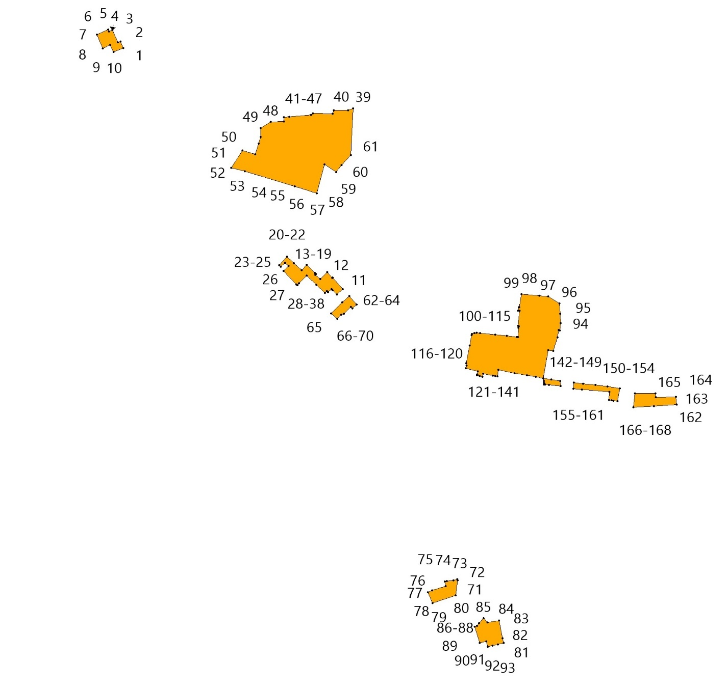

ОД Общественно-деловая зона
№№ точек | X | Y
1 | 613199.69 | 2234538.93
2 | 613309.73 | 2234421.31
3 | 613345.12 | 2234382.87
4 | 613210.89 | 2234237.28
5 | 613142.43 | 2234305.59
6 | 613070.55 | 2234376.50
7 | 613108.73 | 2234416.23
8 | 613088.08 | 2234438.66
9 | 612542.14 | 2235161.41
10 | 612570.45 | 2235128.41
11 | 612677.03 | 2235015.43
12 | 612759.44 | 2234928.96
13 | 612639.99 | 2234812.73
14 | 612695.58 | 2234757.14
15 | 612683.62 | 2234745.12
16 | 612663.91 | 2234764.46
17 | 612605.35 | 2234711.80
18 | 612571.95 | 2234746.75
19 | 612502.11 | 2234680.31
20 | 612409.25 | 2234768.78
21 | 612403.37 | 2234762.82
22 | 612376.07 | 2234734.86
23 | 612371.12 | 2234730.75
24 | 612368.88 | 2234728.90
25 | 612341.70 | 2234704.72
26 | 612335.99 | 2234699.64
27 | 612326.94 | 2234691.28
28 | 612324.37 | 2234688.66
29 | 612316.40 | 2234690.86
30 | 612314.44 | 2234691.91
31 | 612313.39 | 2234689.90
32 | 612311.30 | 2234691.40
33 | 612303.68 | 2234697.37
34 | 612299.70 | 2234693.31
35 | 612295.25 | 2234697.45
36 | 612293.32 | 2234700.84
37 | 612291.10 | 2234704.23
38 | 612287.55 | 2234709.90
39 | 612285.11 | 2234707.28
40 | 612281.02 | 2234712.95
41 | 612282.82 | 2234714.47
42 | 612282.14 | 2234716.33
43 | 612282.34 | 2234720.70
44 | 612293.83 | 2234732.18
45 | 612294.59 | 2234731.38
46 | 612295.61 | 2234730.31
47 | 612297.55 | 2234732.17
48 | 612303.54 | 2234739.08
49 | 612308.11 | 2234743.60
50 | 612353.02 | 2234788.00
51 | 612365.19 | 2234799.32
52 | 612371.90 | 2234806.05
53 | 612245.98 | 2234934.23
54 | 612395.48 | 2235073.31
55 | 612411.16 | 2235046.10
56 | 612582.76 | 2235194.72
57 | 612596.72 | 2235177.31
58 | 612575.57 | 2235156.98
59 | 612615.58 | 2235113.29
60 | 612612.30 | 2235110.14
61 | 612642.58 | 2235078.56
62 | 612688.85 | 2235033.26
63 | 612692.76 | 2235037.11
64 | 612692.17 | 2235037.73
65 | 612700.77 | 2235045.71
66 | 612717.45 | 2235028.09
67 | 612752.17 | 2234991.37
68 | 612752.44 | 2234991.09
69 | 612752.46 | 2234991.11
70 | 612765.56 | 2234977.41
71 | 612780.76 | 2234961.51
72 | 612766.22 | 2234947.97
73 | 612803.56 | 2234906.62
74 | 612819.18 | 2234922.15
75 | 612820.59 | 2234920.73
76 | 612838.39 | 2234905.36
77 | 612847.83 | 2234897.82
78 | 612848.28 | 2234898.28
79 | 612849.44 | 2234897.20
80 | 612850.54 | 2234896.82
81 | 612856.55 | 2234890.99
82 | 612860.87 | 2234888.35
83 | 612868.30 | 2234880.33
84 | 612876.85 | 2234872.37
85 | 612895.24 | 2234852.50
86 | 612871.92 | 2234830.92
87 | 612867.50 | 2234830.01
88 | 612765.00 | 2234937.25
89 | 612764.98 | 2234937.27
90 | 612764.93 | 2234937.32
91 | 612683.14 | 2235022.89
92 | 612551.74 | 2235165.28
93 | 612787.88 | 2235299.23
94 | 612796.75 | 2235290.41
95 | 612786.65 | 2235280.72
96 | 612784.94 | 2235279.98
97 | 612784.96 | 2235279.93
98 | 612784.10 | 2235279.18
99 | 612767.99 | 2235262.63
100 | 612767.23 | 2235260.62
101 | 612770.86 | 2235257.00
102 | 612752.12 | 2235234.81
103 | 612774.20 | 2235206.43
104 | 612772.35 | 2235204.73
105 | 612812.63 | 2235161.84
106 | 612799.03 | 2235149.11
107 | 612794.34 | 2235154.11
108 | 612773.22 | 2235154.11
109 | 612758.37 | 2235156.86
110 | 612738.31 | 2235163.64
111 | 612734.21 | 2235161.05
112 | 612731.70 | 2235161.19
113 | 612724.80 | 2235166.76
114 | 612678.14 | 2235204.39
115 | 612675.50 | 2235211.01
116 | 612671.58 | 2235217.55
117 | 612665.69 | 2235224.84
118 | 612691.39 | 2235247.45
119 | 612709.05 | 2235229.74
120 | 614442.87 | 2235393.69
121 | 614440.01 | 2235340.35
122 | 614446.53 | 2235340.13
123 | 614446.11 | 2235331.38
124 | 614439.44 | 2235331.16
125 | 614436.22 | 2235274.16
126 | 614436.69 | 2235263.51
127 | 614564.39 | 2235256.08
128 | 614551.06 | 2235112.01
129 | 614518.27 | 2235113.10
130 | 614300.90 | 2235119.08
131 | 614275.88 | 2235120.86
132 | 614281.21 | 2235152.71
133 | 614285.29 | 2235289.51
134 | 614287.27 | 2235385.63
135 | 614369.21 | 2235385.36
136 | 614369.43 | 2235392.64
137 | 613368.30 | 2236410.74
138 | 613400.99 | 2236193.18
139 | 613272.44 | 2236173.87
140 | 613239.74 | 2236391.42
141 | 612002.08 | 2236584.38
142 | 612111.27 | 2236351.72
143 | 612085.23 | 2236339.85
144 | 612072.90 | 2236334.20
145 | 612064.68 | 2236333.17
146 | 611999.59 | 2236472.52
147 | 611908.57 | 2236431.13
148 | 611867.16 | 2236522.16
149 | 611958.20 | 2236563.56
150 | 611985.38 | 2236575.92
151 | 612210.46 | 2236846.92
152 | 612308.46 | 2236813.77
153 | 612320.55 | 2236774.95
154 | 612361.71 | 2236701.69
155 | 612365.55 | 2236678.26
156 | 612349.26 | 2236675.60
157 | 612354.70 | 2236647.43
158 | 612358.82 | 2236624.83
159 | 612357.63 | 2236608.36
160 | 612366.84 | 2236584.20
161 | 612340.48 | 2236573.93
162 | 612350.72 | 2236548.13
163 | 612264.10 | 2236525.63
164 | 612263.21 | 2236472.98
165 | 612101.67 | 2236397.99
166 | 612005.71 | 2236602.64
167 | 612052.96 | 2236625.27
168 | 612024.47 | 2236694.18
169 | 612164.16 | 2236772.31
170 | 612140.02 | 2236832.14
Площадь = 410778.29 кв.м

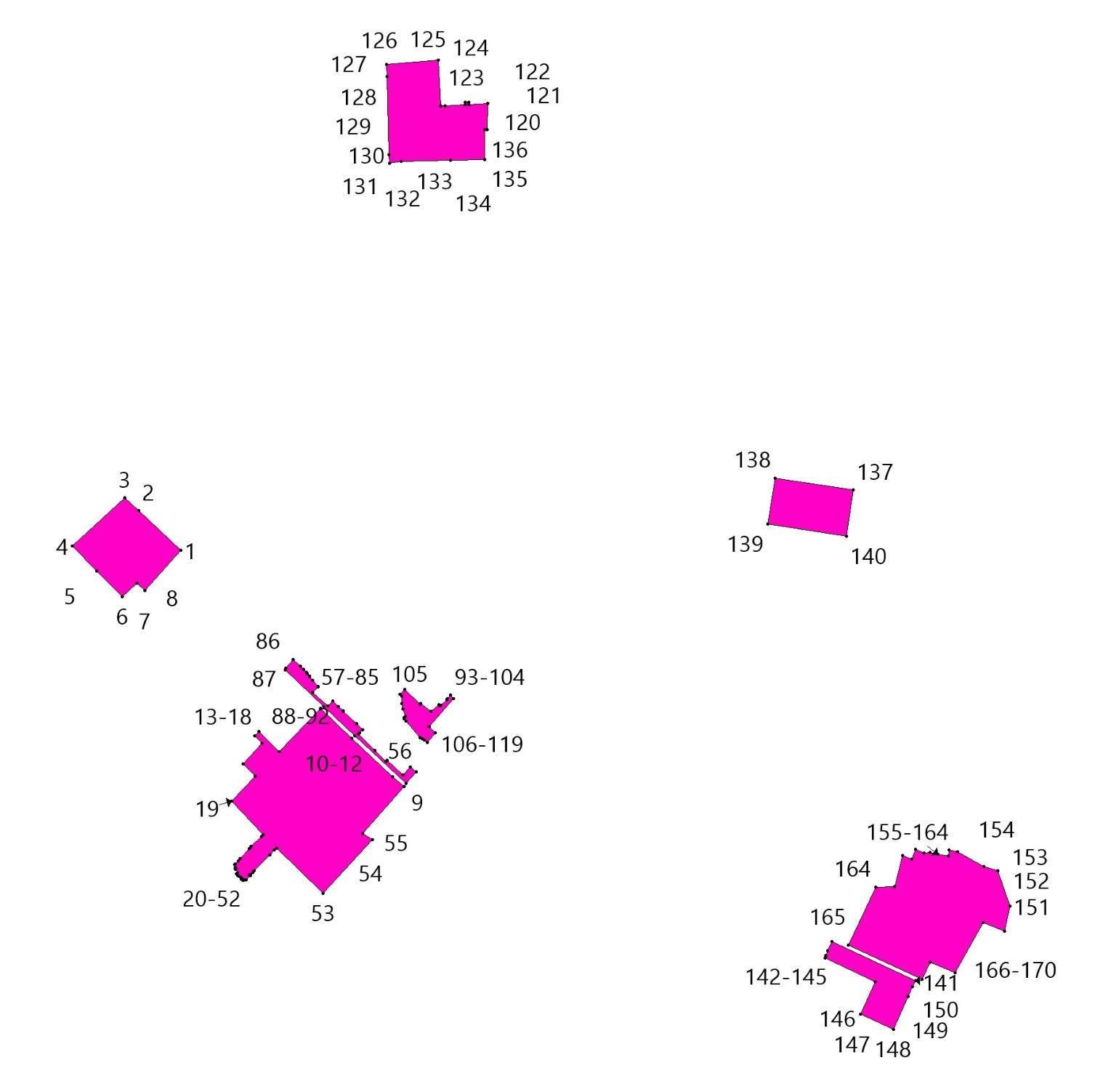

П1 Производственная зона
№№ точек | X | Y
1 | 613797.85 | 2233892.94
2 | 613796.61 | 2233891.64
3 | 613728.28 | 2233819.94
4 | 613719.15 | 2233809.21
5 | 613711.58 | 2233802.13
6 | 613695.87 | 2233786.94
7 | 613664.72 | 2233760.79
8 | 613680.98 | 2233733.70
9 | 613743.40 | 2233686.26
10 | 613676.80 | 2233665.20
11 | 613600.32 | 2233615.51
12 | 613580.72 | 2233628.81
13 | 613551.86 | 2233623.37
14 | 613473.55 | 2233517.22
15 | 613571.68 | 2233442.77
16 | 613470.25 | 2233320.44
17 | 613543.94 | 2233322.59
18 | 613577.23 | 2233353.52
19 | 613577.95 | 2233369.99
20 | 613599.23 | 2233438.26
21 | 613644.57 | 2233490.72
22 | 613677.50 | 2233517.01
23 | 613706.02 | 2233529.04
24 | 613734.88 | 2233508.85
25 | 613818.48 | 2233448.52
26 | 613992.26 | 2233333.90
27 | 614050.02 | 2233273.89
28 | 614052.34 | 2233238.21
29 | 613940.56 | 2233146.63
30 | 614087.86 | 2232987.83
31 | 614132.08 | 2232942.83
32 | 614145.74 | 2232925.75
33 | 614220.43 | 2232856.71
34 | 614249.09 | 2232907.71
35 | 614374.68 | 2232772.88
36 | 614458.66 | 2232679.74
37 | 614423.09 | 2232656.60
38 | 614366.99 | 2232673.10
39 | 614307.90 | 2232707.07
40 | 614264.39 | 2232736.43
41 | 614230.48 | 2232764.00
42 | 614212.18 | 2232812.91
43 | 614175.58 | 2232829.71
44 | 614143.78 | 2232853.11
45 | 614155.42 | 2232535.57
46 | 614163.47 | 2232536.19
47 | 614179.70 | 2232548.45
48 | 614188.76 | 2232571.62
49 | 614202.93 | 2232582.76
50 | 614226.20 | 2232590.86
51 | 614236.32 | 2232581.75
52 | 614236.32 | 2232554.41
53 | 614256.55 | 2232548.34
54 | 614292.98 | 2232529.10
55 | 614287.92 | 2232487.59
56 | 614277.80 | 2232475.44
57 | 614239.35 | 2232487.59
58 | 614179.66 | 2232498.73
59 | 614169.54 | 2232507.84
60 | 614156.46 | 2232507.36
61 | 614159.41 | 2232426.85
62 | 614182.94 | 2232430.16
63 | 614232.10 | 2232379.02
64 | 614242.78 | 2232357.37
65 | 614263.26 | 2232345.41
66 | 614312.78 | 2232369.33
67 | 614345.23 | 2232352.25
68 | 614360.60 | 2232345.41
69 | 614386.32 | 2232372.97
70 | 614430.58 | 2232390.17
71 | 614468.53 | 2232420.04
72 | 614491.80 | 2232420.55
73 | 614499.90 | 2232408.90
74 | 614489.78 | 2232395.24
75 | 614487.75 | 2232377.01
76 | 614484.72 | 2232357.78
77 | 614473.08 | 2232354.24
78 | 614446.27 | 2232362.84
79 | 614412.88 | 2232368.91
80 | 614393.04 | 2232360.79
81 | 614391.33 | 2232297.57
82 | 614389.91 | 2232283.92
83 | 614616.83 | 2232294.65
84 | 614672.13 | 2232349.09
85 | 614672.16 | 2232354.74
86 | 614665.08 | 2232377.01
87 | 614659.01 | 2232406.38
88 | 614686.32 | 2232432.70
89 | 614733.88 | 2232430.67
90 | 614751.08 | 2232443.84
91 | 614767.27 | 2232445.86
92 | 614769.13 | 2232444.71
93 | 614769.26 | 2232444.63
94 | 614865.24 | 2232527.21
95 | 614751.87 | 2232600.45
96 | 614762.86 | 2232617.54
97 | 614774.11 | 2232612.79
98 | 614880.97 | 2232540.74
99 | 614984.15 | 2232633.28
100 | 614897.96 | 2232723.79
101 | 614725.55 | 2232903.12
102 | 614726.46 | 2232903.57
103 | 614662.82 | 2232967.46
104 | 614659.78 | 2232965.95
105 | 614647.46 | 2232993.21
106 | 614646.90 | 2232992.89
107 | 614606.75 | 2233035.40
108 | 614295.15 | 2233364.81
109 | 614287.45 | 2233357.53
110 | 614151.06 | 2233505.40
111 | 614006.26 | 2233664.93
112 | 614008.82 | 2233667.22
113 | 613908.56 | 2233776.34
114 | 613854.77 | 2233628.64
115 | 613836.54 | 2233613.13
116 | 613836.54 | 2233608.89
117 | 613813.46 | 2233587.57
118 | 613837.71 | 2233552.00
119 | 613840.16 | 2233549.55
120 | 613849.81 | 2233534.95
121 | 613853.15 | 2233537.15
122 | 613858.69 | 2233534.31
123 | 613872.98 | 2233534.29
124 | 613875.90 | 2233536.01
125 | 613892.38 | 2233552.38
126 | 613894.74 | 2233554.10
127 | 613904.99 | 2233565.14
128 | 613904.76 | 2233571.20
129 | 613901.61 | 2233582.17
130 | 613889.44 | 2233587.23
131 | 612021.87 | 2233037.21
132 | 611935.27 | 2233035.44
133 | 611940.76 | 2232926.20
134 | 612021.49 | 2232928.66
135 | 611884.99 | 2233256.45
136 | 611794.33 | 2233247.32
137 | 611786.35 | 2233246.74
138 | 611781.47 | 2233239.14
139 | 611782.06 | 2233234.40
140 | 611786.95 | 2233194.93
141 | 611789.76 | 2233195.42
142 | 611794.90 | 2233164.34
143 | 611790.79 | 2233164.03
144 | 611791.35 | 2233159.56
145 | 611793.09 | 2233153.71
146 | 611782.18 | 2233131.78
147 | 611765.54 | 2233120.32
148 | 611742.63 | 2233111.03
149 | 611736.00 | 2233104.79
150 | 611703.81 | 2233105.62
151 | 611680.46 | 2233101.62
152 | 611661.05 | 2233116.69
153 | 611656.61 | 2233199.70
154 | 611628.75 | 2233202.70
155 | 611592.38 | 2233201.00
156 | 611595.67 | 2233178.24
157 | 611680.09 | 2233093.18
158 | 611752.44 | 2233072.94
159 | 611760.84 | 2232963.14
160 | 611865.53 | 2233006.34
161 | 611896.64 | 2233008.59
162 | 611895.72 | 2233028.25
163 | 614627.64 | 2235906.02
164 | 614350.29 | 2235623.91
165 | 614314.41 | 2235589.09
166 | 614322.43 | 2235580.83
167 | 614347.94 | 2235552.67
168 | 614327.93 | 2235534.55
169 | 614322.55 | 2235540.47
170 | 614285.50 | 2235506.91
171 | 614275.22 | 2235502.70
172 | 614286.31 | 2235475.39
173 | 614288.11 | 2235448.61
174 | 614287.27 | 2235385.63
175 | 614369.21 | 2235385.36
176 | 614369.43 | 2235392.64
177 | 614442.87 | 2235393.69
178 | 614440.01 | 2235340.35
179 | 614446.53 | 2235340.13
180 | 614446.11 | 2235331.38
181 | 614439.44 | 2235331.16
182 | 614436.22 | 2235274.16
183 | 614436.69 | 2235263.51
184 | 614564.39 | 2235256.08
185 | 614551.06 | 2235112.01
186 | 614518.27 | 2235113.10
187 | 614502.61 | 2234988.72
188 | 614496.33 | 2234939.01
189 | 614484.55 | 2234894.48
190 | 614484.77 | 2234815.54
191 | 614472.06 | 2234783.97
192 | 614473.90 | 2234693.25
193 | 614451.38 | 2234685.33
194 | 614452.85 | 2234561.34
195 | 614442.82 | 2234549.47
196 | 614430.30 | 2234412.51
197 | 614428.18 | 2234378.96
198 | 614402.92 | 2234378.12
199 | 614399.69 | 2234294.73
200 | 614361.36 | 2234231.92
201 | 614304.63 | 2234231.73
202 | 614261.94 | 2234218.52
203 | 614193.69 | 2234198.10
204 | 614219.43 | 2234117.32
205 | 614109.57 | 2234046.16
206 | 614086.75 | 2234130.92
207 | 613991.55 | 2234446.85
208 | 613942.95 | 2234430.45
209 | 613931.21 | 2234454.79
210 | 613942.41 | 2234465.01
211 | 613855.41 | 2234565.58
212 | 613815.16 | 2234530.82
213 | 613756.70 | 2234594.64
214 | 613547.60 | 2234396.65
215 | 613494.76 | 2234347.69
216 | 613511.15 | 2234330.53
217 | 613744.21 | 2234078.87
218 | 613777.97 | 2234111.59
219 | 613790.87 | 2234098.26
220 | 613789.71 | 2234097.16
221 | 613805.76 | 2234081.79
222 | 613871.03 | 2234009.61
223 | 613885.18 | 2233988.23
224 | 613905.98 | 2233950.21
225 | 613906.23 | 2233950.22
226 | 613926.46 | 2233913.29
227 | 613938.52 | 2233892.72
228 | 613935.38 | 2233912.71
229 | 613932.43 | 2233957.95
230 | 613932.10 | 2234033.14
231 | 613926.58 | 2234047.69
232 | 613925.49 | 2234064.33
233 | 613937.57 | 2234064.99
234 | 613938.01 | 2234084.26
235 | 613938.58 | 2234084.57
236 | 613939.20 | 2234136.09
237 | 613955.20 | 2234135.64
238 | 613953.20 | 2234048.90
239 | 613947.76 | 2233970.34
240 | 613949.83 | 2233937.70
241 | 613949.75 | 2233934.71
242 | 613950.16 | 2233932.44
243 | 613951.30 | 2233914.46
244 | 613958.92 | 2233876.86
245 | 613976.68 | 2233843.40
246 | 613992.41 | 2233817.83
247 | 614010.42 | 2233798.42
248 | 614077.70 | 2233720.05
249 | 614259.24 | 2233891.95
250 | 614355.23 | 2233790.55
251 | 614464.19 | 2233668.45
252 | 614459.10 | 2233665.14
253 | 614453.77 | 2233663.87
254 | 614445.55 | 2233660.96
255 | 614360.16 | 2233644.24
256 | 614351.23 | 2233639.87
257 | 614305.13 | 2233635.82
258 | 614268.00 | 2233636.63
259 | 614249.63 | 2233637.76
260 | 614249.30 | 2233632.46
261 | 614250.54 | 2233627.00
262 | 614227.92 | 2233630.11
263 | 614194.60 | 2233638.49
264 | 614170.05 | 2233615.24
265 | 614249.44 | 2233559.59
266 | 614368.45 | 2233410.72
267 | 614402.67 | 2233373.39
268 | 614434.37 | 2233399.50
269 | 614473.08 | 2233372.09
270 | 614501.06 | 2233358.27
271 | 614569.49 | 2233325.91
272 | 614653.43 | 2233288.15
273 | 614719.43 | 2233256.38
274 | 614725.09 | 2233268.21
275 | 614795.66 | 2233231.93
276 | 614818.38 | 2233278.73
277 | 614788.73 | 2233292.88
278 | 614794.88 | 2233305.25
279 | 614768.51 | 2233318.29
280 | 614777.32 | 2233338.51
281 | 614788.11 | 2233359.26
282 | 614804.29 | 2233388.69
283 | 614886.44 | 2233482.47
284 | 614881.27 | 2233485.28
285 | 614976.22 | 2233433.76
286 | 615037.34 | 2233363.89
287 | 615112.33 | 2233411.95
288 | 615430.01 | 2233077.26
289 | 615438.96 | 2233085.47
290 | 614991.14 | 2233570.62
291 | 614976.16 | 2233632.79
292 | 614980.21 | 2233671.12
293 | 614969.18 | 2233683.30
294 | 614987.74 | 2233707.60
295 | 615101.80 | 2233816.66
296 | 614907.42 | 2234045.84
297 | 614892.80 | 2234063.08
298 | 615125.89 | 2234237.52
299 | 615275.38 | 2234361.28
300 | 615243.66 | 2234436.92
301 | 614670.67 | 2235803.40
302 | 611879.48 | 2233655.50
303 | 611876.37 | 2233655.23
304 | 611785.22 | 2233649.56
305 | 611783.24 | 2233679.18
306 | 611786.98 | 2233680.50
307 | 611854.51 | 2233688.44
308 | 611851.88 | 2233710.88
309 | 611841.82 | 2233709.70
310 | 611841.20 | 2233716.30
311 | 611816.97 | 2233714.03
312 | 611817.15 | 2233712.12
313 | 611806.82 | 2233711.11
314 | 611806.64 | 2233713.01
315 | 611784.03 | 2233710.79
316 | 611777.74 | 2233794.51
317 | 611796.50 | 2233796.77
318 | 611858.69 | 2233800.37
319 | 611870.61 | 2233800.68
320 | 611861.02 | 2233957.63
321 | 611817.60 | 2233934.73
322 | 611770.84 | 2233905.93
323 | 611728.68 | 2233879.96
324 | 611719.21 | 2233874.13
325 | 611596.87 | 2233802.95
326 | 611430.14 | 2233742.08
327 | 611391.13 | 2233729.09
328 | 611391.57 | 2233223.51
329 | 611493.73 | 2233228.45
330 | 611507.01 | 2233274.75
331 | 611571.37 | 2233280.91
332 | 611552.90 | 2233667.64
333 | 611756.36 | 2233683.44
334 | 611763.01 | 2233574.82
335 | 611839.26 | 2233579.56
336 | 611852.99 | 2233593.65
337 | 611854.82 | 2233584.07
338 | 611851.15 | 2233580.30
339 | 611884.24 | 2233582.35
340 | 611881.48 | 2233622.84
341 | 610757.85 | 2234487.92
342 | 610748.11 | 2234487.69
343 | 610732.78 | 2234483.67
344 | 610729.43 | 2234482.79
345 | 610705.20 | 2234477.70
346 | 610669.17 | 2234470.14
347 | 610657.52 | 2234467.70
348 | 610617.53 | 2234458.34
349 | 610555.75 | 2234444.10
350 | 610556.54 | 2234440.57
351 | 610464.03 | 2234419.66
352 | 610434.72 | 2234413.30
353 | 610299.69 | 2234398.26
354 | 610251.49 | 2234384.08
355 | 610285.28 | 2233771.99
356 | 610369.22 | 2233768.38
357 | 610502.59 | 2233767.53
358 | 610501.40 | 2233880.14
359 | 610829.82 | 2234157.83
360 | 610916.88 | 2234216.52
361 | 610824.79 | 2234418.92
362 | 610812.59 | 2234451.82
363 | 610809.62 | 2234466.64
364 | 610803.79 | 2234484.48
365 | 610796.23 | 2234485.45
366 | 610796.50 | 2234487.13
367 | 610761.47 | 2234486.78
368 | 613421.04 | 2234300.51
369 | 613414.08 | 2234294.40
370 | 613398.69 | 2234279.86
371 | 613395.78 | 2234276.88
372 | 613437.09 | 2234234.56
373 | 613444.77 | 2234225.57
374 | 613475.41 | 2234193.08
375 | 613511.28 | 2234155.17
376 | 613521.05 | 2234147.05
377 | 613477.39 | 2234098.88
378 | 613486.85 | 2234089.72
379 | 613522.13 | 2234059.56
380 | 613515.77 | 2234053.22
381 | 613514.96 | 2234053.94
382 | 613507.75 | 2234046.46
383 | 613509.38 | 2234044.81
384 | 613492.73 | 2234026.72
385 | 613503.13 | 2234016.43
386 | 613507.81 | 2234011.79
387 | 613518.15 | 2234001.43
388 | 613527.37 | 2233992.49
389 | 613525.27 | 2233990.24
390 | 613530.25 | 2233985.39
391 | 613533.91 | 2233981.74
392 | 613534.94 | 2233982.76
393 | 613545.19 | 2233970.89
394 | 613550.38 | 2233969.52
395 | 613560.66 | 2233979.65
396 | 613562.70 | 2233977.60
397 | 613574.58 | 2233991.41
398 | 613604.52 | 2234024.95
399 | 613631.17 | 2233997.75
400 | 613666.84 | 2234033.32
401 | 613637.77 | 2234063.96
402 | 613640.50 | 2234066.55
403 | 613613.10 | 2234095.59
404 | 613590.53 | 2234073.47
405 | 613573.03 | 2234092.02
406 | 613576.91 | 2234102.03
407 | 613584.61 | 2234110.48
408 | 613566.68 | 2234130.40
409 | 613567.41 | 2234131.00
410 | 613545.59 | 2234154.16
411 | 613529.09 | 2234138.59
412 | 613522.12 | 2234145.98
413 | 613545.11 | 2234167.66
414 | 613468.49 | 2234248.87
415 | 611828.54 | 2234133.92
416 | 611765.36 | 2234128.91
417 | 611740.99 | 2234126.94
418 | 611747.43 | 2234071.37
419 | 611750.25 | 2234037.30
420 | 611778.49 | 2234036.49
421 | 611781.24 | 2234033.66
422 | 611783.88 | 2234036.23
423 | 611791.59 | 2234036.26
424 | 611812.82 | 2234038.92
425 | 611813.35 | 2234038.99
426 | 611813.20 | 2234043.44
427 | 611852.89 | 2234046.97
428 | 611855.51 | 2234047.26
429 | 611854.51 | 2234063.46
430 | 611851.90 | 2234063.33
431 | 611829.44 | 2234062.72
432 | 611829.55 | 2234076.01
433 | 611833.18 | 2234094.14
434 | 611839.49 | 2234094.84
435 | 611846.17 | 2234095.41
436 | 611846.02 | 2234099.50
437 | 611845.57 | 2234103.54
438 | 611845.47 | 2234104.45
439 | 611833.47 | 2234104.63
440 | 611830.37 | 2234131.94
441 | 611989.85 | 2234248.42
442 | 611964.42 | 2234221.24
443 | 611975.77 | 2234210.16
444 | 611962.85 | 2234196.70
445 | 611975.40 | 2234183.91
446 | 611938.40 | 2234149.31
447 | 612051.54 | 2234038.15
448 | 612114.47 | 2234101.20
449 | 612082.81 | 2234129.34
450 | 612094.76 | 2234159.86
451 | 612033.05 | 2234221.04
452 | 612020.67 | 2234224.75
453 | 612018.96 | 2234226.97
454 | 612011.93 | 2234233.41
455 | 612000.77 | 2234239.39
456 | 610702.22 | 2235898.55
457 | 610561.04 | 2235841.93
458 | 610562.34 | 2235821.96
459 | 610734.86 | 2235605.28
460 | 610756.21 | 2235581.79
461 | 610786.95 | 2235549.53
462 | 610742.61 | 2235474.93
463 | 610787.58 | 2235435.20
464 | 610835.55 | 2235422.83
465 | 610971.50 | 2235297.76
466 | 610848.23 | 2234971.06
467 | 610421.30 | 2234892.15
468 | 610426.65 | 2234857.59
469 | 610428.29 | 2234854.34
470 | 610447.71 | 2234816.03
471 | 610458.99 | 2234784.27
472 | 610465.82 | 2234761.96
473 | 610500.75 | 2234720.19
474 | 610502.70 | 2234576.19
475 | 610490.02 | 2234577.22
476 | 610471.86 | 2234570.03
477 | 610464.67 | 2234563.51
478 | 610455.41 | 2234551.86
479 | 610450.27 | 2234540.90
480 | 610451.99 | 2234530.27
481 | 610453.70 | 2234519.99
482 | 610456.44 | 2234516.57
483 | 610457.47 | 2234507.31
484 | 610453.70 | 2234496.69
485 | 610442.73 | 2234487.44
486 | 610435.54 | 2234486.75
487 | 610416.69 | 2234486.75
488 | 610392.01 | 2234486.75
489 | 610370.42 | 2234487.44
490 | 610353.98 | 2234490.18
491 | 610310.35 | 2234510.63
492 | 610282.57 | 2234515.89
493 | 610245.91 | 2234485.13
494 | 610250.29 | 2234405.73
495 | 610295.26 | 2234417.78
496 | 610296.73 | 2234418.06
497 | 610431.96 | 2234433.12
498 | 610673.98 | 2234487.41
499 | 610674.49 | 2234484.94
500 | 610758.70 | 2234503.77
501 | 610759.62 | 2234506.62
502 | 610760.44 | 2234509.17
503 | 610773.38 | 2234601.06
504 | 610883.50 | 2234612.88
505 | 611199.82 | 2234779.17
506 | 611185.52 | 2234889.93
507 | 611495.45 | 2234911.29
508 | 611570.95 | 2234916.49
509 | 611567.14 | 2235036.51
510 | 611626.23 | 2235036.53
511 | 611645.30 | 2235046.39
512 | 611656.15 | 2235026.31
513 | 611724.51 | 2235073.79
514 | 611744.59 | 2235089.36
515 | 611747.68 | 2235091.59
516 | 611750.02 | 2235088.65
517 | 611791.11 | 2235121.46
518 | 611908.57 | 2235255.94
519 | 611934.09 | 2235218.20
520 | 611941.98 | 2235223.30
521 | 611971.46 | 2235238.16
522 | 612000.34 | 2235246.76
523 | 612003.23 | 2235243.44
524 | 612011.75 | 2235234.65
525 | 612018.06 | 2235227.86
526 | 612024.13 | 2235220.68
527 | 612030.78 | 2235211.93
528 | 612037.56 | 2235201.26
529 | 612045.12 | 2235190.00
530 | 612053.58 | 2235178.62
531 | 612058.58 | 2235171.06
532 | 612062.68 | 2235164.50
533 | 612071.53 | 2235169.46
534 | 612107.56 | 2235190.11
535 | 612117.95 | 2235189.01
536 | 612139.53 | 2235200.31
537 | 612142.99 | 2235220.29
538 | 612160.51 | 2235234.54
539 | 612134.34 | 2235266.73
540 | 612116.98 | 2235252.62
541 | 612082.46 | 2235236.42
542 | 612057.56 | 2235289.48
543 | 612035.20 | 2235337.13
544 | 611984.65 | 2235314.11
545 | 611952.21 | 2235303.84
546 | 611893.67 | 2235282.78
547 | 611863.23 | 2235353.52
548 | 611849.43 | 2235352.52
549 | 611819.34 | 2235341.92
550 | 611859.59 | 2235279.18
551 | 611876.42 | 2235248.35
552 | 611859.25 | 2235231.83
553 | 611850.27 | 2235242.43
554 | 611841.73 | 2235235.96
555 | 611838.11 | 2235239.81
556 | 611804.68 | 2235208.39
557 | 611799.12 | 2235203.17
558 | 611736.63 | 2235283.53
559 | 611717.80 | 2235311.83
560 | 611709.84 | 2235325.33
561 | 611699.45 | 2235341.58
562 | 611679.72 | 2235334.11
563 | 611675.59 | 2235333.26
564 | 611667.82 | 2235332.49
565 | 611662.38 | 2235332.15
566 | 611659.60 | 2235331.63
567 | 611647.23 | 2235323.22
568 | 611633.65 | 2235295.09
569 | 611636.60 | 2235290.36
570 | 611613.71 | 2235277.51
571 | 611599.49 | 2235303.19
572 | 611594.42 | 2235300.88
573 | 611591.22 | 2235307.13
574 | 611536.89 | 2235277.62
575 | 611515.77 | 2235313.72
576 | 611520.61 | 2235335.82
577 | 611521.14 | 2235337.14
578 | 611536.23 | 2235394.80
579 | 611496.52 | 2235404.48
580 | 611493.98 | 2235392.27
581 | 611464.76 | 2235398.40
582 | 611439.73 | 2235313.88
583 | 611426.18 | 2235285.41
584 | 611285.08 | 2235205.17
585 | 611100.61 | 2235448.55
586 | 611052.68 | 2235502.53
587 | 610903.76 | 2235627.63
588 | 610822.91 | 2235738.93
589 | 613259.65 | 2234745.78
590 | 613189.85 | 2234675.80
591 | 613200.51 | 2234664.48
592 | 613223.31 | 2234685.88
593 | 613257.69 | 2234649.29
594 | 613276.30 | 2234665.67
595 | 613290.65 | 2234649.38
596 | 613287.92 | 2234646.97
597 | 613339.64 | 2234588.24
598 | 613347.80 | 2234576.99
599 | 613350.64 | 2234573.73
600 | 613355.13 | 2234571.40
601 | 613359.01 | 2234568.86
602 | 613352.18 | 2234559.05
603 | 613332.40 | 2234540.39
604 | 613336.52 | 2234536.03
605 | 613334.94 | 2234534.54
606 | 613378.57 | 2234473.62
607 | 613427.84 | 2234521.91
608 | 613369.07 | 2234582.81
609 | 613316.98 | 2234636.97
610 | 613329.59 | 2234649.10
611 | 613322.22 | 2234657.07
612 | 613343.30 | 2234677.36
613 | 613335.53 | 2234684.20
614 | 613308.98 | 2234711.05
615 | 613302.53 | 2234703.93
616 | 613279.34 | 2234725.69
617 | 613280.00 | 2234728.04
618 | 613192.63 | 2234884.67
619 | 613094.68 | 2234782.23
620 | 613135.42 | 2234735.68
621 | 613155.15 | 2234713.97
622 | 613180.28 | 2234738.05
623 | 613185.34 | 2234755.65
624 | 613231.04 | 2234799.58
625 | 613220.34 | 2234809.63
626 | 613245.70 | 2234836.98
627 | 611801.67 | 2234921.24
628 | 611779.07 | 2234905.96
629 | 611782.94 | 2234901.20
630 | 611803.10 | 2234880.09
631 | 611816.84 | 2234888.70
632 | 611823.20 | 2234893.68
633 | 611812.03 | 2234907.95
634 | 612973.62 | 2235027.96
635 | 612957.57 | 2235015.05
636 | 612947.24 | 2234987.13
637 | 612936.97 | 2234962.76
638 | 612936.90 | 2234960.16
639 | 612937.76 | 2234957.85
640 | 613003.55 | 2234882.10
641 | 613044.78 | 2234924.29
642 | 613007.76 | 2234962.10
643 | 613022.20 | 2234976.71
644 | 613022.14 | 2234980.61
645 | 613019.17 | 2234983.48
646 | 613022.04 | 2234986.21
647 | 613020.54 | 2234987.85
648 | 613021.43 | 2234988.60
649 | 613020.33 | 2234990.02
650 | 613019.26 | 2234989.31
651 | 613018.01 | 2234990.65
652 | 613014.94 | 2234988.10
653 | 613011.12 | 2234987.59
654 | 612985.91 | 2235013.24
655 | 612001.09 | 2235118.98
656 | 611989.84 | 2235111.02
657 | 611956.24 | 2235089.06
658 | 611951.52 | 2235090.27
659 | 611958.72 | 2235079.43
660 | 611933.30 | 2235062.75
661 | 611929.10 | 2235068.72
662 | 611920.10 | 2235062.37
663 | 611905.60 | 2235051.84
664 | 611908.02 | 2235048.35
665 | 611908.49 | 2235047.31
666 | 611909.35 | 2235047.98
667 | 611912.58 | 2235045.55
668 | 611914.00 | 2235043.20
669 | 611916.75 | 2235039.34
670 | 611917.59 | 2235038.39
671 | 611920.26 | 2235033.78
672 | 611928.85 | 2235020.25
673 | 611934.93 | 2235011.91
674 | 611953.19 | 2235024.40
675 | 612028.15 | 2235079.03
676 | 612220.51 | 2235264.85
677 | 612213.46 | 2235262.08
678 | 612211.04 | 2235261.13
679 | 612185.07 | 2235251.84
680 | 612172.11 | 2235238.58
681 | 612193.72 | 2235200.95
682 | 612238.10 | 2235220.93
683 | 612235.67 | 2235226.97
684 | 613400.99 | 2236193.18
685 | 613272.44 | 2236173.87
686 | 613251.53 | 2236115.61
687 | 613297.09 | 2236045.26
688 | 613301.61 | 2235988.54
689 | 613310.66 | 2235877.15
690 | 613227.57 | 2235862.59
691 | 613227.08 | 2235862.50
692 | 613227.71 | 2235858.50
693 | 613206.49 | 2235855.46
694 | 613205.32 | 2235863.32
695 | 613109.74 | 2235853.82
696 | 613109.25 | 2235858.81
697 | 613097.49 | 2235857.66
698 | 613040.40 | 2235855.68
699 | 613040.69 | 2235847.19
700 | 613047.65 | 2235785.05
701 | 613055.58 | 2235711.21
702 | 613064.52 | 2235615.98
703 | 613065.61 | 2235592.40
704 | 613064.51 | 2235578.19
705 | 613060.41 | 2235563.01
706 | 613055.71 | 2235545.11
707 | 613081.04 | 2235521.04
708 | 613082.11 | 2235520.02
709 | 613099.03 | 2235509.75
710 | 613149.46 | 2235513.45
711 | 613172.44 | 2235505.87
712 | 613189.64 | 2235506.77
713 | 613191.06 | 2235484.96
714 | 613238.69 | 2235489.34
715 | 613230.29 | 2235555.88
716 | 613228.22 | 2235574.43
717 | 613369.93 | 2235597.44
718 | 613350.46 | 2235727.82
719 | 613448.84 | 2235740.74
720 | 613416.19 | 2236100.00
721 | 613477.78 | 2236154.37
722 | 611191.61 | 2236064.81
723 | 611184.24 | 2236037.83
724 | 611148.78 | 2235908.51
725 | 611176.54 | 2235899.41
726 | 611135.34 | 2235758.06
727 | 611246.96 | 2235734.38
728 | 611273.92 | 2235848.29
729 | 611292.39 | 2235878.16
730 | 611304.03 | 2235952.07
731 | 611296.45 | 2236032.26
732 | 611230.66 | 2236048.15
733 | 612755.50 | 2235903.81
734 | 612752.06 | 2235903.40
735 | 612750.15 | 2235903.17
736 | 612708.54 | 2235898.64
737 | 612701.65 | 2235897.90
738 | 612690.38 | 2235896.51
739 | 612702.79 | 2235820.53
740 | 612703.85 | 2235813.93
741 | 612734.31 | 2235818.01
742 | 612770.75 | 2235824.69
743 | 611798.13 | 2236020.80
744 | 611786.92 | 2236009.63
745 | 611757.82 | 2235985.04
746 | 611752.96 | 2235980.90
747 | 611750.22 | 2235979.43
748 | 611738.93 | 2235975.91
749 | 611733.60 | 2235973.22
750 | 611731.21 | 2235971.53
751 | 611729.06 | 2235969.50
752 | 611725.69 | 2235964.54
753 | 611724.49 | 2235962.01
754 | 611731.36 | 2235908.94
755 | 611745.18 | 2235897.60
756 | 611756.80 | 2235888.28
757 | 611757.22 | 2235887.86
758 | 611735.80 | 2235866.84
759 | 611770.83 | 2235831.16
760 | 611792.24 | 2235852.17
761 | 611813.03 | 2235852.59
762 | 611815.62 | 2235854.15
763 | 611841.46 | 2235878.80
764 | 611856.67 | 2235892.99
765 | 611845.17 | 2235905.70
766 | 611877.69 | 2235932.98
767 | 614675.76 | 2236301.55
768 | 614674.20 | 2236298.81
769 | 614669.85 | 2236293.44
770 | 614659.21 | 2236284.00
771 | 614638.26 | 2236272.48
772 | 614618.40 | 2236264.81
773 | 614606.24 | 2236261.26
774 | 614605.55 | 2236263.30
775 | 614479.66 | 2236234.55
776 | 614542.16 | 2236106.43
777 | 614547.64 | 2236096.80
778 | 614712.96 | 2236179.08
779 | 614714.42 | 2236243.35
780 | 614667.70 | 2236266.72
781 | 614667.05 | 2236267.74
782 | 614679.18 | 2236289.27
783 | 611679.68 | 2238146.48
784 | 611038.03 | 2237575.05
785 | 610586.39 | 2237418.58
786 | 610580.77 | 2237413.27
787 | 610774.62 | 2237208.97
788 | 611053.66 | 2236921.89
789 | 611255.49 | 2236713.95
790 | 611468.64 | 2236480.25
791 | 611558.60 | 2236380.32
792 | 611607.57 | 2236403.85
793 | 611867.16 | 2236522.16
794 | 611985.38 | 2236575.92
795 | 612002.08 | 2236584.38
796 | 611962.38 | 2236669.16
797 | 611868.17 | 2236869.09
798 | 611810.54 | 2236994.02
799 | 611735.57 | 2237152.05
800 | 611710.95 | 2237206.01
801 | 611692.28 | 2237251.06
802 | 611675.42 | 2237300.19
803 | 611656.00 | 2237372.37
804 | 611647.96 | 2237412.72
805 | 611636.77 | 2237495.19
806 | 611631.71 | 2237556.29
807 | 611630.26 | 2237602.37
808 | 611631.45 | 2237674.51
809 | 611641.64 | 2237781.02
810 | 611649.13 | 2237852.07
811 | 611660.13 | 2237958.68
812 | 612392.67 | 2236509.24
813 | 612422.88 | 2236520.65
814 | 612421.13 | 2236527.42
815 | 612468.55 | 2236541.47
816 | 612509.11 | 2236549.98
817 | 612545.35 | 2236560.51
818 | 612595.95 | 2236581.99
819 | 612603.75 | 2236711.78
820 | 612450.89 | 2236686.44
821 | 612427.11 | 2236827.37
822 | 612479.38 | 2236836.57
823 | 612500.41 | 2237221.22
824 | 612726.25 | 2237184.52
825 | 612726.27 | 2237261.02
826 | 612717.21 | 2237377.79
827 | 612698.83 | 2237830.90
828 | 612465.88 | 2238076.35
829 | 612170.38 | 2238154.08
830 | 611795.41 | 2238249.55
831 | 611691.86 | 2238157.33
832 | 611671.51 | 2237962.42
833 | 611660.42 | 2237854.47
834 | 611652.59 | 2237779.93
835 | 611642.44 | 2237673.90
836 | 611641.26 | 2237602.45
837 | 611642.69 | 2237556.92
838 | 611647.71 | 2237496.39
839 | 611658.81 | 2237414.54
840 | 611666.72 | 2237374.87
841 | 611685.94 | 2237303.41
842 | 611702.57 | 2237254.96
843 | 611721.04 | 2237210.40
844 | 611745.54 | 2237156.69
845 | 611820.50 | 2236998.68
846 | 611877.83 | 2236874.38
847 | 611991.58 | 2236935.59
848 | 612009.99 | 2236897.26
849 | 612101.82 | 2236932.17
850 | 612140.02 | 2236832.14
851 | 612210.46 | 2236846.92
852 | 612308.46 | 2236813.77
853 | 612320.55 | 2236774.95
854 | 612361.71 | 2236701.69
855 | 612365.55 | 2236678.26
856 | 612349.26 | 2236675.60
857 | 612354.70 | 2236647.43
858 | 612358.82 | 2236624.83
859 | 612357.63 | 2236608.36
860 | 612366.84 | 2236584.20
861 | 612340.48 | 2236573.93
862 | 612350.72 | 2236548.13
863 | 612377.02 | 2236557.36
864 | 612726.27 | 2237184.51
865 | 612714.72 | 2237136.65
866 | 612698.08 | 2237082.83
867 | 612634.67 | 2236951.97
868 | 612622.59 | 2236934.86
869 | 612615.54 | 2236907.67
870 | 612612.28 | 2236856.36
871 | 612661.58 | 2236850.58
872 | 612658.35 | 2236722.50
873 | 612682.40 | 2236721.93
874 | 612810.63 | 2236718.52
875 | 612854.57 | 2237126.18
Площадь = 6479040.42 кв.м

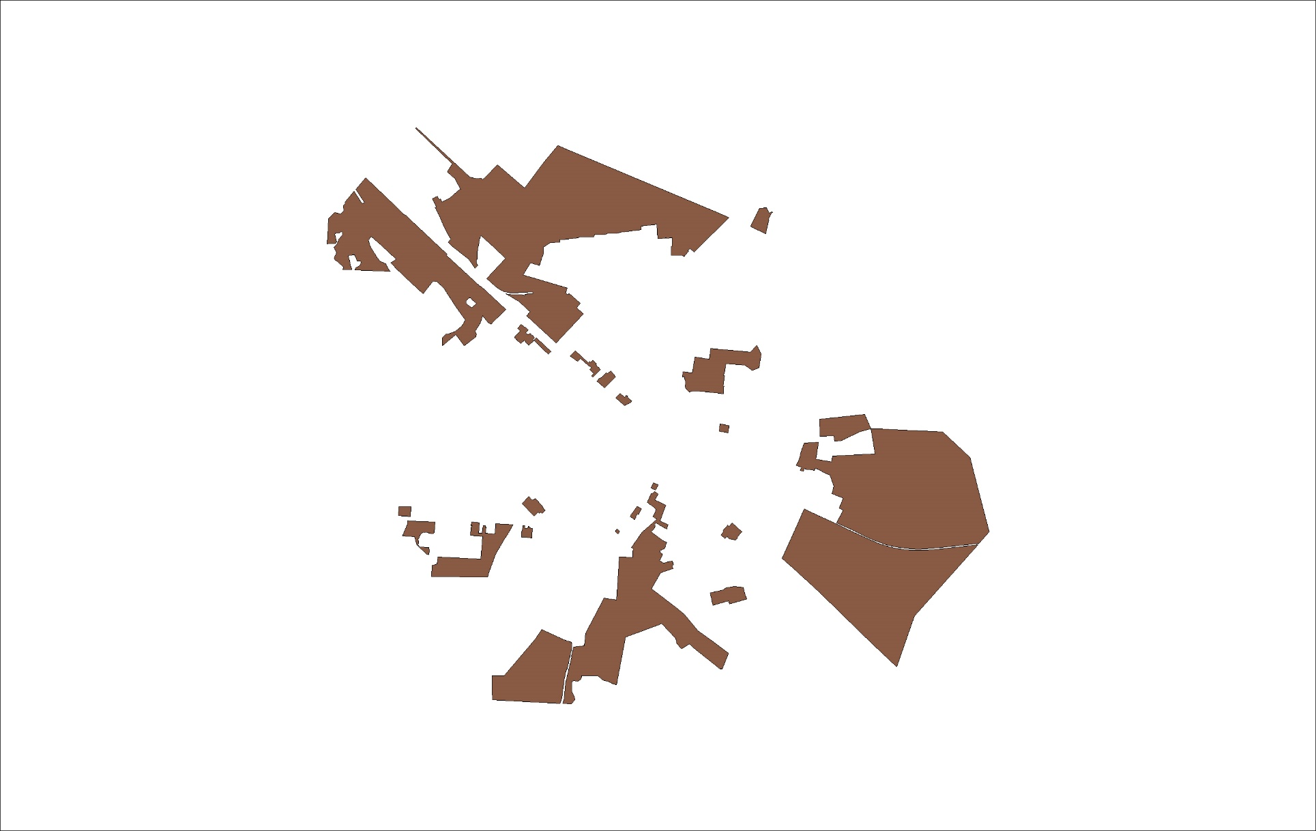
Р1 Зона рекреационного назначения
№ точек | X | Y
1 | 610829.82 | 2234157.83
2 | 611056.58 | 2233879.95
3 | 611130.32 | 2233940.72
4 | 611196.47 | 2233853.10
5 | 611278.30 | 2233908.28
6 | 611430.14 | 2233742.08
7 | 611391.13 | 2233729.09
8 | 611391.57 | 2233223.51
9 | 610889.70 | 2233186.24
10 | 610395.49 | 2233179.93
11 | 610369.22 | 2233768.38
12 | 610502.59 | 2233767.53
13 | 610501.40 | 2233880.14
14 | 611908.57 | 2235255.94
15 | 611934.09 | 2235218.20
16 | 611985.82 | 2235141.77
17 | 611980.03 | 2235137.83
18 | 611877.40 | 2235054.81
19 | 611828.81 | 2235113.33
20 | 611724.61 | 2234989.68
21 | 611679.84 | 2234920.05
22 | 611687.23 | 2234846.52
23 | 611644.23 | 2234819.13
24 | 611558.59 | 2234841.67
25 | 611517.66 | 2234848.78
26 | 611495.45 | 2234911.29
27 | 611570.95 | 2234916.49
28 | 611567.14 | 2235036.51
29 | 611626.23 | 2235036.53
30 | 611645.30 | 2235046.39
31 | 611656.15 | 2235026.31
32 | 611724.51 | 2235073.79
33 | 611744.59 | 2235089.36
34 | 611747.68 | 2235091.59
35 | 611750.02 | 2235088.65
36 | 611791.11 | 2235121.46
37 | 613616.85 | 2235527.30
38 | 613655.63 | 2235492.06
39 | 613642.48 | 2235476.92
40 | 613686.45 | 2235435.13
41 | 613682.63 | 2235431.37
42 | 613635.29 | 2235475.31
43 | 613620.66 | 2235459.74
44 | 613598.02 | 2235480.81
45 | 613477.78 | 2236154.37
46 | 613775.19 | 2235784.76
47 | 613783.99 | 2235773.86
48 | 613758.36 | 2235753.17
49 | 613721.16 | 2235705.39
50 | 613688.26 | 2235626.58
51 | 613626.49 | 2235590.42
52 | 613595.20 | 2235563.90
53 | 613577.11 | 2235528.76
54 | 613561.19 | 2235473.27
55 | 613496.35 | 2235388.93
56 | 613479.14 | 2235376.30
57 | 613465.37 | 2235376.30
58 | 613313.32 | 2235406.14
59 | 613261.50 | 2235406.91
60 | 613197.42 | 2235407.86
61 | 613106.77 | 2235413.60
62 | 613085.52 | 2235418.18
63 | 613089.08 | 2235475.00
64 | 613090.76 | 2235501.74
65 | 613079.17 | 2235511.21
66 | 613076.07 | 2235518.96
67 | 613081.04 | 2235521.04
68 | 613082.11 | 2235520.02
69 | 613099.03 | 2235509.75
70 | 613149.46 | 2235513.45
71 | 613172.44 | 2235505.87
72 | 613189.64 | 2235506.77
73 | 613191.06 | 2235484.96
74 | 613238.69 | 2235489.34
75 | 613230.29 | 2235555.88
76 | 613228.22 | 2235574.43
77 | 613369.93 | 2235597.44
78 | 613350.46 | 2235727.82
79 | 613448.84 | 2235740.74
80 | 613416.19 | 2236100.00
Площадь = 1028861.63 кв.м
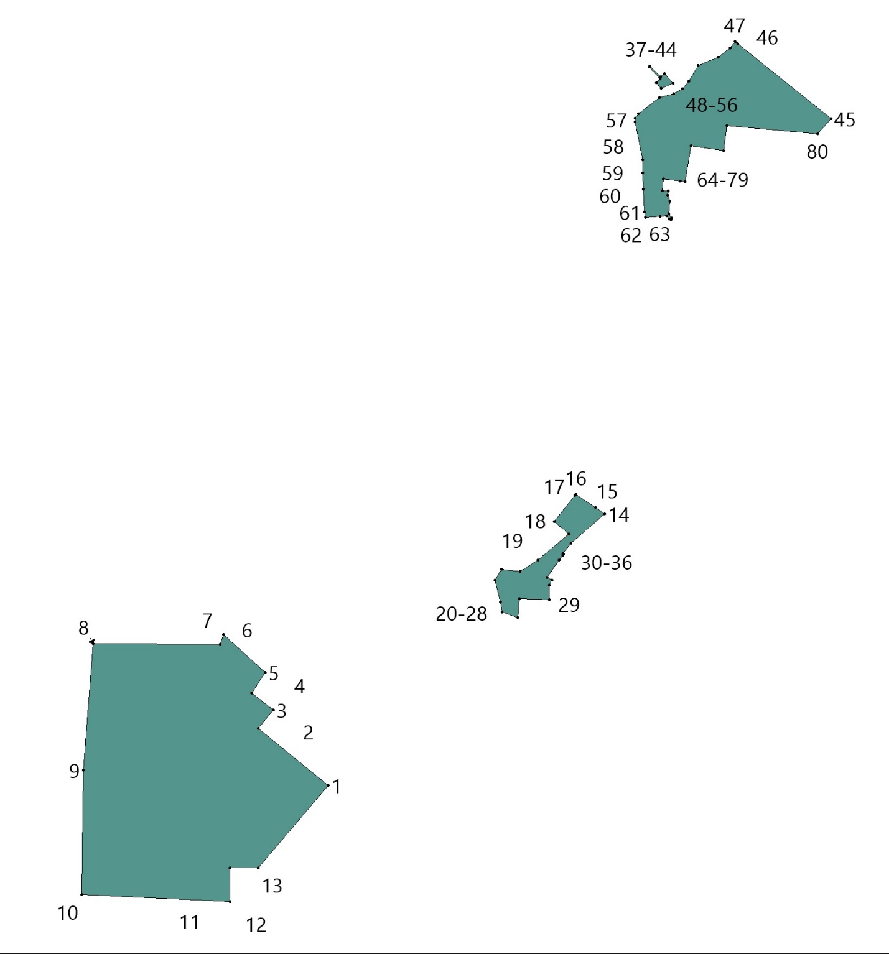

КЛ Зона кладбищ
№№ точек | X | Y
1 | 612098.36 | 2235956.63
2 | 612107.01 | 2235949.05
3 | 612142.07 | 2235911.37
4 | 612169.47 | 2235883.23
5 | 612184.32 | 2235866.28
6 | 612186.40 | 2235859.31
7 | 612187.87 | 2235853.68
8 | 612225.42 | 2235827.95
9 | 612236.69 | 2235816.52
10 | 612277.24 | 2235774.13
11 | 612322.79 | 2235726.25
12 | 612347.66 | 2235699.85
13 | 612369.08 | 2235669.47
14 | 612388.15 | 2235649.13
15 | 612415.81 | 2235617.89
16 | 612442.83 | 2235563.79
17 | 612449.46 | 2235546.62
18 | 612448.30 | 2235545.90
19 | 612455.66 | 2235523.35
20 | 612458.04 | 2235513.90
21 | 612459.66 | 2235507.45
22 | 612463.06 | 2235494.37
23 | 612463.09 | 2235490.79
24 | 612463.18 | 2235476.48
25 | 612387.43 | 2235519.65
26 | 612354.41 | 2235496.42
27 | 612292.50 | 2235560.90
28 | 612298.05 | 2235566.52
29 | 612295.42 | 2235569.59
30 | 612301.39 | 2235575.45
31 | 612279.10 | 2235598.93
32 | 612020.90 | 2235887.64
33 | 612009.96 | 2235877.87
34 | 612003.77 | 2235884.80
35 | 612008.64 | 2235889.15
36 | 612013.14 | 2235896.32
37 | 612034.65 | 2235917.97
38 | 612037.42 | 2235920.49
39 | 612053.25 | 2235929.14
40 | 612091.01 | 2235952.16
41 | 610808.50 | 2235880.17
42 | 610833.35 | 2235869.82
43 | 610799.27 | 2235836.96
44 | 610782.78 | 2235855.53
Площадь = 64308.24 кв.м
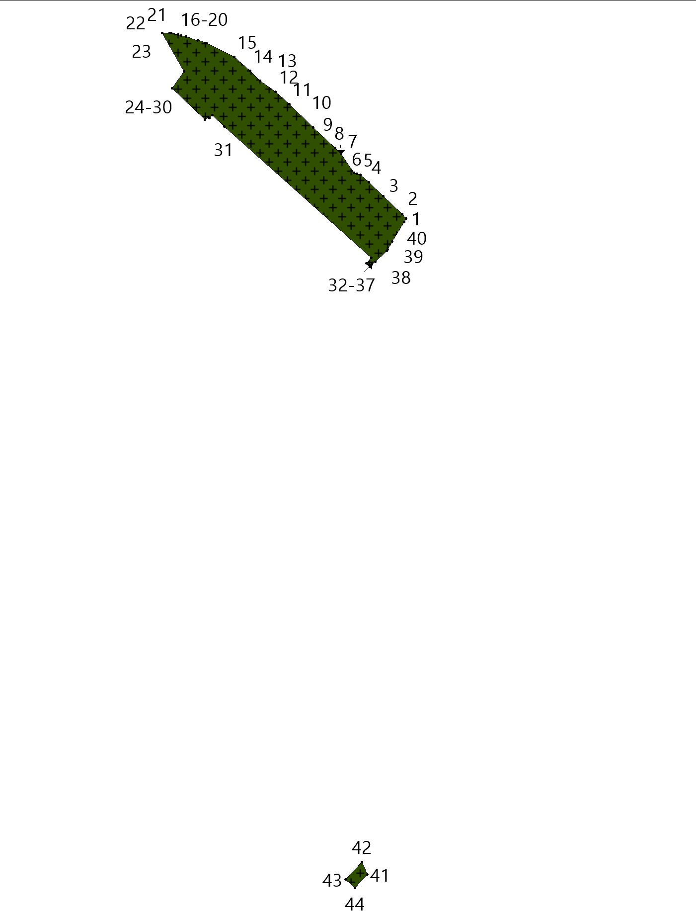

Т Территория транспортной инфраструктуры

№ точек | X | Y
1 | 611042.41 | 2234511.08
2 | 611045.22 | 2234503.88
3 | 611051.28 | 2234495.53
4 | 611040.67 | 2234491.95
5 | 611037.30 | 2234496.19
6 | 611018.93 | 2234489.85
7 | 610998.38 | 2234482.43
8 | 611000.30 | 2234478.43
9 | 610985.14 | 2234472.10
10 | 610983.14 | 2234471.50
11 | 610976.33 | 2234470.22
12 | 610974.08 | 2234474.89
13 | 610970.00 | 2234473.75
14 | 610969.86 | 2234474.10
15 | 610949.36 | 2234471.22
16 | 610951.32 | 2234466.60
17 | 610935.33 | 2234466.60
18 | 610932.43 | 2234473.28
19 | 610914.42 | 2234475.06
20 | 610897.56 | 2234476.30
21 | 610898.15 | 2234472.84
22 | 610898.46 | 2234472.03
23 | 610879.28 | 2234474.80
24 | 610878.62 | 2234476.62
25 | 610839.72 | 2234481.18
26 | 610839.36 | 2234482.89
27 | 610802.75 | 2234487.67
28 | 610803.79 | 2234484.48
29 | 610796.23 | 2234485.45
30 | 610796.50 | 2234487.13
31 | 610761.47 | 2234486.78
32 | 610757.85 | 2234487.92
33 | 610748.11 | 2234487.69
34 | 610732.78 | 2234483.67
35 | 610729.43 | 2234482.79
36 | 610705.20 | 2234477.70
37 | 610669.17 | 2234470.14
38 | 610657.52 | 2234467.70
39 | 610617.53 | 2234458.34
40 | 610555.75 | 2234444.10
41 | 610556.54 | 2234440.57
42 | 610464.03 | 2234419.66
43 | 610434.72 | 2234413.30
44 | 610299.69 | 2234398.26
45 | 610251.49 | 2234384.08
46 | 610250.29 | 2234405.73
47 | 610295.26 | 2234417.78
48 | 610296.73 | 2234418.06
49 | 610431.96 | 2234433.12
50 | 610673.98 | 2234487.41
51 | 610674.49 | 2234484.94
52 | 610758.70 | 2234503.77
53 | 610759.62 | 2234506.62
54 | 610770.56 | 2234508.82
55 | 610891.93 | 2234493.35
56 | 610933.59 | 2234486.60
57 | 610955.22 | 2234486.60
58 | 610978.41 | 2234490.96
59 | 611001.91 | 2234500.65
60 | 611003.18 | 2234498.11
61 | 611022.16 | 2234505.02
62 | 611022.75 | 2234503.80
63 | 612396.95 | 2235405.73
64 | 612409.70 | 2235394.07
65 | 612363.22 | 2235364.13
66 | 612373.71 | 2235322.02
67 | 612376.90 | 2235316.38
68 | 612404.87 | 2235297.19
69 | 612470.36 | 2235261.30
70 | 612483.70 | 2235251.69
71 | 612508.55 | 2235225.58
72 | 612549.65 | 2235167.54
73 | 612551.74 | 2235165.28
74 | 612683.14 | 2235022.89
75 | 612764.98 | 2234937.27
76 | 612867.50 | 2234830.01
77 | 612871.92 | 2234830.92
78 | 612936.10 | 2234759.87
79 | 613114.42 | 2234621.34
80 | 613144.96 | 2234593.64
81 | 613145.47 | 2234581.47
82 | 612870.57 | 2234301.86
83 | 612470.28 | 2233897.20
84 | 612198.78 | 2233622.41
85 | 612042.13 | 2233461.46
86 | 611918.89 | 2233335.99
87 | 611914.40 | 2233328.02
88 | 611911.67 | 2233319.33
89 | 611911.45 | 2233302.73
90 | 611913.81 | 2233256.09
91 | 611914.36 | 2233246.95
92 | 611916.10 | 2233246.99
93 | 611929.52 | 2233035.33
94 | 611935.27 | 2233035.44
95 | 611940.76 | 2232926.20
96 | 611933.44 | 2232925.98
97 | 611943.52 | 2232743.96
98 | 611956.84 | 2232444.80
99 | 611971.75 | 2232177.68
100 | 611952.84 | 2232176.81
101 | 611911.14 | 2233009.64
102 | 611896.64 | 2233008.59
103 | 611895.72 | 2233028.25
104 | 611884.99 | 2233256.45
105 | 611871.79 | 2233316.81
106 | 611841.77 | 2233315.41
107 | 611839.68 | 2233359.55
108 | 611845.72 | 2233365.11
109 | 611891.03 | 2233369.86
110 | 611898.73 | 2233370.86
111 | 611884.24 | 2233582.35
112 | 611881.48 | 2233622.84
113 | 611881.48 | 2233622.88
114 | 611879.48 | 2233655.48
115 | 611870.57 | 2233800.82
116 | 611861.02 | 2233957.63
117 | 611852.99 | 2234089.57
118 | 611852.98 | 2234089.87
119 | 611852.98 | 2234089.88
120 | 611853.01 | 2234102.60
121 | 611853.12 | 2234103.64
122 | 611855.93 | 2234116.75
123 | 611856.30 | 2234117.84
124 | 611861.58 | 2234128.96
125 | 611861.77 | 2234129.32
126 | 611862.23 | 2234129.99
127 | 611886.57 | 2234159.72
128 | 611886.78 | 2234159.96
129 | 611906.28 | 2234180.89
130 | 611909.78 | 2234177.30
131 | 611910.87 | 2234176.20
132 | 611913.36 | 2234173.77
133 | 611894.21 | 2234153.26
134 | 611870.36 | 2234124.12
135 | 611865.59 | 2234114.08
136 | 611863.01 | 2234102.05
137 | 611862.98 | 2234090.02
138 | 611891.46 | 2233623.50
139 | 611910.74 | 2233341.77
140 | 611918.54 | 2233351.58
141 | 612190.93 | 2233629.66
142 | 612462.56 | 2233905.04
143 | 612867.89 | 2234314.85
144 | 613094.13 | 2234543.38
145 | 613118.92 | 2234569.85
146 | 613125.29 | 2234579.36
147 | 613127.96 | 2234591.72
148 | 613123.05 | 2234603.91
149 | 613078.90 | 2234641.32
150 | 612947.49 | 2234736.24
151 | 612928.98 | 2234752.00
152 | 612885.24 | 2234796.96
153 | 612759.44 | 2234928.96
154 | 612677.03 | 2235015.43
155 | 612570.45 | 2235128.41
156 | 612542.14 | 2235161.41
157 | 612500.71 | 2235219.13
158 | 612476.81 | 2235243.33
159 | 612464.78 | 2235252.03
160 | 612404.97 | 2235285.15
161 | 612369.53 | 2235308.36
162 | 612358.10 | 2235322.52
163 | 612348.57 | 2235360.19
164 | 612357.19 | 2235380.74
165 | 612267.65 | 2235517.90
166 | 612297.93 | 2235496.01
167 | 612326.25 | 2235470.57
168 | 612320.12 | 2235463.49
169 | 612259.93 | 2235461.56
170 | 612234.63 | 2235501.88
171 | 612247.24 | 2235512.31
172 | 612249.64 | 2235512.02
173 | 612253.36 | 2235507.95
174 | 612260.31 | 2235513.67
175 | 615478.43 | 2236638.30
176 | 615478.92 | 2236633.35
177 | 615457.99 | 2236629.52
178 | 615314.82 | 2236603.18
179 | 615251.27 | 2236586.01
180 | 615250.12 | 2236587.81
181 | 615239.29 | 2236582.95
182 | 615175.43 | 2236564.48
183 | 615174.85 | 2236566.57
184 | 615048.87 | 2236527.52
185 | 615045.86 | 2236523.38
186 | 614936.45 | 2236485.82
187 | 614871.17 | 2236462.69
188 | 614848.00 | 2236455.39
189 | 614819.06 | 2236445.67
190 | 614793.12 | 2236435.92
191 | 614769.29 | 2236424.52
192 | 614751.93 | 2236414.72
193 | 614746.79 | 2236411.40
194 | 614734.32 | 2236400.07
195 | 614726.97 | 2236390.30
196 | 614721.01 | 2236380.49
197 | 614712.66 | 2236365.46
198 | 614696.71 | 2236335.82
199 | 614687.40 | 2236317.99
200 | 614679.44 | 2236305.31
201 | 614675.76 | 2236301.55
202 | 614674.20 | 2236298.81
203 | 614669.85 | 2236293.44
204 | 614659.21 | 2236284.00
205 | 614638.26 | 2236272.48
206 | 614618.40 | 2236264.81
207 | 614606.24 | 2236261.26
208 | 614605.55 | 2236263.30
209 | 614604.66 | 2236267.10
210 | 614616.41 | 2236270.53
211 | 614635.76 | 2236277.74
212 | 614655.97 | 2236288.65
213 | 614666.15 | 2236297.21
214 | 614674.83 | 2236308.59
215 | 614682.14 | 2236321.00
216 | 614691.36 | 2236338.66
217 | 614707.36 | 2236368.37
218 | 614715.78 | 2236383.54
219 | 614721.96 | 2236393.69
220 | 614729.83 | 2236404.16
221 | 614743.09 | 2236416.21
222 | 614748.80 | 2236419.90
223 | 614766.49 | 2236429.89
224 | 614790.75 | 2236441.49
225 | 614817.03 | 2236451.37
226 | 614846.13 | 2236461.14
227 | 614869.25 | 2236468.43
228 | 614934.46 | 2236491.53
229 | 615095.18 | 2236546.71
230 | 615110.09 | 2236551.64
231 | 615126.83 | 2236556.72
232 | 615238.24 | 2236587.85
233 | 615249.64 | 2236590.75
234 | 615313.62 | 2236608.03
235 | 615313.82 | 2236608.08
236 | 615457.09 | 2236634.44
237 | 611691.86 | 2238157.33
238 | 611671.51 | 2237962.42
239 | 611660.42 | 2237854.47
240 | 611652.59 | 2237779.93
241 | 611642.44 | 2237673.90
242 | 611641.26 | 2237602.45
243 | 611642.69 | 2237556.92
244 | 611647.71 | 2237496.39
245 | 611658.81 | 2237414.54
246 | 611666.72 | 2237374.87
247 | 611685.94 | 2237303.41
248 | 611702.57 | 2237254.96
249 | 611721.04 | 2237210.40
250 | 611745.54 | 2237156.69
251 | 611820.50 | 2236998.68
252 | 611877.83 | 2236874.38
253 | 611991.58 | 2236935.59
254 | 612009.99 | 2236897.26
255 | 612101.82 | 2236932.17
256 | 612140.02 | 2236832.14
257 | 612164.16 | 2236772.31
258 | 612024.47 | 2236694.18
259 | 612052.96 | 2236625.27
260 | 612005.71 | 2236602.64
261 | 612101.67 | 2236397.99
262 | 612118.11 | 2236363.02
263 | 612123.88 | 2236353.81
264 | 612136.38 | 2236327.33
265 | 612143.15 | 2236309.63
266 | 612271.89 | 2236034.90
267 | 612378.91 | 2235810.75
268 | 612451.93 | 2235658.28
269 | 612458.12 | 2235641.59
270 | 612466.41 | 2235614.91
271 | 612486.06 | 2235534.25
272 | 612491.40 | 2235507.38
273 | 612493.22 | 2235481.71
274 | 612495.69 | 2235476.36
275 | 612494.98 | 2235472.42
276 | 612488.41 | 2235444.63
277 | 612457.51 | 2235424.77
278 | 612444.46 | 2235436.05
279 | 612467.98 | 2235451.03
280 | 612476.68 | 2235462.23
281 | 612481.10 | 2235481.93
282 | 612481.50 | 2235493.60
283 | 612479.65 | 2235514.09
284 | 612475.95 | 2235534.43
285 | 612456.23 | 2235611.94
286 | 612448.45 | 2235637.61
287 | 612442.54 | 2235653.74
288 | 612369.74 | 2235805.91
289 | 612262.21 | 2236029.55
290 | 612111.27 | 2236351.72
291 | 612002.08 | 2236584.38
292 | 611962.38 | 2236669.16
293 | 611868.17 | 2236869.09
294 | 611810.54 | 2236994.02
295 | 611735.57 | 2237152.05
296 | 611710.95 | 2237206.01
297 | 611692.28 | 2237251.06
298 | 611675.42 | 2237300.19
299 | 611656.00 | 2237372.37
300 | 611647.96 | 2237412.72
301 | 611636.77 | 2237495.19
302 | 611631.71 | 2237556.29
303 | 611630.26 | 2237602.37
304 | 611631.45 | 2237674.51
305 | 611641.64 | 2237781.02
306 | 611649.13 | 2237852.07
307 | 611660.13 | 2237958.68
308 | 611679.68 | 2238146.48

Площадь = 174364.29 кв.м
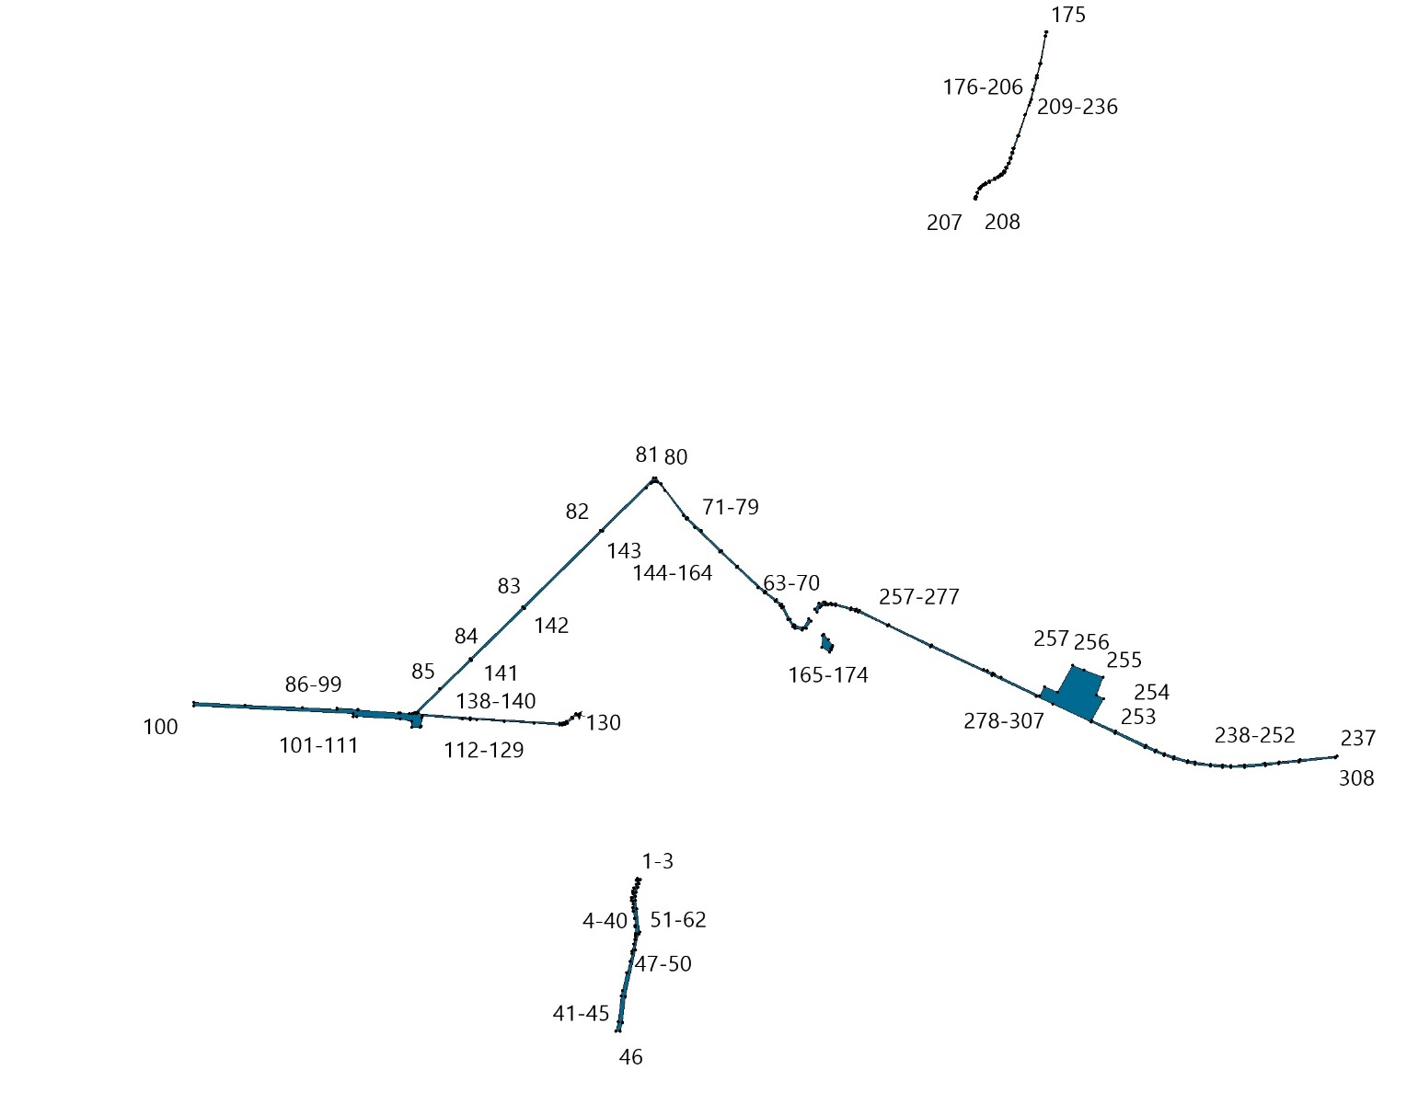

И Территория инженерной инфраструктуры
№№ точек | X | Y
1 | 612999.34 | 2235274.90
2 | 613000.76 | 2235234.88
3 | 612976.48 | 2235221.90
4 | 612959.58 | 2235272.73
5 | 612989.14 | 2235426.10
6 | 612996.14 | 2235423.42
7 | 613005.43 | 2235299.06
8 | 613003.58 | 2235288.64
9 | 612993.60 | 2235291.38
10 | 612956.26 | 2235292.77
11 | 612925.07 | 2235295.95
12 | 612914.37 | 2235301.85
13 | 612901.19 | 2235311.02
14 | 612891.64 | 2235327.06
15 | 612888.01 | 2235347.12
16 | 612890.53 | 2235375.52
17 | 612933.84 | 2235405.69
18 | 612944.74 | 2235415.41
19 | 612959.45 | 2235425.11
20 | 612961.91 | 2235425.73
21 | 612752.28 | 2236206.49
22 | 612759.36 | 2236145.57
23 | 612723.43 | 2236144.05
24 | 612713.19 | 2236151.75
25 | 612712.33 | 2236173.17
26 | 612711.84 | 2236204.80
Площадь = 16562.12 кв.м
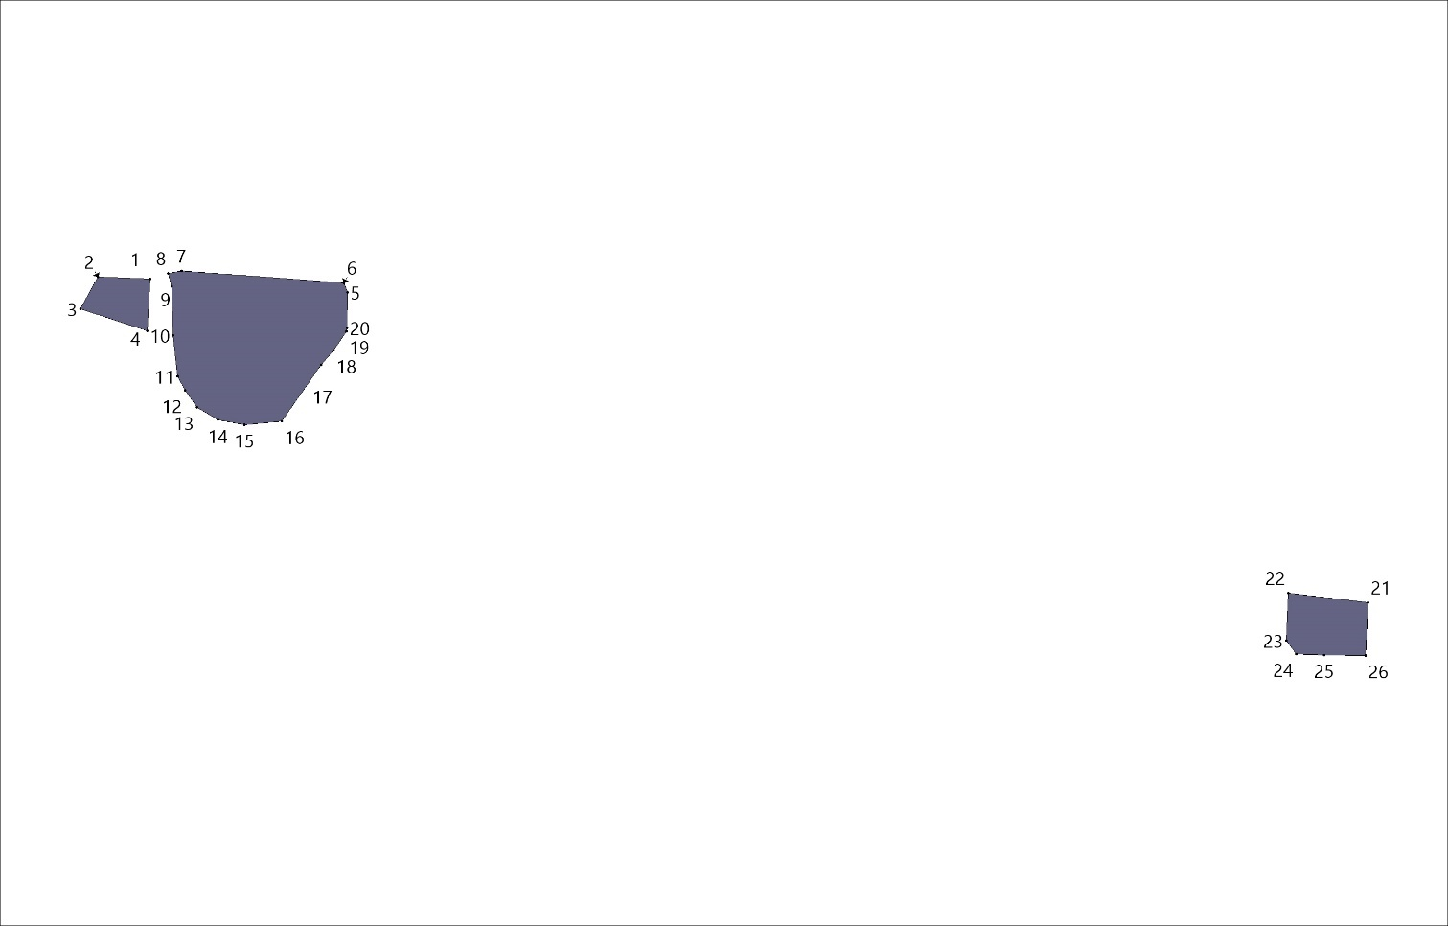
2. Территориальные зоны д.Глутно
Ж1 Зона застройки индивидуальными жилыми домами и домами блокированной застройки
№ точек | X | Y
1 | 608559.78 | 2234262.83
2 | 608585.22 | 2234173.41
3 | 608598.15 | 2234140.54
4 | 608643.26 | 2234114.35
5 | 608650.96 | 2234054.79
6 | 608576.04 | 2234096.35
7 | 608554.80 | 2234128.81
8 | 608524.04 | 2234175.80
9 | 608503.60 | 2234246.61
10 | 608907.31 | 2234515.56
11 | 608914.29 | 2234502.66
12 | 608920.85 | 2234478.14
13 | 608930.69 | 2234462.32
14 | 608953.40 | 2234448.19
15 | 608981.16 | 2234415.00
16 | 609010.08 | 2234392.14
17 | 609026.55 | 2234379.13
18 | 609025.03 | 2234370.15
19 | 609017.22 | 2234318.24
20 | 609060.61 | 2234333.44
21 | 609069.62 | 2234404.51
22 | 609075.81 | 2234424.59
23 | 609212.26 | 2234308.00
24 | 609214.19 | 2234225.75
25 | 609288.12 | 2234146.65
26 | 609300.52 | 2234133.38
27 | 609304.65 | 2234118.76
28 | 609185.38 | 2234061.57
29 | 609325.81 | 2233912.32
30 | 609353.91 | 2233882.46
31 | 609336.96 | 2233865.46
32 | 609307.67 | 2233836.06
33 | 609282.97 | 2233811.26
34 | 609254.74 | 2233782.93
35 | 609223.68 | 2233751.76
36 | 609196.22 | 2233724.21
37 | 609175.17 | 2233643.01
38 | 609159.91 | 2233584.14
39 | 609154.32 | 2233581.61
40 | 609105.02 | 2233559.28
41 | 609047.51 | 2233533.24
42 | 608955.82 | 2233491.71
43 | 608941.17 | 2233571.42
44 | 608926.59 | 2233592.36
45 | 608909.41 | 2233612.74
46 | 608864.75 | 2233665.03
47 | 608811.13 | 2233630.64
48 | 608776.31 | 2233628.58
49 | 608672.50 | 2233582.72
50 | 608584.78 | 2233531.71
51 | 608553.95 | 2233525.12
52 | 608505.22 | 2233515.13
53 | 608397.68 | 2233485.32
54 | 608297.02 | 2233444.87
55 | 608262.53 | 2233537.52
56 | 608247.52 | 2233568.82
57 | 608238.61 | 2233576.03
58 | 608290.92 | 2233586.64
59 | 608372.68 | 2233627.60
60 | 608299.15 | 2233764.63
61 | 608290.61 | 2233780.27
62 | 608651.45 | 2233878.72
63 | 608677.67 | 2234003.98
64 | 608732.91 | 2234036.82
65 | 608782.75 | 2234100.11
66 | 608689.87 | 2234291.97
67 | 608635.76 | 2234351.33
68 | 608596.84 | 2234342.67
69 | 608585.16 | 2234366.82
70 | 608590.26 | 2234383.52
71 | 608644.00 | 2234414.19
72 | 608709.71 | 2234344.02
73 | 608729.59 | 2234306.65
74 | 608741.18 | 2234316.23
75 | 608810.10 | 2234347.58
76 | 608848.18 | 2234392.60
77 | 608852.99 | 2234396.06
78 | 608841.39 | 2234440.92
79 | 608832.29 | 2234469.48
Площадь = 573351.67 кв.м

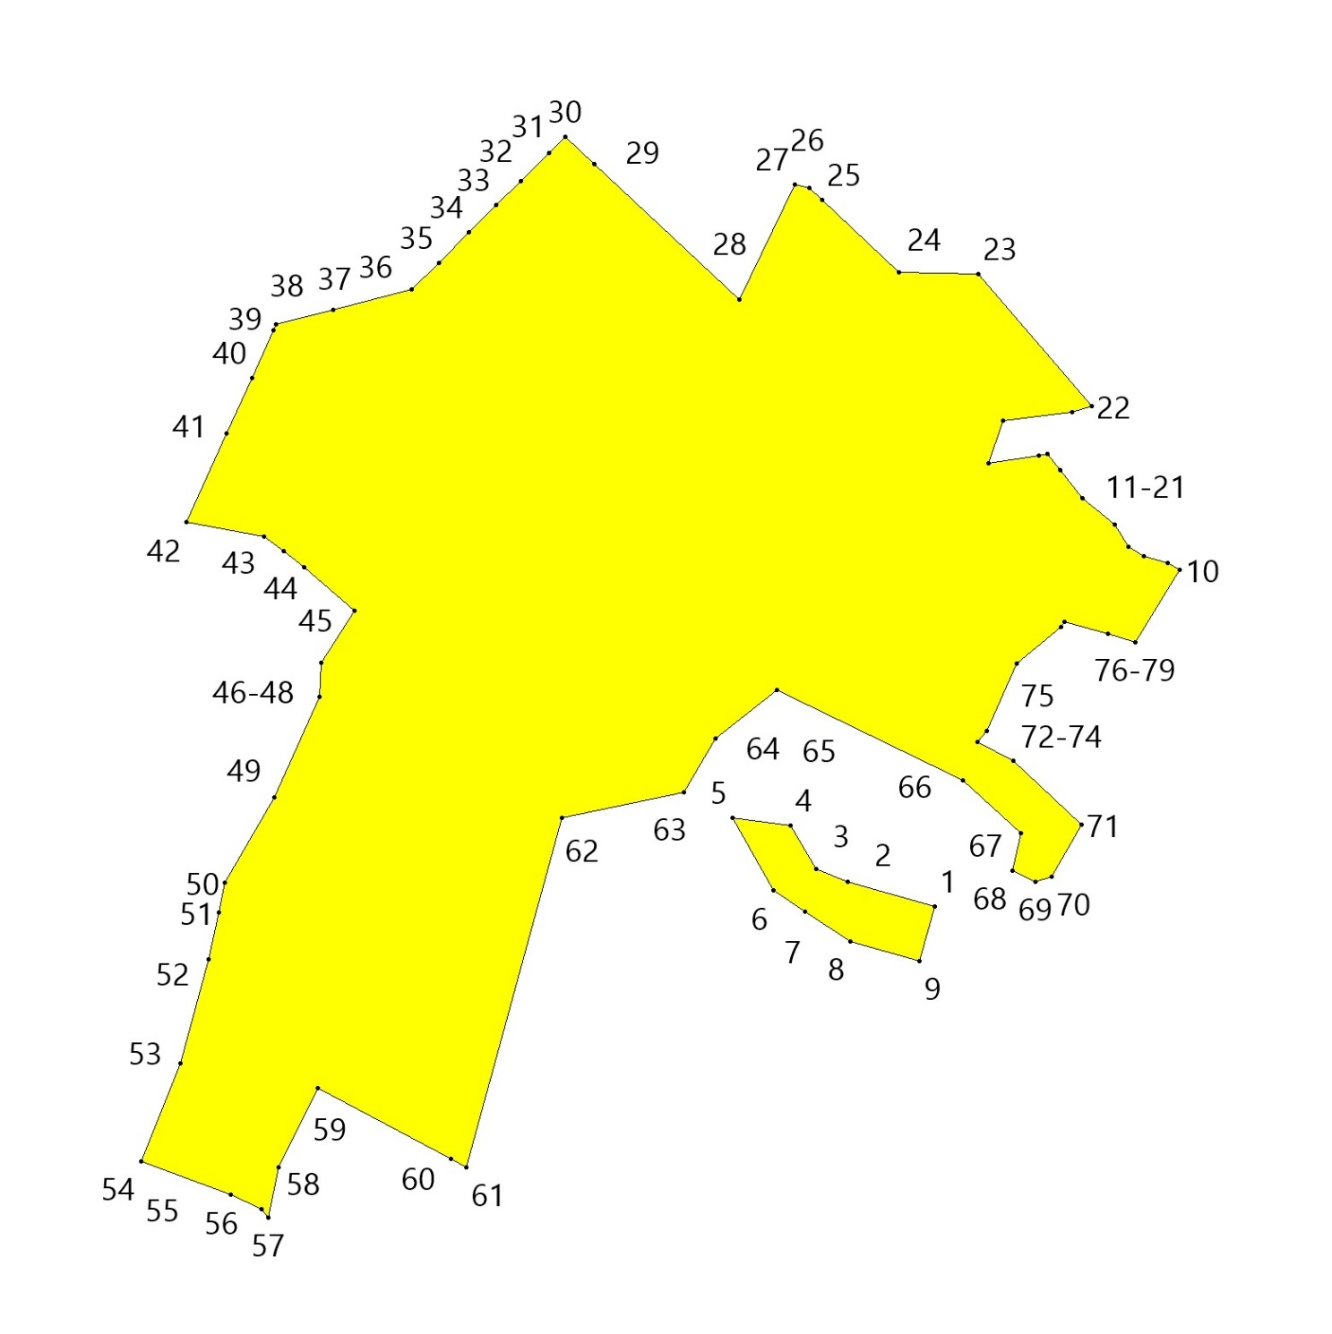
П1 Производственная зона
№ точек | X | Y
1 | 608782.75 | 2234100.11
2 | 608689.87 | 2234291.97
3 | 608635.76 | 2234351.33
4 | 608540.62 | 2234330.16
5 | 608585.22 | 2234173.41
6 | 608598.15 | 2234140.54
7 | 608643.26 | 2234114.35
8 | 608650.97 | 2234054.78
9 | 608656.53 | 2234011.69
10 | 608662.62 | 2233995.04
11 | 608732.91 | 2234036.82
Площадь = 43633.52 кв.м
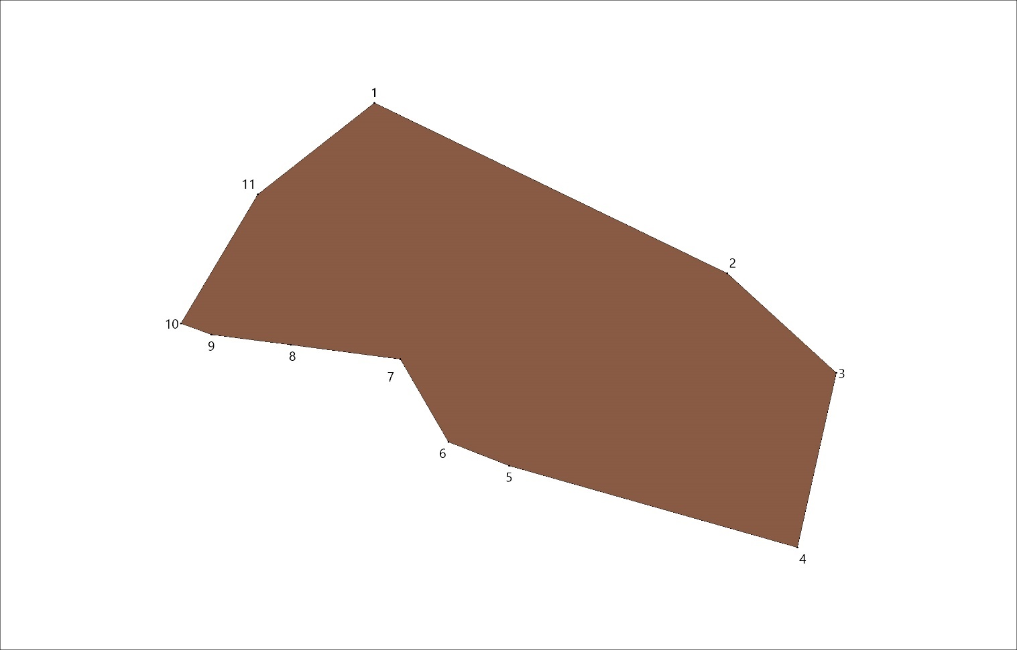

3. Территориальные зоны д.Некрасово
Ж1 Зона застройки индивидуальными жилыми домами и домами блокированной застройки

№ точек | X | Y
1 | 612048.61 | 2226685.30
2 | 612094.94 | 2226678.46
3 | 612099.70 | 2226677.75
4 | 612098.85 | 2226666.89
5 | 612093.26 | 2226570.73
6 | 612096.51 | 2226505.98
7 | 612103.84 | 2226459.29
8 | 612117.02 | 2226412.20
9 | 612151.94 | 2226300.82
10 | 612157.27 | 2226284.85
11 | 612132.00 | 2226276.60
12 | 612075.21 | 2226282.28
13 | 611998.56 | 2226304.99
14 | 611967.32 | 2226307.83
15 | 611941.77 | 2226301.79
16 | 611898.47 | 2226283.34
17 | 611882.86 | 2226271.62
18 | 611864.91 | 2226273.00
19 | 611860.41 | 2226272.96
20 | 611854.04 | 2226275.10
21 | 611849.70 | 2226278.37
22 | 611839.02 | 2226303.57
23 | 611835.90 | 2226310.93
24 | 611930.95 | 2226349.35
25 | 611980.73 | 2226366.41
26 | 611984.04 | 2226370.95
27 | 611984.50 | 2226371.59
28 | 611976.07 | 2226397.24
29 | 611963.34 | 2226439.20
30 | 611961.88 | 2226448.33
31 | 611959.90 | 2226456.18
32 | 612046.29 | 2226486.69
33 | 612033.16 | 2226594.58
34 | 612416.97 | 2226713.60
35 | 612469.10 | 2226662.81
36 | 612486.56 | 2226645.72
37 | 612531.78 | 2226610.32
38 | 612545.21 | 2226567.20
39 | 612546.00 | 2226564.77
40 | 612551.81 | 2226546.96
41 | 612539.40 | 2226519.88
42 | 612526.80 | 2226476.26
43 | 612512.74 | 2226386.14
44 | 612498.07 | 2226353.19
45 | 612486.03 | 2226333.88
46 | 612463.22 | 2226310.09
47 | 612422.07 | 2226289.97
48 | 612402.60 | 2226285.82
49 | 612384.15 | 2226285.82
50 | 612367.82 | 2226292.21
51 | 612361.43 | 2226307.47
52 | 612356.30 | 2226317.89
53 | 612365.34 | 2226316.70
54 | 612375.98 | 2226330.54
55 | 612378.83 | 2226347.94
56 | 612370.17 | 2226369.70
57 | 612349.37 | 2226382.71
58 | 612336.94 | 2226386.97
59 | 612320.27 | 2226383.06
60 | 612285.17 | 2226378.40
61 | 612264.91 | 2226367.81
62 | 612176.17 | 2226291.40
63 | 612170.96 | 2226306.98
64 | 612136.20 | 2226417.88
65 | 612123.42 | 2226463.55
66 | 612116.43 | 2226508.04
67 | 612115.90 | 2226518.54
68 | 612113.28 | 2226570.65
69 | 612117.04 | 2226635.19
70 | 612127.26 | 2226638.78
71 | 612249.83 | 2226681.84
72 | 612283.59 | 2226698.14
73 | 612370.90 | 2226710.96
74 | 612801.66 | 2226734.40
75 | 612817.91 | 2226729.43
76 | 612831.07 | 2226684.55
77 | 612808.29 | 2226670.76
78 | 612814.14 | 2226645.10
79 | 612825.17 | 2226622.44
80 | 612762.14 | 2226594.75
81 | 612758.97 | 2226606.36
82 | 612744.28 | 2226641.30
83 | 612733.05 | 2226636.52
84 | 612715.75 | 2226692.10
85 | 612779.24 | 2226715.67

Площадь = 193692.93 кв.м
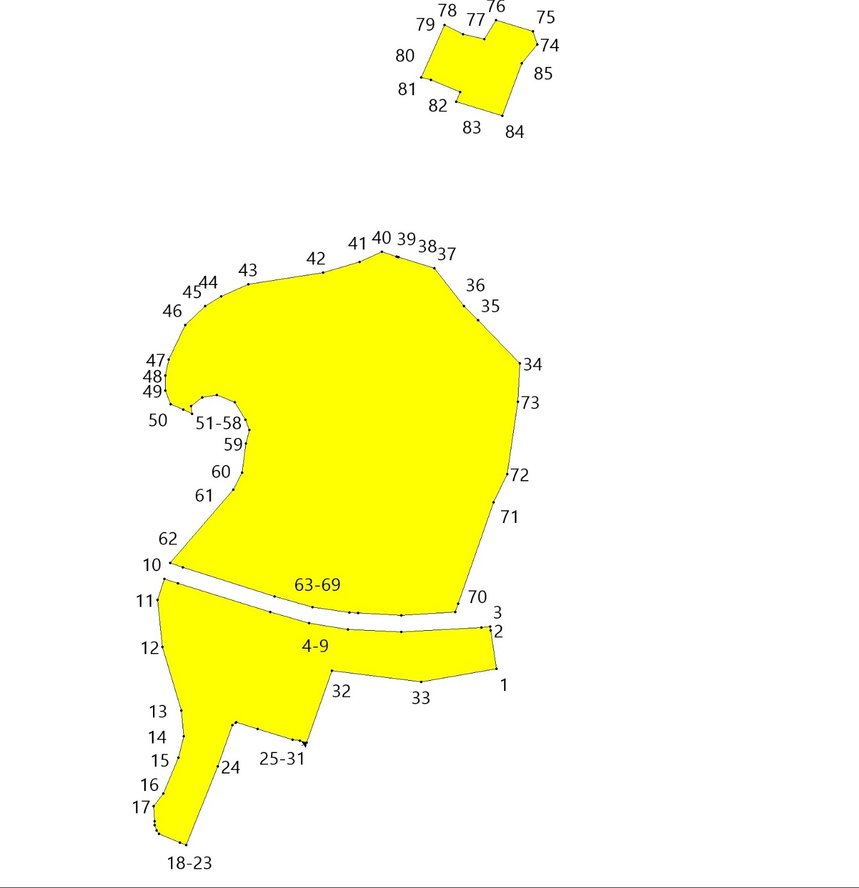

4. Территориальные зоны д.Поддубье
Ж1 Зона застройки индивидуальными жилыми домами и домами блокированной застройки

№ точек | X | Y
1 | 598552.89 | 2229478.87
2 | 598544.00 | 2229499.13
3 | 598533.32 | 2229516.61
4 | 598540.49 | 2229524.76
5 | 598549.58 | 2229524.76
6 | 598560.54 | 2229512.15
7 | 598575.01 | 2229499.34
8 | 598593.40 | 2229490.86
9 | 598613.87 | 2229493.55
10 | 598629.58 | 2229510.91
11 | 598652.93 | 2229540.26
12 | 598675.88 | 2229580.16
13 | 598668.64 | 2229590.70
14 | 598636.40 | 2229603.52
15 | 598623.51 | 2229607.65
16 | 598623.37 | 2229613.02
17 | 598640.32 | 2229636.80
18 | 598662.86 | 2229662.43
19 | 598677.32 | 2229690.13
20 | 598699.44 | 2229704.59
21 | 598745.85 | 2229713.28
22 | 598805.79 | 2229740.56
23 | 598914.52 | 2229756.27
24 | 598924.53 | 2229768.05
25 | 598937.26 | 2229780.57
26 | 598921.39 | 2229804.17
27 | 598943.22 | 2229865.96
28 | 598937.43 | 2229873.64
29 | 598882.14 | 2229881.67
30 | 598840.84 | 2229879.75
31 | 598812.21 | 2229875.70
32 | 598732.35 | 2229860.24
33 | 598698.37 | 2229851.79
34 | 598477.44 | 2229859.54
35 | 598473.84 | 2229787.33
36 | 598382.72 | 2229767.79
37 | 598330.49 | 2229779.53
38 | 598319.03 | 2229776.99
39 | 598317.39 | 2229819.65
40 | 598136.43 | 2229738.46
41 | 598188.31 | 2229599.62
42 | 598167.00 | 2229587.77
43 | 598180.06 | 2229563.86
44 | 598217.01 | 2229521.03
45 | 598215.42 | 2229513.27
46 | 598217.40 | 2229497.06
47 | 598226.71 | 2229502.02
48 | 598243.24 | 2229512.15
49 | 598279.42 | 2229514.43
50 | 598286.03 | 2229521.45
51 | 598290.99 | 2229534.27
52 | 598300.71 | 2229539.02
53 | 598318.07 | 2229541.92
54 | 598333.54 | 2229539.06
55 | 598338.53 | 2229541.71
56 | 598344.12 | 2229548.12
57 | 598347.63 | 2229564.03
58 | 598342.87 | 2229571.06
59 | 598337.09 | 2229580.16
60 | 598341.11 | 2229589.96
61 | 598347.01 | 2229596.07
62 | 598368.30 | 2229608.89
63 | 598381.53 | 2229605.38
64 | 598386.28 | 2229594.42
65 | 598376.15 | 2229578.71
66 | 598370.99 | 2229560.11
67 | 598378.63 | 2229551.01
68 | 598400.80 | 2229549.58
69 | 598413.77 | 2229550.60
70 | 598422.04 | 2229545.22
71 | 598425.76 | 2229531.79
72 | 598436.10 | 2229511.53
73 | 598445.61 | 2229498.10
74 | 598439.82 | 2229484.25
75 | 598416.88 | 2229457.37
76 | 598407.37 | 2229435.88
77 | 598417.08 | 2229426.37
78 | 598435.69 | 2229421.82
79 | 598455.53 | 2229428.23
80 | 598467.31 | 2229445.59
81 | 598488.81 | 2229457.99
82 | 598508.45 | 2229463.99
83 | 598519.40 | 2229459.03
84 | 598540.49 | 2229453.45
85 | 598546.07 | 2229459.03

Площадь = 183947.87 кв.м
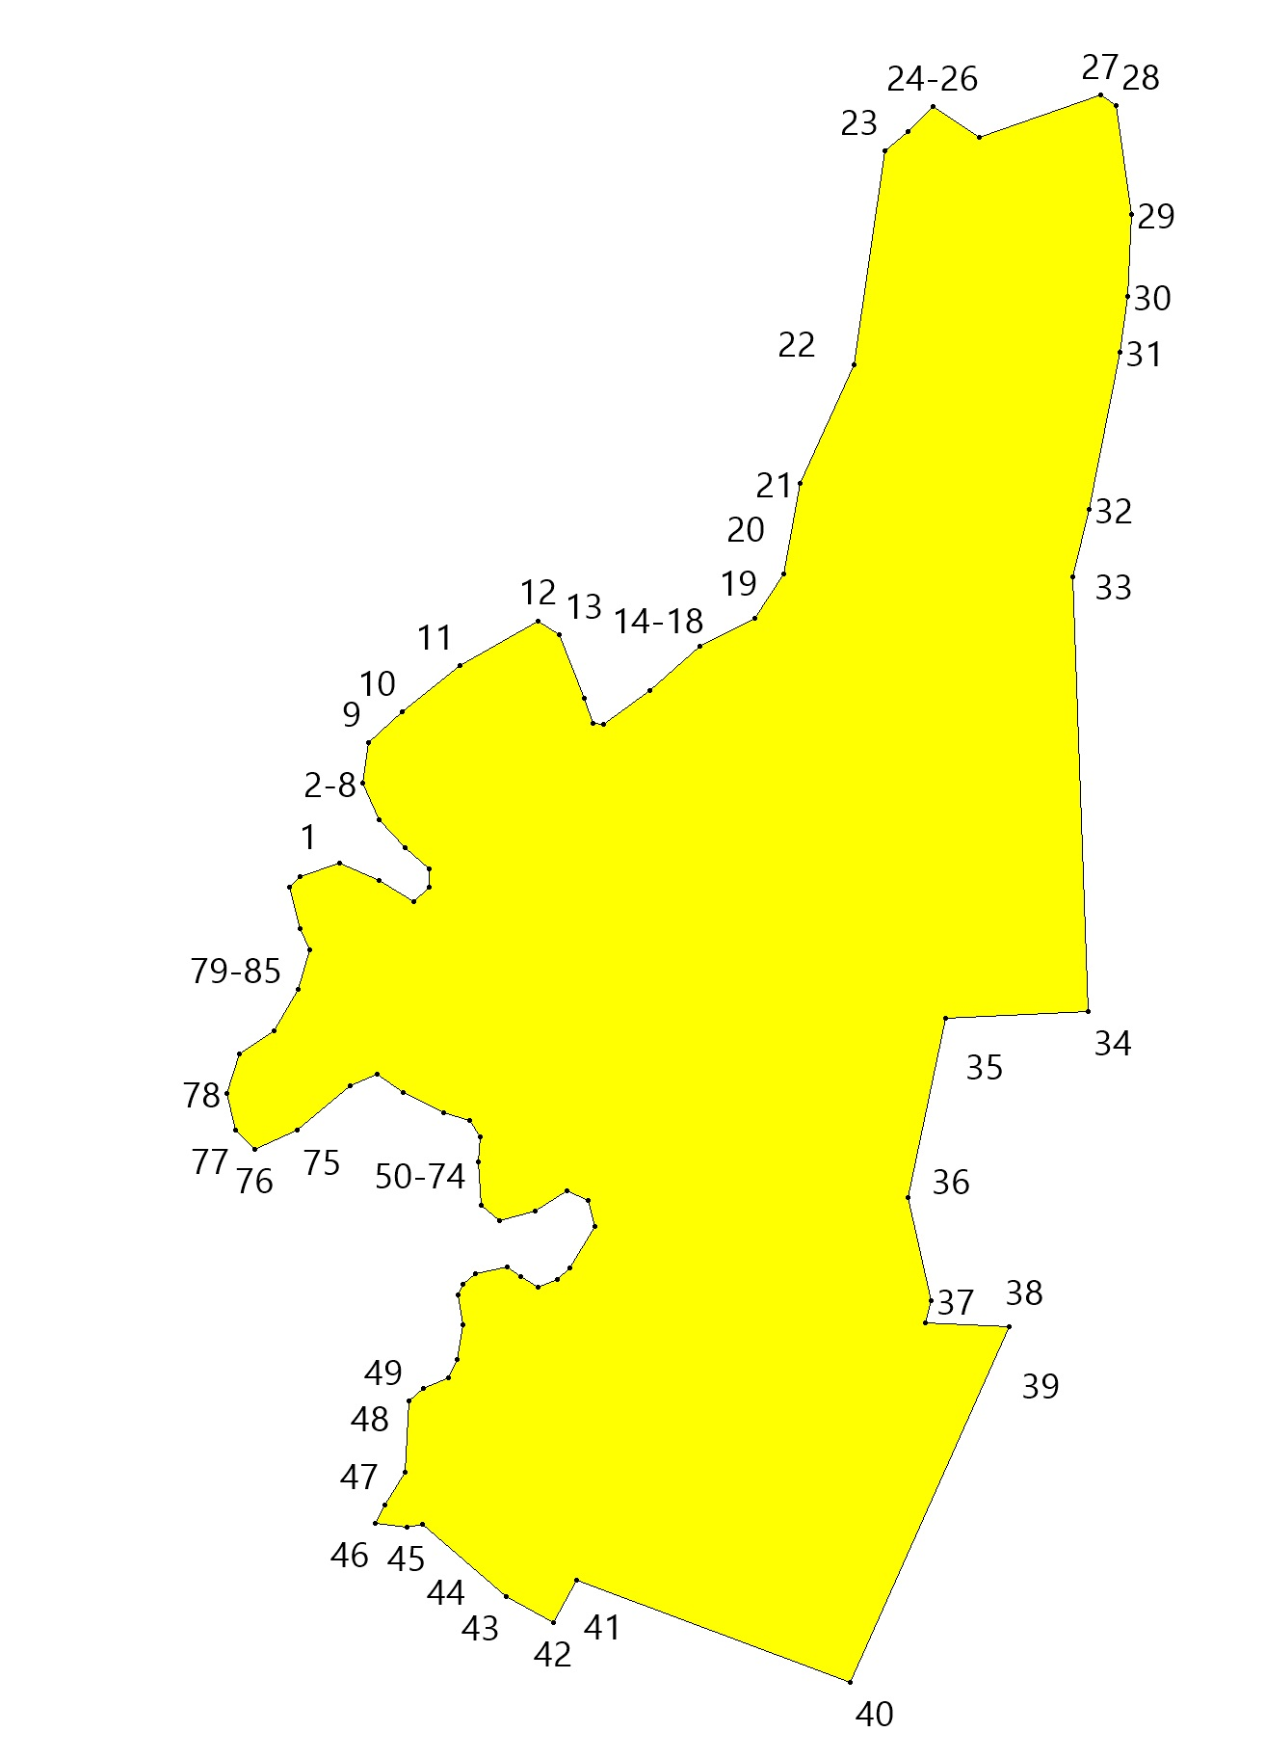

5. Территориальные зоны д.Подмошье
Ж1 Зона застройки индивидуальными жилыми домами и домами блокированной застройки
№ точек | X | Y
1 | 593805.99 | 2227544.19
2 | 593827.19 | 2227540.91
3 | 593825.37 | 2227530.20
4 | 593845.08 | 2227526.84
5 | 593844.31 | 2227522.34
6 | 593854.85 | 2227518.34
7 | 593851.48 | 2227498.69
8 | 593846.02 | 2227492.04
9 | 593841.98 | 2227483.98
10 | 593840.72 | 2227474.65
11 | 593843.24 | 2227469.36
12 | 593846.11 | 2227467.34
13 | 593841.04 | 2227437.77
14 | 593814.86 | 2227285.05
15 | 593802.03 | 2227231.58
16 | 593804.59 | 2227195.22
17 | 593788.77 | 2227088.73
18 | 593803.31 | 2227078.46
19 | 593780.13 | 2227035.59
20 | 593749.04 | 2227030.85
21 | 593736.74 | 2227033.55
22 | 593720.22 | 2227044.39
23 | 593703.41 | 2227075.74
24 | 593693.79 | 2227075.02
25 | 593698.45 | 2227060.88
26 | 593695.66 | 2227049.90
27 | 593677.55 | 2227055.10
28 | 593657.84 | 2227058.50
29 | 593642.67 | 2227061.10
30 | 593627.48 | 2227044.00
31 | 593598.55 | 2227011.60
32 | 593562.28 | 2226970.40
33 | 593521.73 | 2226950.67
34 | 593521.54 | 2226952.56
35 | 593520.73 | 2226960.62
36 | 593570.14 | 2227012.62
37 | 593588.43 | 2227027.28
38 | 593596.46 | 2227049.62
39 | 593594.47 | 2227062.22
40 | 593603.95 | 2227071.41
41 | 593598.44 | 2227099.82
42 | 593590.30 | 2227117.19
43 | 593585.02 | 2227142.93
44 | 593587.88 | 2227170.86
45 | 593566.20 | 2227177.79
46 | 593549.80 | 2227185.51
47 | 593560.38 | 2227211.21
48 | 593561.64 | 2227227.01
49 | 593564.53 | 2227235.03
50 | 593556.82 | 2227244.00
51 | 593563.75 | 2227276.30
52 | 593559.83 | 2227282.70
53 | 593551.01 | 2227281.70
54 | 593540.22 | 2227256.70
55 | 593536.88 | 2227248.60
56 | 593534.69 | 2227247.94
57 | 593524.44 | 2227226.28
58 | 593510.81 | 2227228.28
59 | 593491.20 | 2227266.13
60 | 593484.83 | 2227299.84
61 | 593470.61 | 2227307.69
62 | 593459.83 | 2227304.75
63 | 593443.66 | 2227276.19
64 | 593439.74 | 2227275.90
65 | 593448.19 | 2227290.79
66 | 593446.27 | 2227300.30
67 | 593461.22 | 2227321.10
68 | 593429.44 | 2227325.07
69 | 593438.15 | 2227339.75
70 | 593462.55 | 2227380.89
71 | 593524.65 | 2227485.57
72 | 593546.84 | 2227501.37
73 | 593613.72 | 2227529.68
74 | 593622.59 | 2227519.87
75 | 593611.52 | 2227505.76
76 | 593645.31 | 2227507.07
77 | 593653.11 | 2227494.31
78 | 593665.33 | 2227494.35
79 | 593666.97 | 2227494.37
80 | 593701.34 | 2227494.88
81 | 593722.17 | 2227500.54
82 | 593733.37 | 2227494.32
83 | 593745.92 | 2227499.18
84 | 593799.17 | 2227539.46
85 | 593804.76 | 2227537.34

Площадь = 137732.11 кв.м
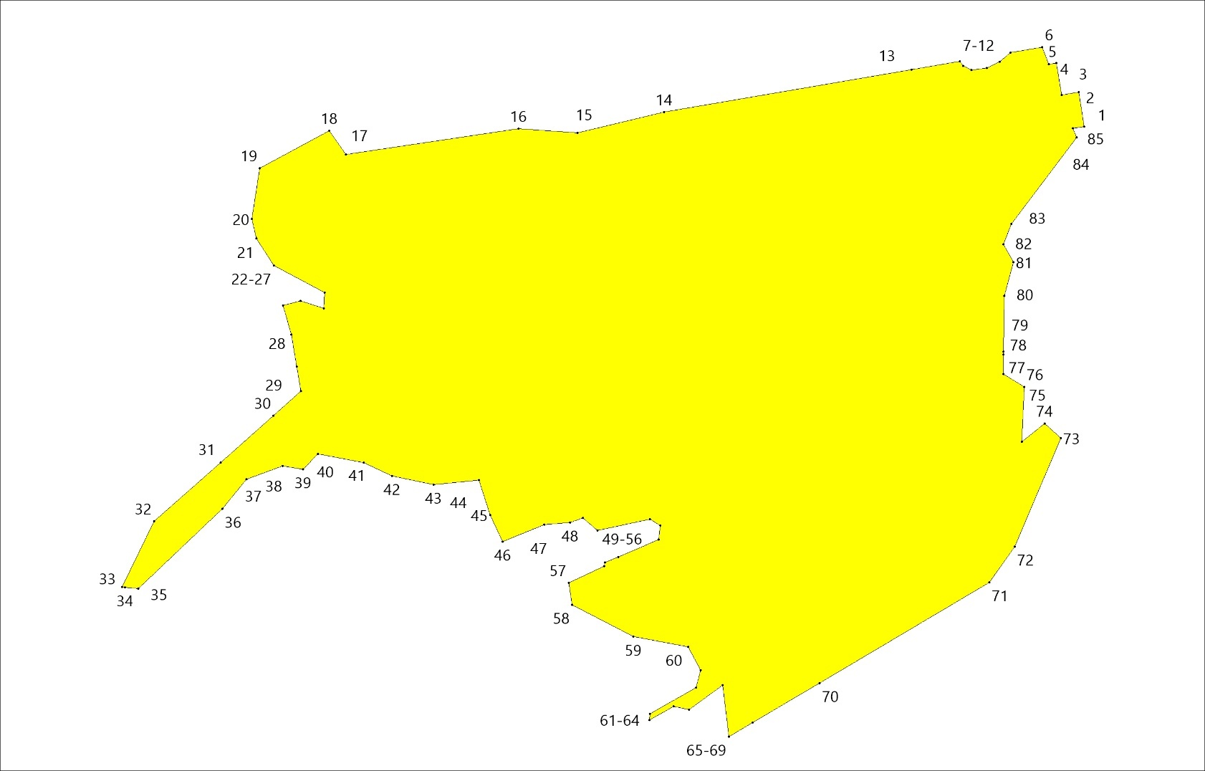

6. Территориальные зоны д.Пруды
Ж1 Зона застройки индивидуальными жилыми домами и домами блокированной застройки
№ точек | X | Y
1 | 593054.87 | 2227024.80
2 | 593050.72 | 2227031.73
3 | 593040.28 | 2227041.83
4 | 593005.74 | 2227060.41
5 | 592994.16 | 2227043.21
6 | 592962.20 | 2227062.99
7 | 592941.15 | 2227029.52
8 | 592941.05 | 2227024.74
9 | 592923.45 | 2227000.46
10 | 592918.55 | 2227001.30
11 | 592907.10 | 2226981.88
12 | 592894.42 | 2226989.64
13 | 592884.74 | 2226973.74
14 | 592879.68 | 2226965.41
15 | 592892.18 | 2226956.18
16 | 592867.75 | 2226913.74
17 | 592886.36 | 2226888.03
18 | 592892.90 | 2226882.85
19 | 592899.89 | 2226878.07
20 | 592897.21 | 2226873.02
21 | 592901.87 | 2226866.59
22 | 592899.21 | 2226862.53
23 | 592905.05 | 2226859.27
24 | 592958.28 | 2226841.17
25 | 592960.17 | 2226856.32
26 | 592973.58 | 2226873.67
27 | 592979.91 | 2226924.93
28 | 593021.17 | 2226972.73
29 | 593030.37 | 2226979.46
30 | 593038.18 | 2226988.50
31 | 593045.81 | 2226999.95

Площадь = 21308.89 кв.м
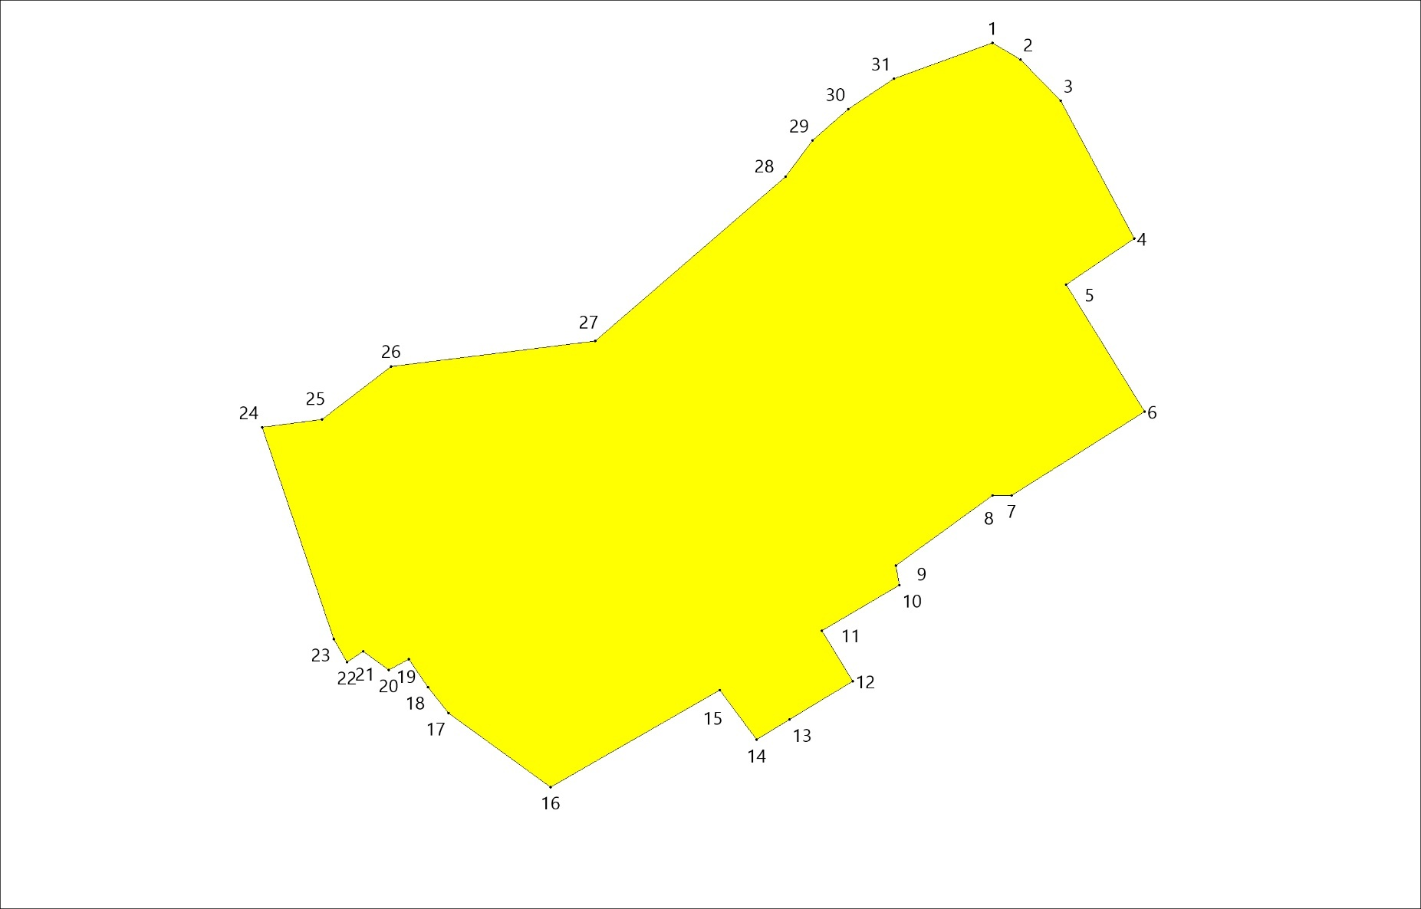

7. Территориальные зоны д.Пустая Вишерка
Ж1 Зона застройки индивидуальными жилыми домами и домами блокированной застройки
№№ точек | X | Y
1 | 618426.65 | 2237853.66
2 | 618445.34 | 2237862.12
3 | 618466.20 | 2237867.20
4 | 618492.67 | 2237866.15
5 | 618500.17 | 2237872.88
6 | 618530.49 | 2237897.86
7 | 618559.55 | 2237920.64
8 | 618587.36 | 2237938.08
9 | 618611.08 | 2237945.93
10 | 618626.95 | 2237945.62
11 | 618636.87 | 2237940.38
12 | 618639.83 | 2237931.01
13 | 618638.57 | 2237929.44
14 | 618634.80 | 2237925.19
15 | 618627.73 | 2237918.91
16 | 618609.82 | 2237908.54
17 | 618581.86 | 2237892.84
18 | 618538.01 | 2237869.83
19 | 618523.66 | 2237830.58
20 | 618505.80 | 2237810.54
21 | 618476.56 | 2237783.20
22 | 618451.39 | 2237754.51
23 | 618435.69 | 2237735.83
24 | 618435.69 | 2237708.21
25 | 618379.30 | 2237650.29
26 | 618399.85 | 2237603.78
27 | 618389.09 | 2237595.05
28 | 618382.78 | 2237589.92
29 | 618346.27 | 2237569.00
30 | 618315.49 | 2237548.67
31 | 618281.94 | 2237516.31
32 | 618266.35 | 2237491.25
33 | 618258.46 | 2237471.91
34 | 618259.05 | 2237452.57
35 | 618262.21 | 2237414.48
36 | 618265.36 | 2237397.71
37 | 618264.77 | 2237388.43
38 | 618252.16 | 2237370.10
39 | 618228.09 | 2237342.67
40 | 618211.63 | 2237319.97
41 | 618204.03 | 2237316.23
42 | 618193.43 | 2237317.98
43 | 618159.54 | 2237337.22
44 | 618120.19 | 2237307.72
45 | 618073.33 | 2237358.96
46 | 618004.07 | 2237435.61
47 | 617966.95 | 2237376.45
48 | 617946.07 | 2237290.62
49 | 617903.15 | 2237225.66
50 | 617856.29 | 2237167.66
51 | 617838.84 | 2237156.11
52 | 617828.83 | 2237149.56
53 | 617831.34 | 2237145.39
54 | 617833.95 | 2237140.46
55 | 617837.02 | 2237135.25
56 | 617841.53 | 2237131.02
57 | 617860.78 | 2237114.26
58 | 617870.23 | 2237106.10
59 | 617879.75 | 2237097.63
60 | 617885.18 | 2237093.86
61 | 617895.83 | 2237088.36
62 | 617915.22 | 2237086.18
63 | 617936.48 | 2237092.54
64 | 617947.14 | 2237095.46
65 | 617959.64 | 2237103.39
66 | 617942.55 | 2237088.35
67 | 617926.67 | 2237009.34
68 | 617852.27 | 2237000.40
69 | 617848.64 | 2237003.95
70 | 617841.22 | 2237013.34
71 | 617835.98 | 2237027.10
72 | 617828.01 | 2237025.90
73 | 617820.12 | 2237012.24
74 | 617811.01 | 2236997.06
75 | 617811.92 | 2236981.89
76 | 617819.21 | 2236971.26
77 | 617803.12 | 2236964.89
78 | 617781.57 | 2236957.60
79 | 617764.84 | 2236953.92
80 | 617748.56 | 2236993.12
81 | 617735.41 | 2236978.93
82 | 617716.30 | 2236986.74
83 | 617705.98 | 2236994.64
84 | 617697.79 | 2237014.67
85 | 617690.80 | 2237023.47
86 | 617681.09 | 2237033.19
87 | 617672.29 | 2237019.53
88 | 617665.53 | 2237003.86
89 | 617716.69 | 2236958.73
90 | 617696.53 | 2236936.98
91 | 617657.30 | 2236974.39
92 | 617638.08 | 2236992.71
93 | 617604.87 | 2237024.32
94 | 617574.55 | 2237038.13
95 | 617509.15 | 2236966.90
96 | 617506.22 | 2236945.07
97 | 617442.82 | 2236921.18
98 | 617383.65 | 2236918.29
99 | 617309.98 | 2236893.72
100 | 617285.94 | 2236883.12
101 | 617255.31 | 2236878.47
102 | 617239.06 | 2236875.58
103 | 617257.95 | 2236832.36
104 | 617282.79 | 2236772.47
105 | 617279.09 | 2236751.06
106 | 617245.12 | 2236737.03
107 | 617228.88 | 2236756.23
108 | 617208.22 | 2236756.96
109 | 617175.73 | 2236751.80
110 | 617149.14 | 2236739.25
111 | 617138.81 | 2236713.40
112 | 617096.72 | 2236706.02
113 | 617078.90 | 2236781.34
114 | 616936.18 | 2236766.36
115 | 616864.72 | 2236725.44
116 | 616880.40 | 2236680.92
117 | 616827.37 | 2236663.24
118 | 616895.76 | 2236470.54
119 | 616952.01 | 2236487.47
120 | 616963.08 | 2236466.06
121 | 616958.66 | 2236447.61
122 | 616911.08 | 2236427.35
123 | 616862.57 | 2236409.01
124 | 616545.79 | 2236278.90
125 | 616475.74 | 2236252.20
126 | 616454.44 | 2236245.35
127 | 616330.27 | 2236196.11
128 | 616258.03 | 2236165.21
129 | 616197.45 | 2236140.91
130 | 616146.49 | 2236120.73
131 | 616081.91 | 2236093.54
132 | 615998.78 | 2236058.93
133 | 615856.83 | 2236000.65
134 | 615767.80 | 2236146.87
135 | 615712.53 | 2236229.90
136 | 615636.70 | 2236361.29
137 | 615564.17 | 2236480.11
138 | 615551.75 | 2236530.40
139 | 615491.03 | 2236520.22
140 | 615478.93 | 2236633.31
141 | 615478.43 | 2236638.30
142 | 615468.68 | 2236729.06
143 | 615550.27 | 2236744.60
144 | 615661.00 | 2236729.70
145 | 615684.96 | 2236729.06
146 | 615767.83 | 2236762.73
147 | 615854.60 | 2236789.27
148 | 616045.61 | 2236807.40
149 | 616189.35 | 2236796.40
150 | 616332.45 | 2236808.05
151 | 616368.71 | 2236803.52
152 | 616398.49 | 2236786.69
153 | 616478.14 | 2236814.53
154 | 616531.23 | 2236828.78
155 | 616581.22 | 2236868.90
156 | 616626.41 | 2236905.18
157 | 616681.45 | 2236922.66
158 | 616805.13 | 2236907.72
159 | 616839.81 | 2236907.50
160 | 616859.46 | 2236910.98
161 | 616901.15 | 2236916.62
162 | 616963.27 | 2236937.48
163 | 617038.84 | 2236946.59
164 | 617070.11 | 2236960.93
165 | 617100.95 | 2236965.70
166 | 617119.63 | 2236974.82
167 | 617142.63 | 2236993.06
168 | 617177.81 | 2237012.17
169 | 617221.25 | 2237033.45
170 | 617248.61 | 2237034.76
171 | 617262.94 | 2237049.52
172 | 617282.05 | 2237063.85
173 | 617311.15 | 2237088.18
174 | 617330.26 | 2237091.22
175 | 617349.37 | 2237094.26
176 | 617360.23 | 2237100.78
177 | 617374.99 | 2237118.59
178 | 617459.78 | 2237143.90
179 | 617465.57 | 2237152.52
180 | 617512.35 | 2237182.00
181 | 617570.84 | 2237194.21
182 | 617594.82 | 2237203.46
183 | 617609.31 | 2237205.26
184 | 617613.34 | 2237205.99
185 | 617633.01 | 2237221.98
186 | 617629.74 | 2237228.01
187 | 617656.27 | 2237229.49
188 | 617676.91 | 2237244.23
189 | 617738.82 | 2237307.62
190 | 617788.94 | 2237335.63
191 | 617784.52 | 2237345.95
192 | 617843.49 | 2237379.86
193 | 617875.93 | 2237400.49
194 | 617890.66 | 2237429.98
195 | 617893.46 | 2237456.28
196 | 617924.18 | 2237442.55
197 | 617963.31 | 2237569.14
198 | 617994.07 | 2237535.98
199 | 618040.53 | 2237643.08
200 | 618093.02 | 2237678.43
201 | 618215.38 | 2237783.17
202 | 618222.88 | 2237772.61
203 | 618231.43 | 2237772.61
204 | 618240.52 | 2237769.14
205 | 618253.36 | 2237757.10
206 | 618266.72 | 2237745.88
207 | 618277.42 | 2237741.60
208 | 618285.71 | 2237745.88
209 | 618302.02 | 2237754.97
210 | 618310.57 | 2237755.77
211 | 618329.02 | 2237757.91
212 | 618369.26 | 2237776.22
213 | 618381.71 | 2237793.40
214 | 618382.23 | 2237817.06
215 | 618385.92 | 2237828.63
216 | 618389.95 | 2237831.46
217 | 617668.56 | 2237203.00
218 | 617695.34 | 2237167.69
219 | 617686.14 | 2237164.33
220 | 617654.84 | 2237167.06
221 | 617641.66 | 2237184.36

Площадь = 1208462.60 кв.м

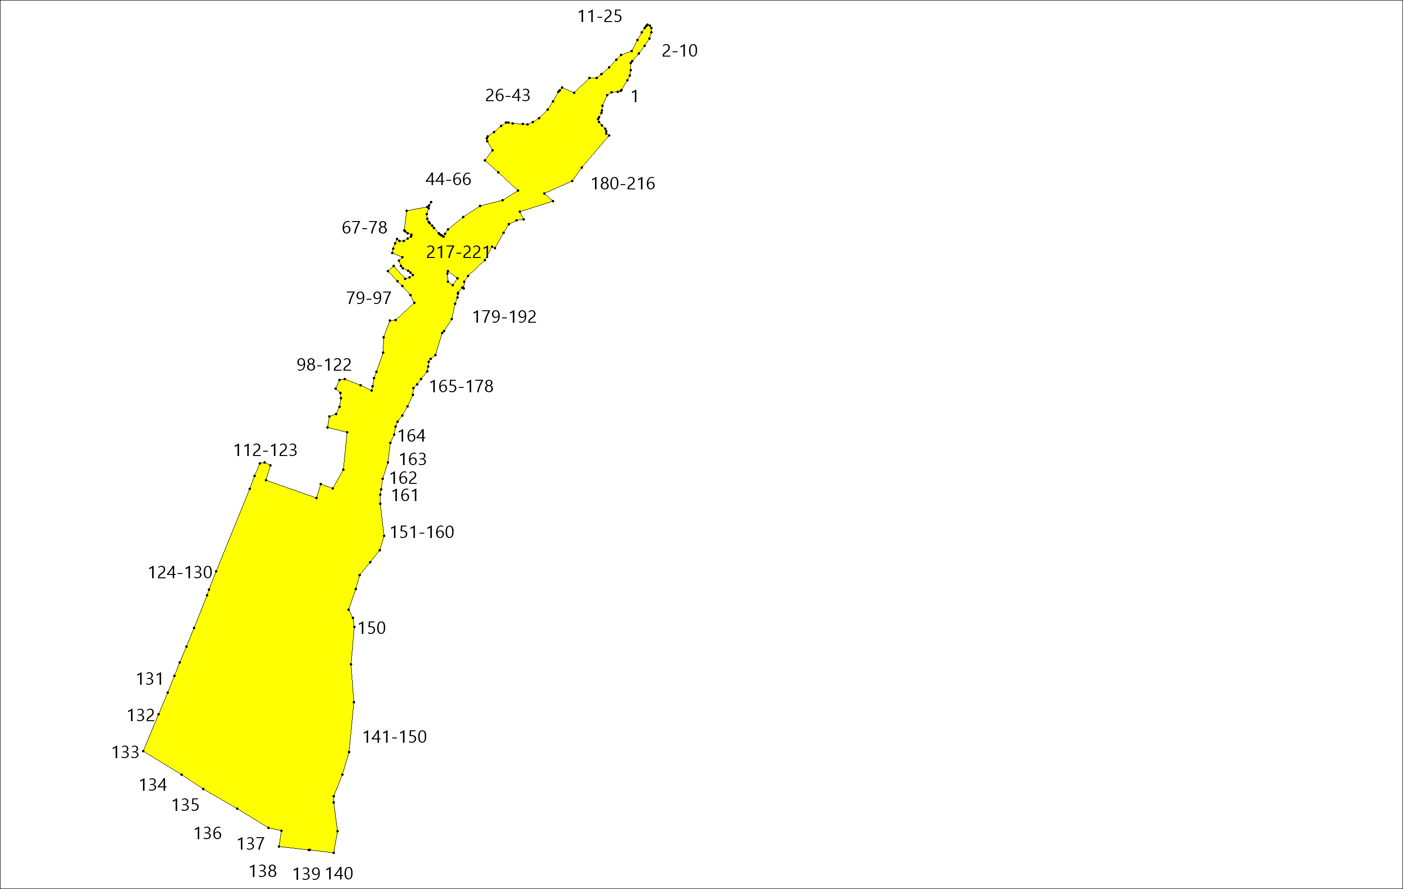

П1 Производственная зона
№№ точек | X | Y
1 | 617657.30 | 2236974.39
2 | 617638.08 | 2236992.71
3 | 617604.87 | 2237024.32
4 | 617574.55 | 2237038.13
5 | 617509.15 | 2236966.90
6 | 617506.22 | 2236945.07
7 | 617521.87 | 2236929.00
8 | 617577.96 | 2236930.51
9 | 617598.30 | 2236936.64
10 | 617634.18 | 2236952.60
Площадь = 10056.43 кв.м
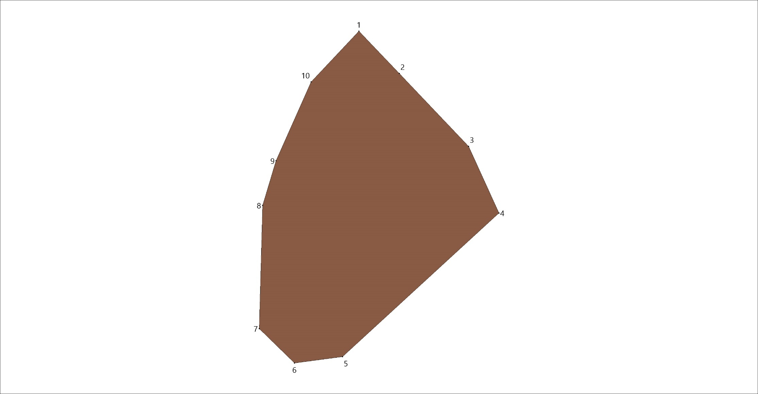
Р1 Зона рекреационного назначения
№№ точек | X | Y
1 | 617494.11 | 2237294.35
2 | 617536.85 | 2237289.93
3 | 617602.70 | 2237233.59
4 | 617629.74 | 2237228.01
5 | 617633.01 | 2237221.98
6 | 617613.34 | 2237205.99
7 | 617609.31 | 2237205.26
8 | 617594.82 | 2237203.46
9 | 617570.84 | 2237194.21
10 | 617512.35 | 2237182.00
11 | 617465.57 | 2237152.52
12 | 617447.44 | 2237152.52
13 | 617417.67 | 2237157.05
14 | 617404.70 | 2237178.42
15 | 617402.44 | 2237213.39
16 | 617425.75 | 2237279.43
17 | 617668.56 | 2237203.00
18 | 617695.34 | 2237167.69
19 | 617686.14 | 2237164.33
20 | 617654.84 | 2237167.06
21 | 617641.66 | 2237184.36

Площадь = 21614.19 кв.м

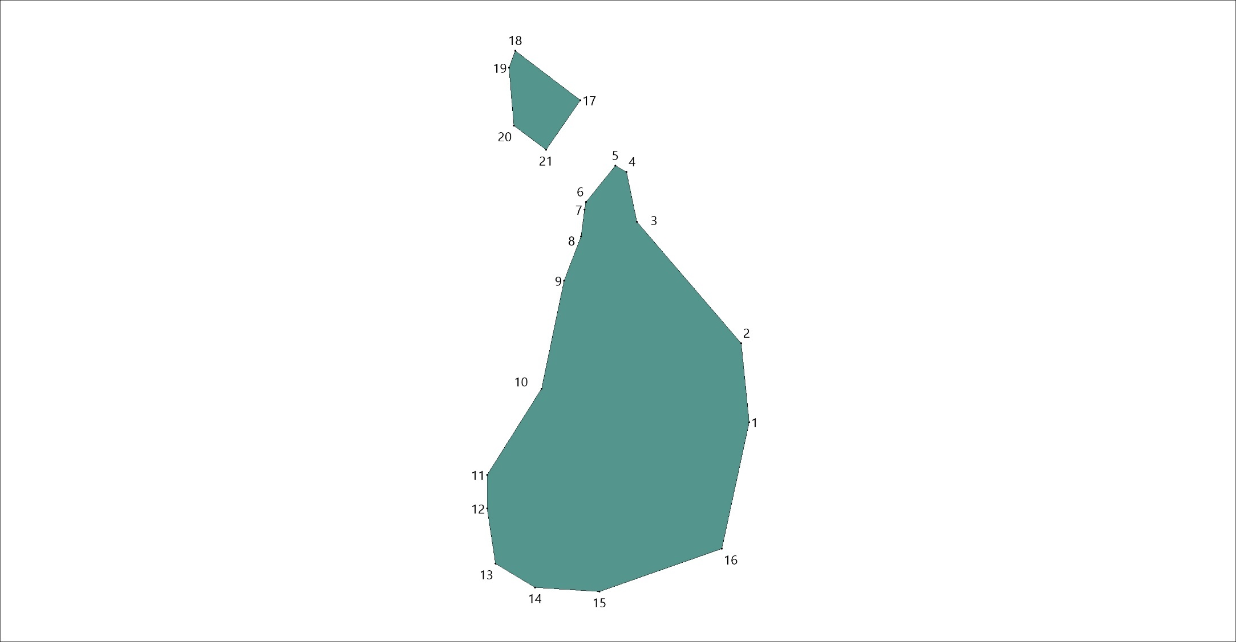
Т Территория транспортной инфраструктуры
№№ точек | X | Y
1 | 615478.43 | 2236638.30
2 | 615478.93 | 2236633.31
3 | 615644.06 | 2236663.52
4 | 615887.75 | 2236708.22
5 | 615956.23 | 2236717.34
6 | 616063.87 | 2236712.01
7 | 616217.60 | 2236721.94
8 | 616413.00 | 2236730.62
9 | 616413.11 | 2236730.63
10 | 616461.95 | 2236734.94
11 | 616487.52 | 2236739.28
12 | 616639.16 | 2236775.21
13 | 616681.00 | 2236783.33
14 | 616704.76 | 2236789.81
15 | 616747.84 | 2236797.66
16 | 616809.45 | 2236801.24
17 | 616848.30 | 2236805.41
18 | 616877.03 | 2236813.78
19 | 616939.12 | 2236839.99
20 | 617061.68 | 2236895.53
21 | 617301.04 | 2237002.77
22 | 617409.16 | 2237050.37
23 | 617445.27 | 2237063.61
24 | 617479.08 | 2237067.18
25 | 617507.26 | 2237064.25
26 | 617507.53 | 2237064.44
27 | 617507.53 | 2237066.73
28 | 617507.55 | 2237069.25
29 | 617479.08 | 2237072.19
30 | 617444.44 | 2237068.55
31 | 617443.84 | 2237068.41
32 | 617407.22 | 2237054.98
33 | 617299.02 | 2237007.34
34 | 617299.01 | 2237007.33
35 | 617059.63 | 2236900.09
36 | 617059.62 | 2236900.09
37 | 616937.09 | 2236844.56
38 | 616875.49 | 2236818.54
39 | 616847.11 | 2236810.27
40 | 616809.10 | 2236806.23
41 | 616747.09 | 2236802.61
42 | 616703.55 | 2236794.66
43 | 616679.95 | 2236788.22
44 | 616638.05 | 2236780.08
45 | 616486.60 | 2236744.19
46 | 616461.41 | 2236739.91
47 | 616412.72 | 2236735.62
48 | 616217.35 | 2236726.94
49 | 616063.85 | 2236717.01
50 | 615956.13 | 2236722.35
51 | 615886.91 | 2236713.15
52 | 615643.16 | 2236668.44
Площадь = 10487.36 кв.м
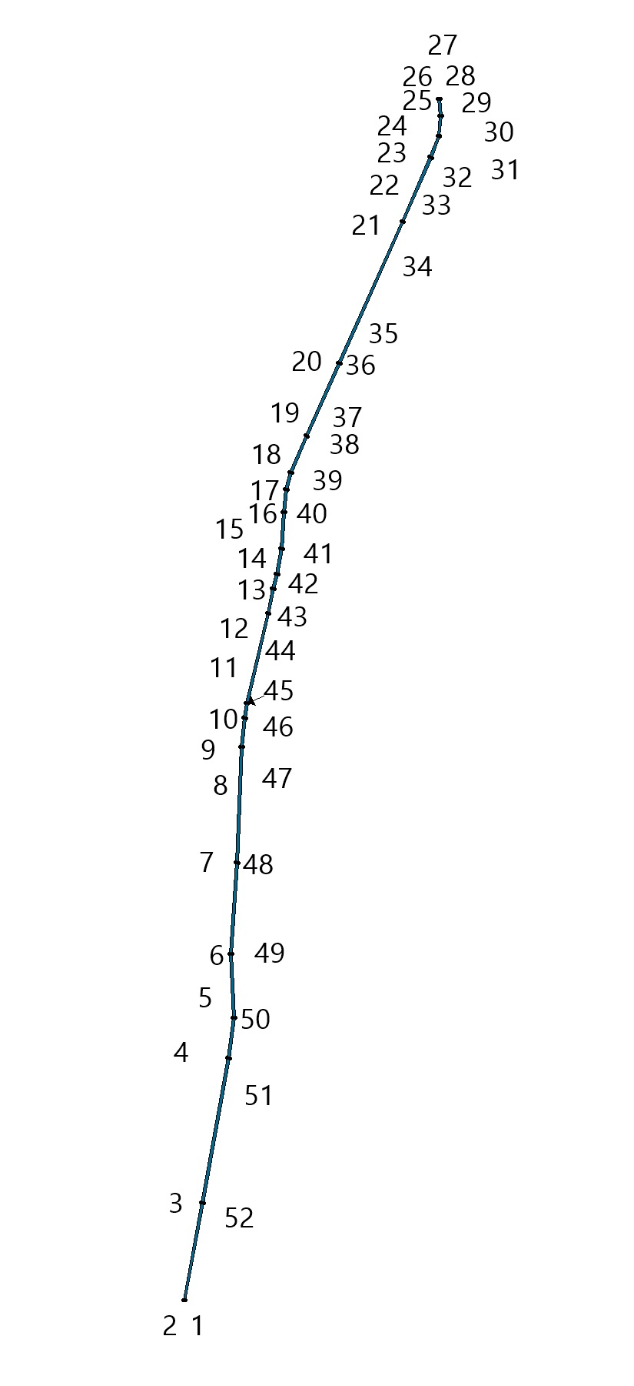
7. Территориальные зоны д.Селищи
Ж1 Зона застройки индивидуальными жилыми домами и домами блокированной застройки
№№ точек | X | Y
1 | 602788.66 | 2231299.39
2 | 602795.37 | 2231311.40
3 | 602798.38 | 2231327.55
4 | 602806.26 | 2231333.56
5 | 602818.29 | 2231344.46
6 | 602826.18 | 2231353.47
7 | 602833.65 | 2231386.16
8 | 602813.59 | 2231381.31
9 | 602641.43 | 2231216.18
10 | 602627.76 | 2231247.89
11 | 602623.26 | 2231247.89
12 | 602606.37 | 2231254.28
13 | 602579.38 | 2231244.59
14 | 602590.44 | 2231208.06
15 | 602463.35 | 2231222.03
16 | 602471.94 | 2231248.12
17 | 602467.43 | 2231277.30
18 | 602383.11 | 2231294.49
19 | 602386.53 | 2231316.32
20 | 602021.18 | 2231542.64
21 | 601999.54 | 2231556.04
22 | 601863.59 | 2231531.94
23 | 601816.41 | 2231564.57
24 | 601798.82 | 2231561.65
25 | 601792.90 | 2231546.59
26 | 601761.53 | 2231571.10
27 | 601753.51 | 2231572.52
28 | 601745.27 | 2231583.21
29 | 601744.15 | 2231584.68
30 | 601724.25 | 2231600.23
31 | 601709.61 | 2231602.38
32 | 601703.15 | 2231608.61
33 | 601690.18 | 2231616.84
34 | 601662.18 | 2231628.79
35 | 601637.13 | 2231637.36
36 | 601631.95 | 2231634.74
37 | 601628.71 | 2231639.67
38 | 601624.38 | 2231644.05
39 | 601606.51 | 2231662.11
40 | 601602.24 | 2231666.43
41 | 601597.48 | 2231670.43
42 | 601593.24 | 2231694.27
43 | 601598.76 | 2231701.89
44 | 601571.66 | 2231720.11
45 | 601562.75 | 2231725.35
46 | 601547.35 | 2231720.74
47 | 601543.61 | 2231725.33
48 | 601528.34 | 2231736.84
49 | 601520.82 | 2231742.81
50 | 601475.43 | 2231761.71
51 | 601475.23 | 2231761.51
52 | 601470.64 | 2231759.46
53 | 601464.86 | 2231761.09
54 | 601476.80 | 2231740.36
55 | 601492.17 | 2231705.43
56 | 601509.27 | 2231687.21
57 | 601577.68 | 2231558.82
58 | 601575.97 | 2231573.07
59 | 601602.87 | 2231600.03
60 | 601807.58 | 2231406.57
61 | 601692.43 | 2231273.95
62 | 601649.44 | 2231309.12
63 | 601633.75 | 2231341.79
64 | 601621.78 | 2231319.79
65 | 601622.08 | 2231315.08
66 | 601623.48 | 2231293.13
67 | 601641.44 | 2231247.96
68 | 601663.39 | 2231226.39
69 | 601677.00 | 2231206.89
70 | 601677.49 | 2231191.66
71 | 601696.34 | 2231192.27
72 | 601746.08 | 2231197.67
73 | 601775.63 | 2231194.02
74 | 601783.05 | 2231179.39
75 | 601777.45 | 2231167.20
76 | 601733.43 | 2231139.47
77 | 601735.58 | 2231125.37
78 | 601743.72 | 2231112.88
79 | 601766.69 | 2231096.03
80 | 601825.78 | 2231104.75
81 | 601850.54 | 2231137.39
82 | 601893.37 | 2231155.31
83 | 601903.89 | 2231156.76
84 | 601899.99 | 2231162.45
85 | 601918.00 | 2231162.45
86 | 601928.29 | 2231162.45
87 | 601942.28 | 2231170.49
88 | 601956.27 | 2231196.07
89 | 601967.85 | 2231208.61
90 | 601982.81 | 2231216.33
91 | 602007.42 | 2231215.37
92 | 602018.52 | 2231200.89
93 | 602026.44 | 2231192.47
94 | 602077.12 | 2231148.46
95 | 602120.32 | 2231038.39
96 | 602138.67 | 2231034.90
97 | 602160.38 | 2231033.94
98 | 602199.95 | 2231030.08
99 | 602239.52 | 2231030.08
100 | 602262.35 | 2231031.14
101 | 602291.82 | 2231005.13
102 | 602301.84 | 2231002.68
103 | 602319.81 | 2231000.03
104 | 602334.37 | 2231004.57
105 | 602342.88 | 2231010.05
106 | 602367.84 | 2231017.61
107 | 602385.42 | 2231024.61
108 | 602404.33 | 2231025.56
109 | 602410.00 | 2231022.15
110 | 602411.29 | 2231016.59
111 | 602467.85 | 2231013.34
112 | 602518.41 | 2231018.51
113 | 602541.69 | 2231028.90
114 | 602546.71 | 2231031.15
115 | 602545.44 | 2231032.84
116 | 602539.50 | 2231039.88
117 | 602532.72 | 2231055.20
118 | 602553.25 | 2231066.84
119 | 602573.47 | 2231073.71
120 | 602599.58 | 2231085.56
121 | 602620.60 | 2231095.78
122 | 602631.73 | 2231104.69
123 | 602656.41 | 2231123.24
124 | 602682.38 | 2231148.56
125 | 602696.34 | 2231162.02
126 | 602719.18 | 2231179.59
127 | 602741.38 | 2231197.23
128 | 602810.15 | 2231271.15
129 | 602810.11 | 2231272.82

Площадь = 347123.12 кв.м

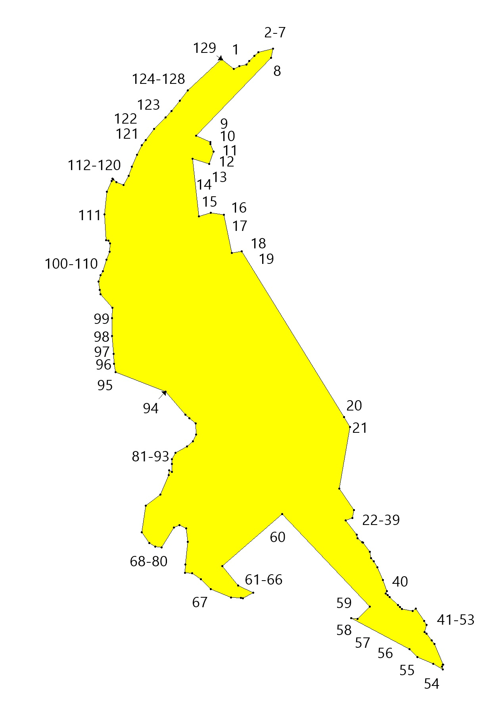
П1 Производственная зона
№№ точек | X | Y
1 | 601807.58 | 2231406.57
2 | 601602.87 | 2231600.03
3 | 601575.97 | 2231573.07
4 | 601581.56 | 2231526.50
5 | 601606.69 | 2231469.85
6 | 601638.92 | 2231422.65
7 | 601639.74 | 2231375.01
8 | 601626.25 | 2231357.40
9 | 601633.75 | 2231341.79
10 | 601649.44 | 2231309.12
11 | 601692.43 | 2231273.95

Площадь = 34004.35 кв.м
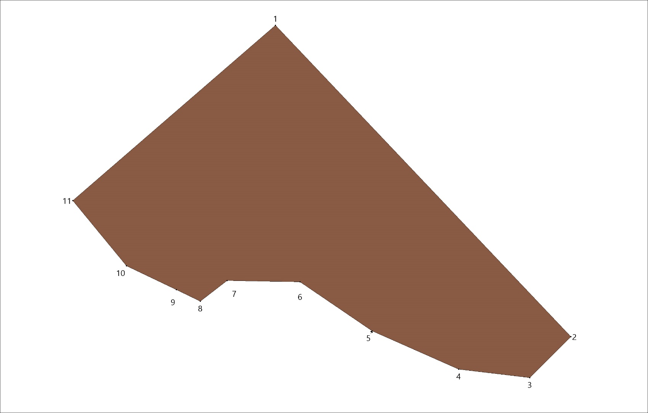

Зоны за границами населенного пункта.
П1 Производственная зона

№№ точек | X | Y
1 | 610406.78 | 2229952.17
2 | 610417.25 | 2229948.42
3 | 610427.22 | 2229926.97
4 | 610441.42 | 2229919.49
5 | 610455.21 | 2229884.32
6 | 610460.98 | 2229886.58
7 | 610469.41 | 2229891.30
8 | 610482.12 | 2229891.30
9 | 610489.85 | 2229887.56
10 | 610489.85 | 2229869.60
11 | 610462.18 | 2229845.16
12 | 610456.45 | 2229822.96
13 | 610444.24 | 2229798.52
14 | 610426.55 | 2229798.52
15 | 610417.33 | 2229822.71
16 | 610411.85 | 2229863.12
17 | 610399.39 | 2229884.32
18 | 610373.84 | 2229876.82
19 | 610346.93 | 2229860.86
20 | 610325.25 | 2229847.64
21 | 610329.07 | 2229833.50
22 | 610341.76 | 2229831.53
23 | 610358.04 | 2229846.10
24 | 610369.15 | 2229850.80
25 | 610381.67 | 2229850.80
26 | 610386.05 | 2229842.50
27 | 610388.42 | 2229821.83
28 | 610387.67 | 2229795.36
29 | 610390.98 | 2229775.81
30 | 610398.22 | 2229751.98
31 | 610404.71 | 2229734.18
32 | 610404.71 | 2229725.48
33 | 610402.11 | 2229717.58
34 | 610395.22 | 2229717.58
35 | 610383.13 | 2229722.98
36 | 610367.26 | 2229760.14
37 | 610361.64 | 2229774.26
38 | 610359.24 | 2229785.98
39 | 610343.68 | 2229789.03
40 | 610330.53 | 2229779.56
41 | 610326.36 | 2229767.52
42 | 610328.26 | 2229752.03
43 | 610335.34 | 2229728.19
44 | 610313.68 | 2229726.29
45 | 610299.50 | 2229723.55
46 | 610292.09 | 2229713.07
47 | 610283.24 | 2229711.13
48 | 610270.67 | 2229714.68
49 | 610253.00 | 2229736.51
50 | 610239.06 | 2229750.35
51 | 610227.95 | 2229754.72
52 | 610207.28 | 2229749.75
53 | 610197.70 | 2229743.07
54 | 610186.62 | 2229735.34
55 | 610170.04 | 2229743.33
56 | 610163.97 | 2229758.60
57 | 610131.91 | 2229783.18
58 | 610108.58 | 2229797.22
59 | 610084.22 | 2229801.93
60 | 610067.50 | 2229801.93
61 | 610048.78 | 2229798.88
62 | 610028.99 | 2229789.59
63 | 610020.94 | 2229777.65
64 | 610022.67 | 2229771.62
65 | 610032.15 | 2229765.70
66 | 610054.08 | 2229765.70
67 | 610082.55 | 2229765.70
68 | 610091.67 | 2229760.64
69 | 610095.14 | 2229751.72
70 | 610093.18 | 2229747.61
71 | 610081.13 | 2229737.08
72 | 610057.48 | 2229721.83
73 | 610037.74 | 2229707.56
74 | 610020.40 | 2229692.05
75 | 610013.83 | 2229671.79
76 | 610002.79 | 2229653.91
77 | 609975.72 | 2229639.96
78 | 609956.17 | 2229639.96
79 | 609939.59 | 2229639.96
80 | 609915.99 | 2229649.45
81 | 609897.09 | 2229678.86
82 | 609882.07 | 2229701.50
83 | 609873.16 | 2229708.27
84 | 609858.80 | 2229708.27
85 | 609849.12 | 2229704.01
86 | 609841.97 | 2229696.58
87 | 609835.34 | 2229677.75
88 | 609817.06 | 2229657.07
89 | 609805.40 | 2229641.42
90 | 609785.00 | 2229619.14
91 | 609761.04 | 2229601.63
92 | 609723.42 | 2229679.33
93 | 609745.41 | 2229695.24
94 | 609775.08 | 2229731.31
95 | 609836.44 | 2229761.27
96 | 609868.68 | 2229784.24
97 | 609889.67 | 2229796.50
98 | 609919.73 | 2229812.48
99 | 609944.86 | 2229812.48
100 | 609960.02 | 2229785.34
101 | 610070.03 | 2229859.13
102 | 610132.95 | 2229859.13
103 | 610143.86 | 2229870.59
104 | 610131.89 | 2229904.41
105 | 610115.66 | 2229913.46
106 | 610089.77 | 2229924.13
107 | 610063.96 | 2229928.40
108 | 610040.55 | 2229937.72
109 | 610040.38 | 2229942.18
110 | 610294.18 | 2229951.42
111 | 610313.48 | 2229880.00
112 | 610324.12 | 2229876.66
113 | 610340.80 | 2229891.48
114 | 610357.17 | 2229935.95
115 | 610378.87 | 2229940.94
116 | 619622.90 | 2244282.69
117 | 619742.30 | 2244270.34
118 | 619944.36 | 2244247.47
119 | 619944.03 | 2244018.17
120 | 619959.47 | 2243967.74
121 | 619956.09 | 2243920.07
122 | 619915.73 | 2243918.85
123 | 619841.62 | 2243925.02
124 | 619824.12 | 2243976.49
125 | 619755.68 | 2243968.77
126 | 619732.01 | 2244010.97
127 | 619649.67 | 2244019.20
128 | 619635.26 | 2244071.69
129 | 619417.05 | 2244081.99
130 | 619391.32 | 2244132.42
131 | 619326.48 | 2244146.83
132 | 619293.54 | 2244206.53
133 | 619386.69 | 2244242.04
134 | 619441.24 | 2244247.18
135 | 619511.75 | 2244279.60

Площадь = 246007.11 кв.м

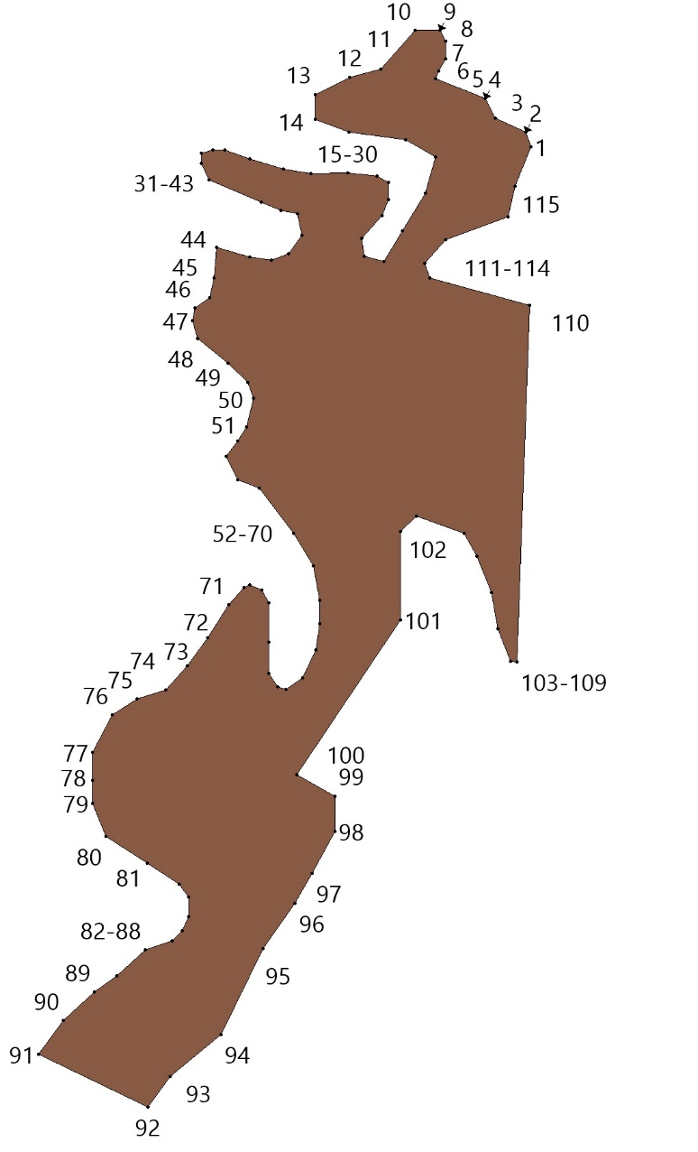

СН Зона специального назначения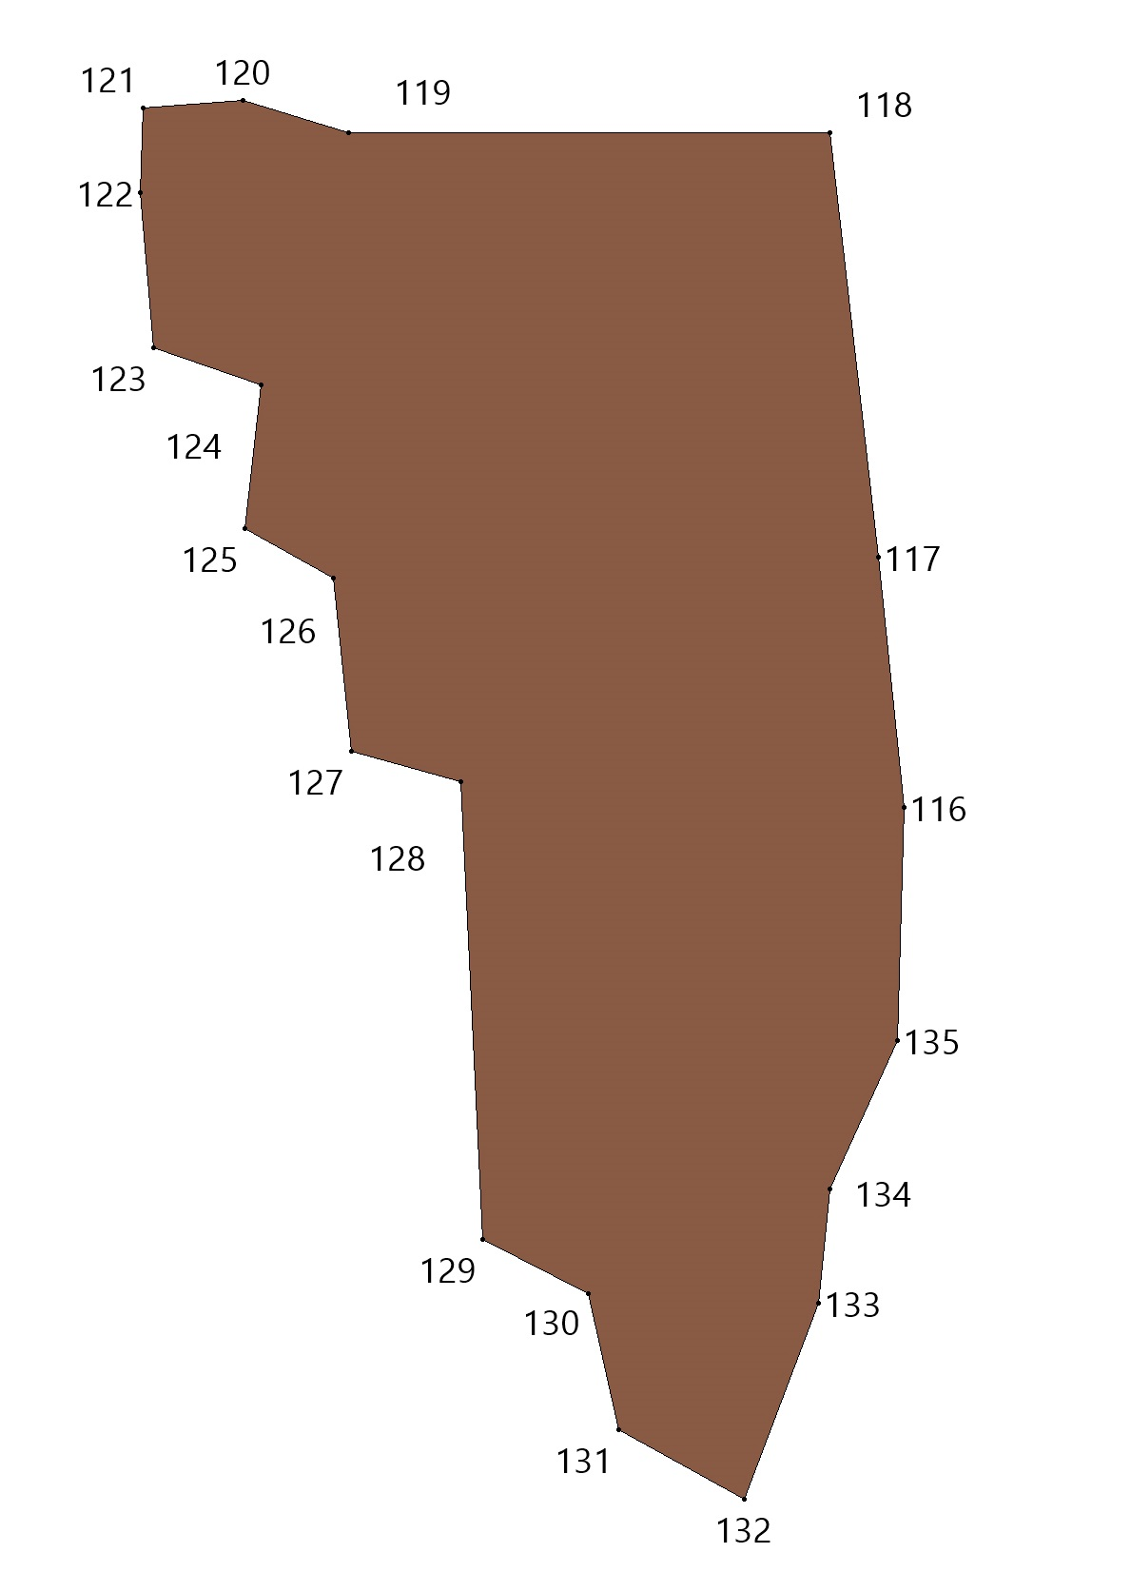
СН Зона специального назначения
№№ точек | X | Y
1 | 611425.15 | 2229952.67
2 | 611423.61 | 2229981.63
3 | 611385.69 | 2229979.59
4 | 611384.67 | 2229998.47
5 | 611376.66 | 2229998.26
6 | 611377.67 | 2229979.14
7 | 611371.68 | 2229978.87
8 | 611371.76 | 2229977.37
9 | 611366.27 | 2229977.09
10 | 611351.09 | 2229976.28
11 | 611351.90 | 2229961.10
12 | 611367.08 | 2229961.91
13 | 611372.57 | 2229962.20
14 | 611373.23 | 2229949.91
15 | 611272.36 | 2229944.56
16 | 611275.13 | 2229892.86
17 | 611275.20 | 2229891.22
18 | 611282.45 | 2229754.72
19 | 611284.14 | 2229722.87
20 | 611297.43 | 2229723.57
21 | 611347.87 | 2229726.26
22 | 611348.52 | 2229726.29
23 | 611505.82 | 2229734.64
24 | 611494.06 | 2229956.33

Площадь = 51257.57 кв.м
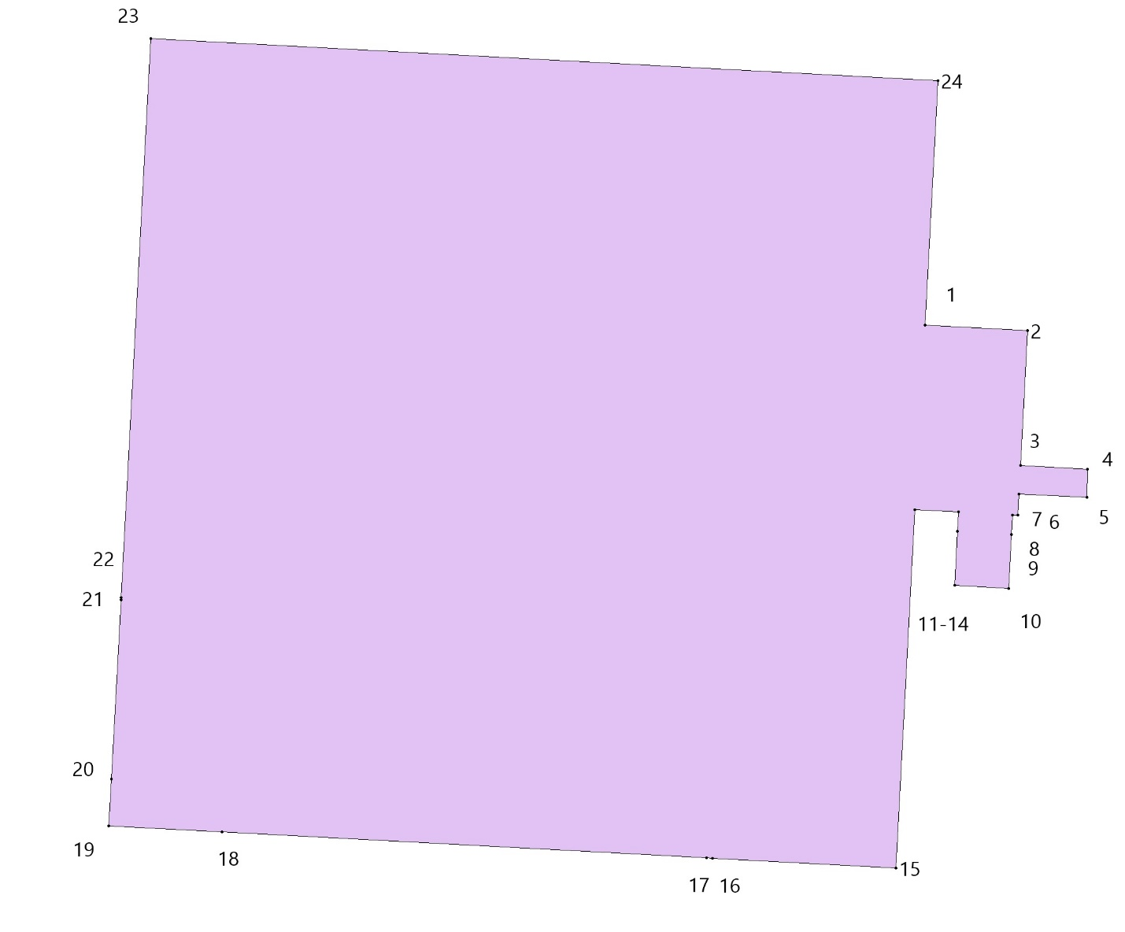

КЛ Зона кладбищ
№№ точек | X | Y
1 | 593216.65 | 2227528.30
2 | 593270.17 | 2227500.72
3 | 593247.27 | 2227454.06
4 | 593192.06 | 2227479.90
5 | 598843.56 | 2230099.05
6 | 598881.87 | 2230059.81
7 | 598818.21 | 2230016.53
8 | 598786.11 | 2230047.85
9 | 601896.32 | 2231088.92
10 | 601896.62 | 2231087.96
11 | 601908.15 | 2231043.29
12 | 601908.22 | 2231042.98
13 | 601908.26 | 2231042.70
14 | 601907.29 | 2231042.46
15 | 601847.79 | 2231030.47
16 | 601843.15 | 2231032.24
17 | 601829.63 | 2231075.17
18 | 601829.50 | 2231075.71
19 | 601830.45 | 2231075.93
20 | 601895.75 | 2231088.85
21 | 613806.92 | 2231170.19
22 | 613818.99 | 2230877.98
23 | 613670.91 | 2230873.17
24 | 613669.70 | 2230893.94
25 | 613665.54 | 2230965.10
26 | 613648.20 | 2230959.05
27 | 613637.73 | 2230994.67
28 | 613626.21 | 2231007.24
29 | 613637.73 | 2231018.76
30 | 613636.68 | 2231043.90
31 | 613612.60 | 2231056.48
32 | 613608.41 | 2231074.29
33 | 613598.99 | 2231114.10
34 | 613583.29 | 2231121.43
35 | 613560.25 | 2231122.48
36 | 613537.22 | 2231064.86
37 | 613542.46 | 2231043.90
38 | 613552.93 | 2231028.19
39 | 613561.30 | 2230962.19
40 | 613559.21 | 2230945.43
41 | 613572.82 | 2230932.86
42 | 613585.38 | 2230928.67
43 | 613594.22 | 2230873.85
44 | 613305.07 | 2230863.39
45 | 613303.77 | 2230885.48
46 | 613302.94 | 2230899.78
47 | 613288.35 | 2231148.60
48 | 613654.03 | 2231161.84
49 | 613654.31 | 2231157.08
50 | 601908.89 | 2231609.83
51 | 601921.41 | 2231602.85
52 | 601920.10 | 2231600.76
53 | 601917.60 | 2231596.79
54 | 601905.42 | 2231603.60
55 | 601905.69 | 2231604.09
56 | 601406.03 | 2231998.28
57 | 601419.54 | 2231988.25
58 | 601441.57 | 2231975.63
59 | 601445.86 | 2231968.50
60 | 601443.20 | 2231960.95
61 | 601432.73 | 2231949.24
62 | 601422.19 | 2231945.03
63 | 601403.69 | 2231955.15
64 | 601387.39 | 2231968.61
65 | 601388.21 | 2231973.84
66 | 601396.96 | 2231984.35
67 | 601399.08 | 2231989.80
68 | 608823.14 | 2233554.21
69 | 608852.47 | 2233525.24
70 | 608831.32 | 2233512.53
71 | 608829.35 | 2233517.81
72 | 608789.53 | 2233490.57
73 | 608773.45 | 2233509.19
74 | 617867.84 | 2237171.02
75 | 617869.63 | 2237168.65
76 | 617866.50 | 2237166.29
77 | 617864.94 | 2237165.11
78 | 617862.03 | 2237163.10
79 | 617860.99 | 2237162.33
80 | 617854.99 | 2237158.71
81 | 617854.54 | 2237158.48
82 | 617852.01 | 2237156.92
83 | 617851.83 | 2237156.88
84 | 617848.30 | 2237154.82
85 | 617848.02 | 2237154.60
86 | 617844.50 | 2237152.60
87 | 617831.34 | 2237145.39
88 | 617828.83 | 2237149.56
89 | 617838.84 | 2237156.11
90 | 617856.29 | 2237167.66
91 | 618016.55 | 2237284.50
92 | 618020.28 | 2237277.62
93 | 618024.63 | 2237242.97
94 | 618025.85 | 2237241.53
95 | 618017.18 | 2237233.79
96 | 618027.12 | 2237214.30
97 | 618014.11 | 2237177.77
98 | 618011.10 | 2237165.45
99 | 618007.19 | 2237149.48
100 | 618007.10 | 2237143.21
101 | 618002.73 | 2237136.79
102 | 617981.77 | 2237117.53
103 | 617967.43 | 2237108.33
104 | 617947.14 | 2237095.46
105 | 617936.48 | 2237092.54
106 | 617915.22 | 2237086.18
107 | 617895.83 | 2237088.36
108 | 617885.18 | 2237093.86
109 | 617879.75 | 2237097.63
110 | 617870.23 | 2237106.10
111 | 617860.78 | 2237114.26
112 | 617841.53 | 2237131.02
113 | 617837.02 | 2237135.25
114 | 617833.95 | 2237140.46
115 | 617855.59 | 2237153.37
116 | 617859.28 | 2237156.03
117 | 617863.34 | 2237156.73
118 | 617867.50 | 2237159.59
119 | 617869.50 | 2237160.91
120 | 617873.58 | 2237163.67
121 | 617877.30 | 2237165.88
122 | 617884.21 | 2237171.86
123 | 617886.75 | 2237173.52
124 | 617888.86 | 2237174.63
125 | 617894.20 | 2237177.85
126 | 617895.18 | 2237178.55
127 | 617893.83 | 2237180.24
128 | 617902.61 | 2237186.30
129 | 617907.55 | 2237190.64
130 | 617910.68 | 2237192.67
131 | 617915.79 | 2237195.74
132 | 617914.66 | 2237197.63
133 | 617920.40 | 2237201.58
134 | 617923.17 | 2237204.29
135 | 617921.67 | 2237206.60
136 | 617930.57 | 2237213.84
137 | 617929.05 | 2237215.75
138 | 617930.91 | 2237218.20
139 | 617937.04 | 2237222.41
140 | 617934.89 | 2237225.15
141 | 617948.70 | 2237239.08
142 | 617947.31 | 2237240.70
143 | 617955.99 | 2237251.56
144 | 617960.63 | 2237255.64
145 | 617967.20 | 2237260.24
146 | 617970.10 | 2237262.18
147 | 617981.42 | 2237268.49
148 | 617989.74 | 2237272.60

Площадь = 162761.90 кв.м

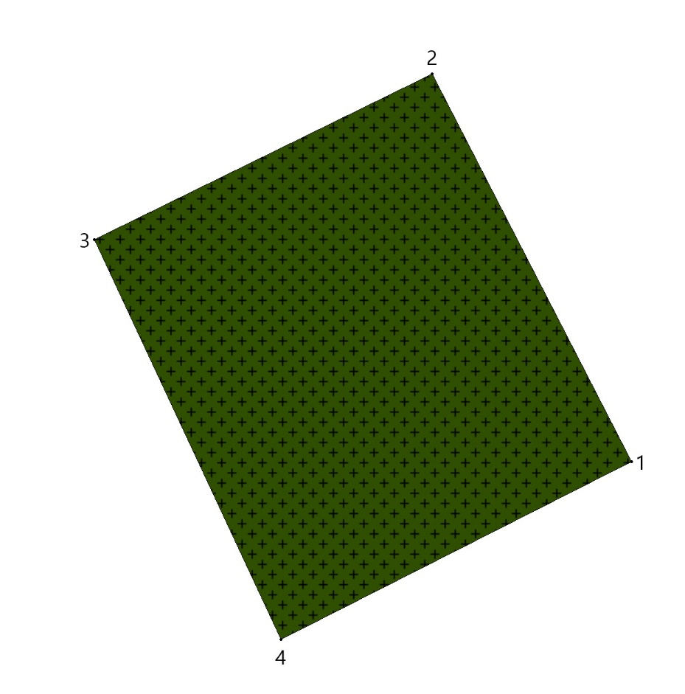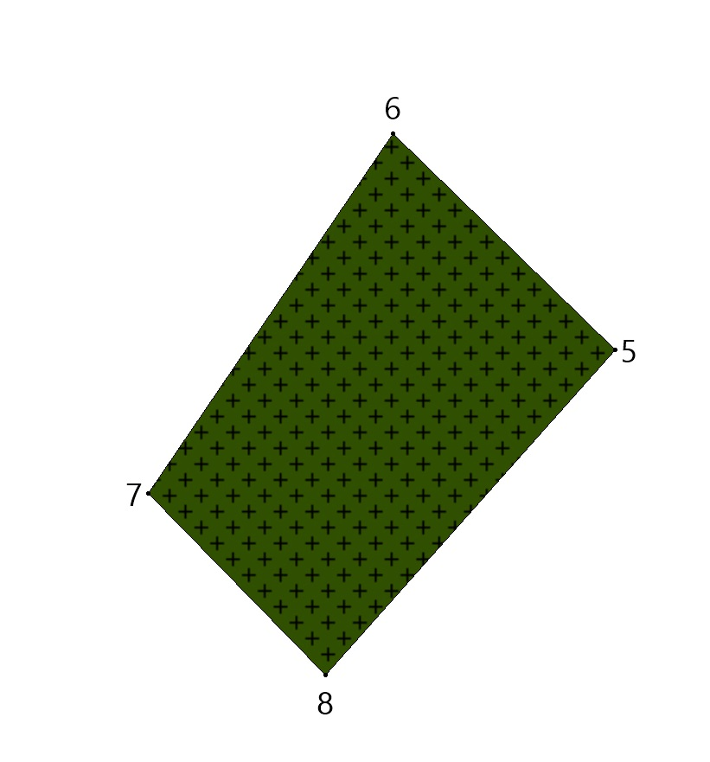

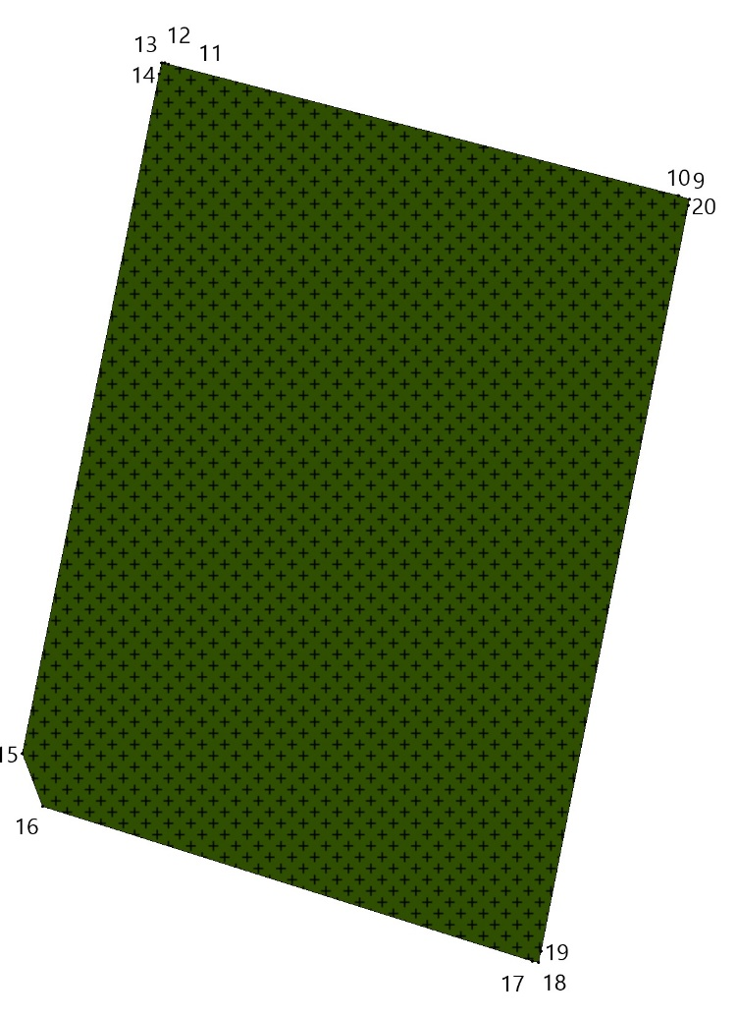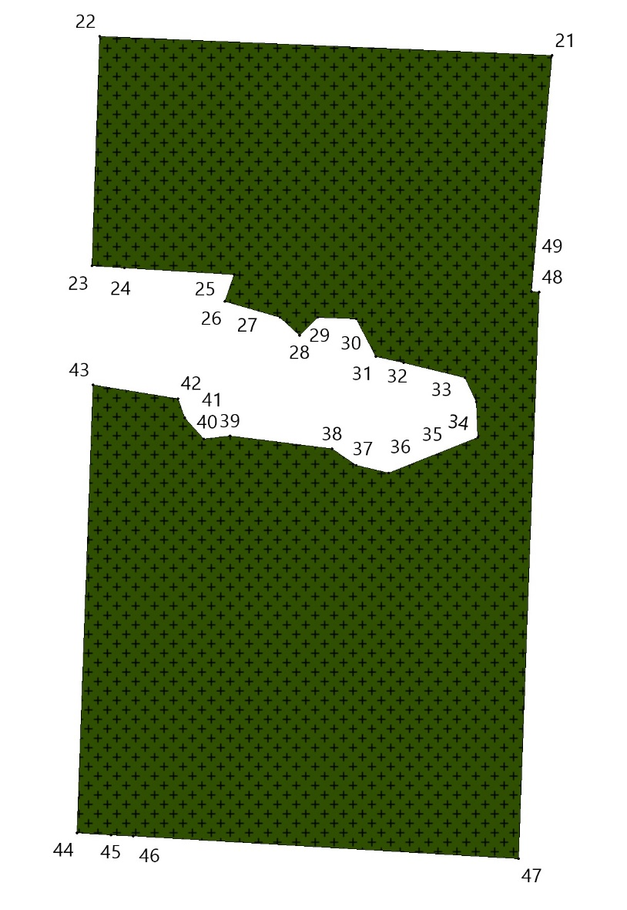
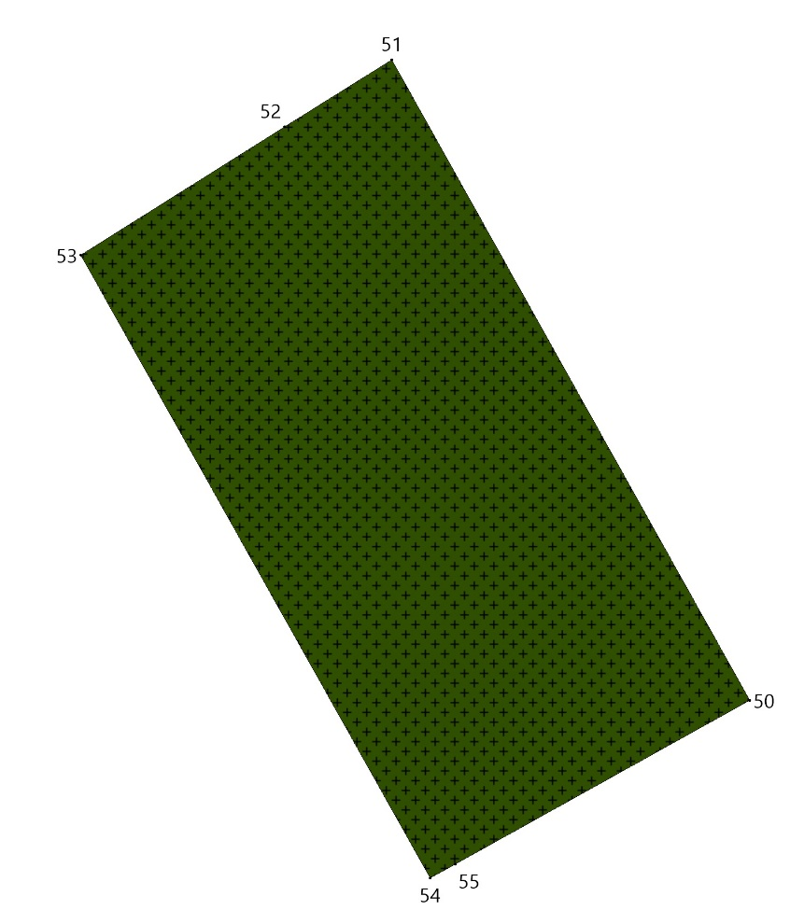
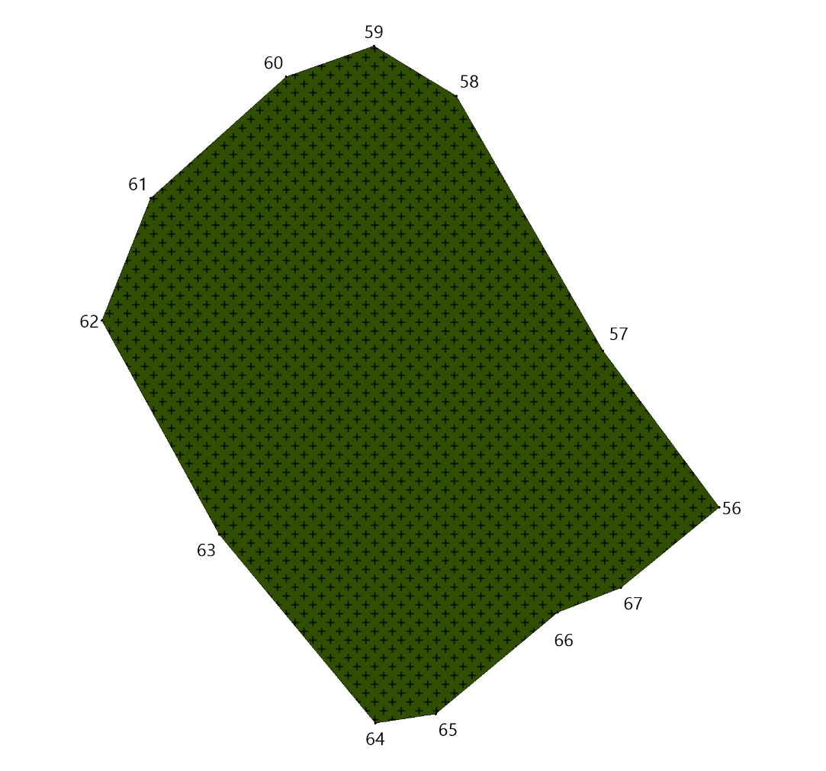

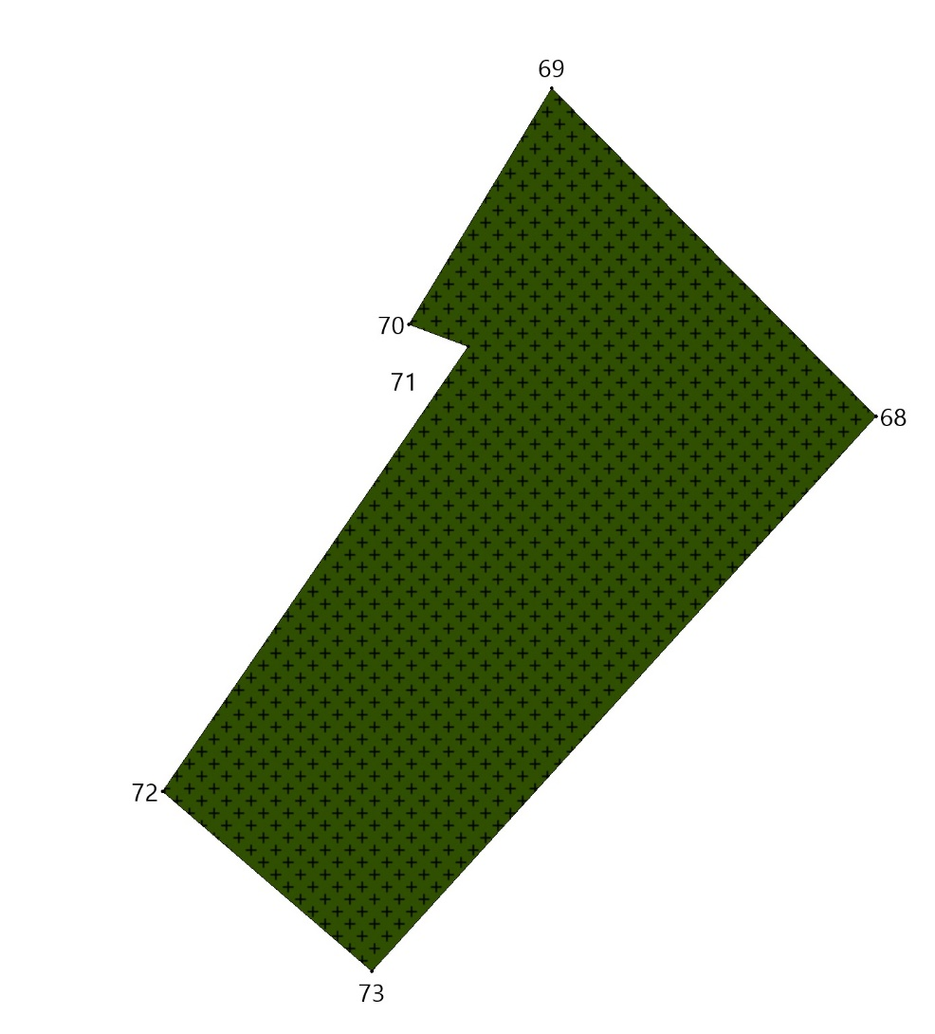
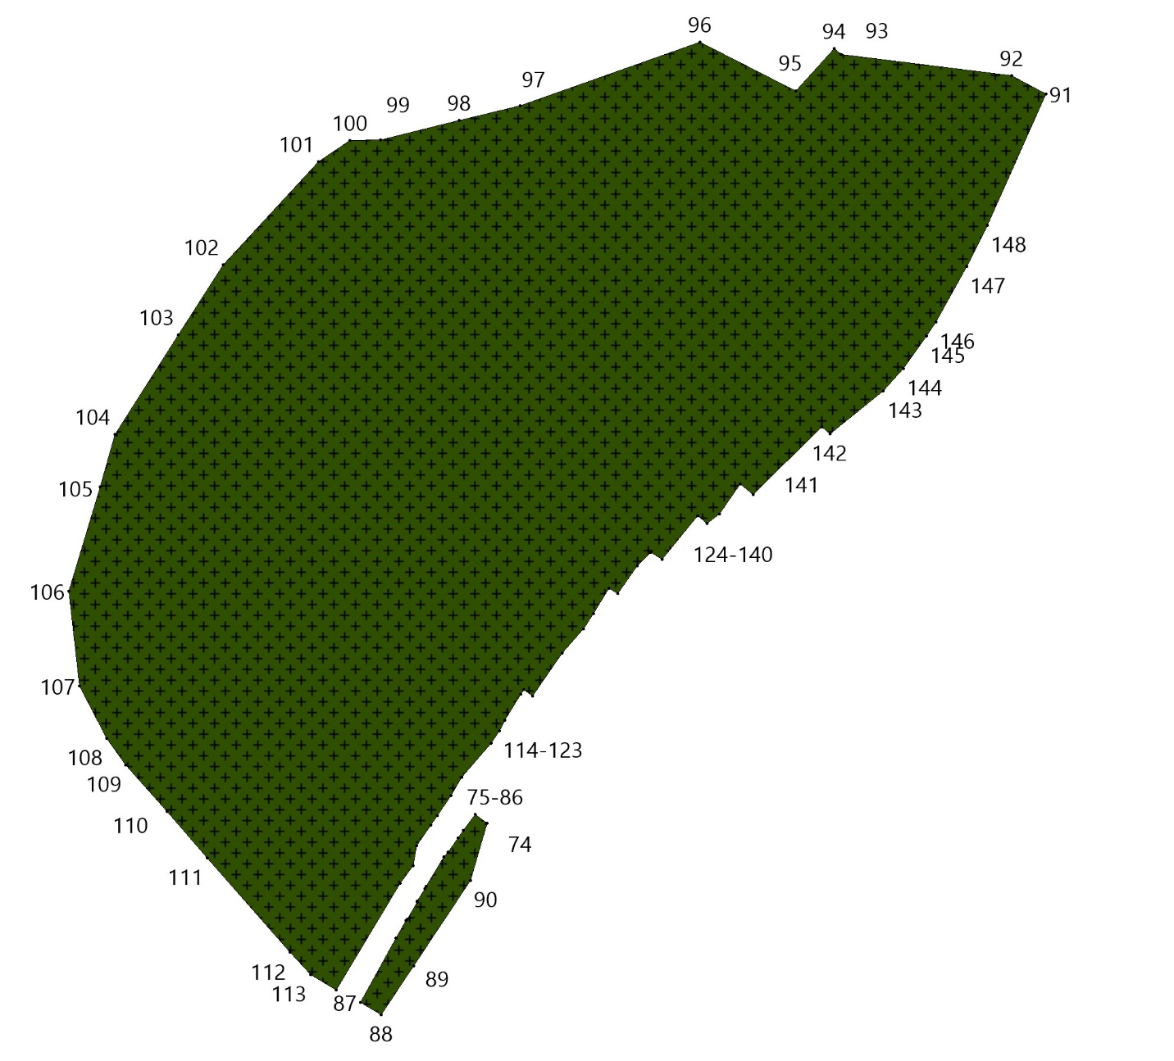
СХ1 Зона садоводства и огородничества
№№ точек | X | Y
1 | 612044.76 | 2226264.47
2 | 612106.58 | 2226255.49
3 | 612135.14 | 2226256.76
4 | 612143.54 | 2226254.71
5 | 612149.01 | 2226245.43
6 | 612157.19 | 2226229.39
7 | 612166.04 | 2226129.88
8 | 612081.88 | 2226110.85
9 | 611908.67 | 2226061.81
10 | 611816.82 | 2226017.76
11 | 611752.08 | 2225959.42
12 | 611665.10 | 2225863.03
13 | 611604.29 | 2225905.98
14 | 611599.64 | 2225906.16
15 | 611568.81 | 2225861.52
16 | 611553.47 | 2225839.22
17 | 611547.68 | 2225840.83
18 | 611542.04 | 2225841.23
19 | 611533.48 | 2225833.04
20 | 611520.75 | 2225904.60
21 | 611518.98 | 2225908.66
22 | 611502.34 | 2225918.71
23 | 611490.66 | 2225932.45
24 | 611481.64 | 2225959.39
25 | 611488.86 | 2226009.87
26 | 611517.52 | 2226071.67
27 | 611533.57 | 2226092.58
28 | 611562.30 | 2226124.80
29 | 611604.46 | 2226189.28
30 | 611635.50 | 2226222.10
31 | 611679.06 | 2226228.47
32 | 611714.63 | 2226224.14
33 | 611756.60 | 2226223.95
34 | 611809.68 | 2226218.68
35 | 611822.10 | 2226219.06
36 | 611838.66 | 2226222.25
37 | 611855.89 | 2226227.45
38 | 611864.86 | 2226232.76
39 | 611901.99 | 2226252.51
40 | 611991.60 | 2226259.93
41 | 612579.64 | 2226448.69
42 | 612627.52 | 2226284.40
43 | 612591.33 | 2226272.86
44 | 612513.48 | 2226244.74
45 | 612429.44 | 2226218.82
46 | 612315.20 | 2226188.27
47 | 612261.28 | 2226169.88
48 | 612228.52 | 2226281.74
49 | 612246.57 | 2226289.59
50 | 612336.72 | 2226318.90
51 | 612344.05 | 2226286.98
52 | 612352.94 | 2226270.75
53 | 612381.73 | 2226265.52
54 | 612409.46 | 2226265.78
55 | 612427.78 | 2226268.13
56 | 612441.39 | 2226273.63
57 | 612464.94 | 2226283.58
58 | 612479.59 | 2226288.28
59 | 612487.97 | 2226295.87
60 | 612500.26 | 2226316.02
61 | 612508.64 | 2226329.10
62 | 612523.29 | 2226359.98
63 | 612536.90 | 2226405.51
64 | 612546.06 | 2226430.64
65 | 612547.76 | 2226440.58
66 | 609304.65 | 2234118.76
67 | 609306.76 | 2234117.07
68 | 609324.50 | 2234098.48
69 | 609351.63 | 2234072.97
70 | 609381.10 | 2234045.26
71 | 609401.38 | 2234023.30
72 | 609415.60 | 2234007.65
73 | 609418.28 | 2234004.71
74 | 609422.92 | 2233997.95
75 | 609421.66 | 2233986.97
76 | 609417.86 | 2233973.87
77 | 609403.49 | 2233953.17
78 | 609392.31 | 2233936.91
79 | 609389.55 | 2233932.90
80 | 609381.29 | 2233921.21
81 | 609370.83 | 2233906.41
82 | 609360.54 | 2233891.84
83 | 609353.91 | 2233882.46
84 | 609325.81 | 2233912.32
85 | 609260.58 | 2233981.65
86 | 609185.38 | 2234061.57

Площадь = 211547.99 кв.м

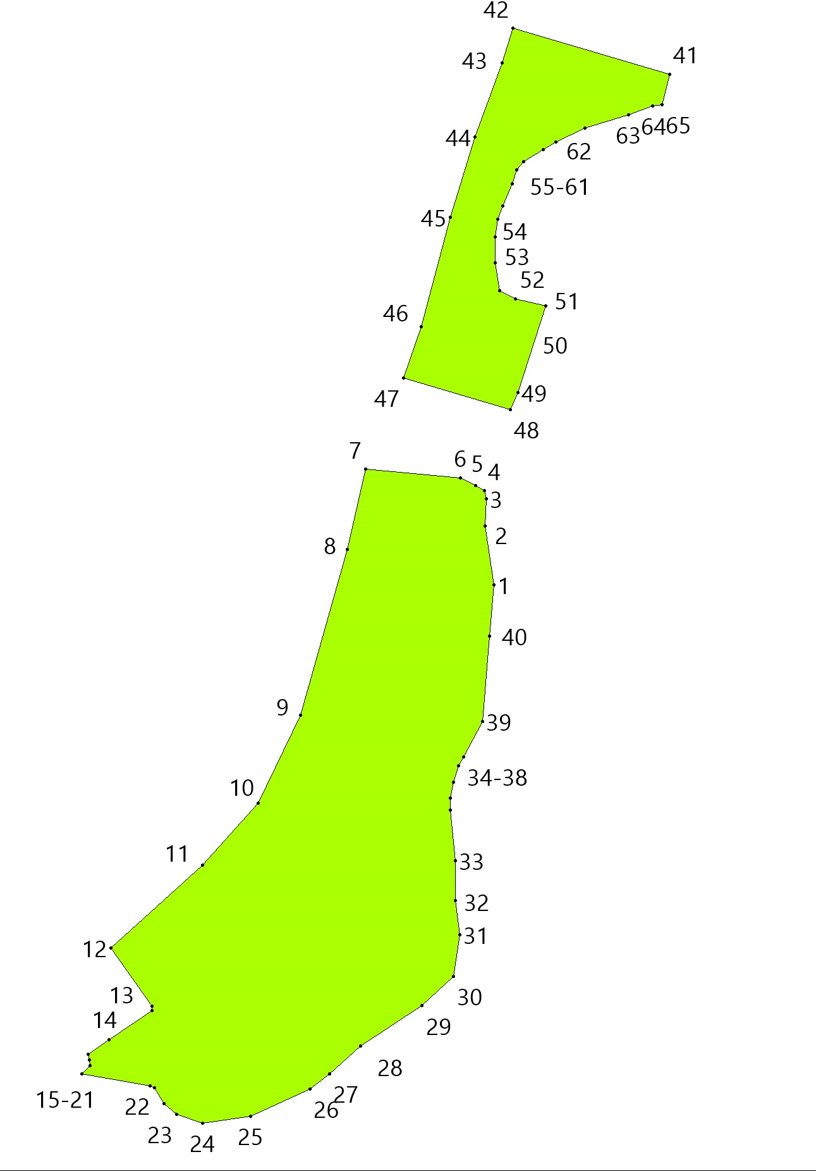
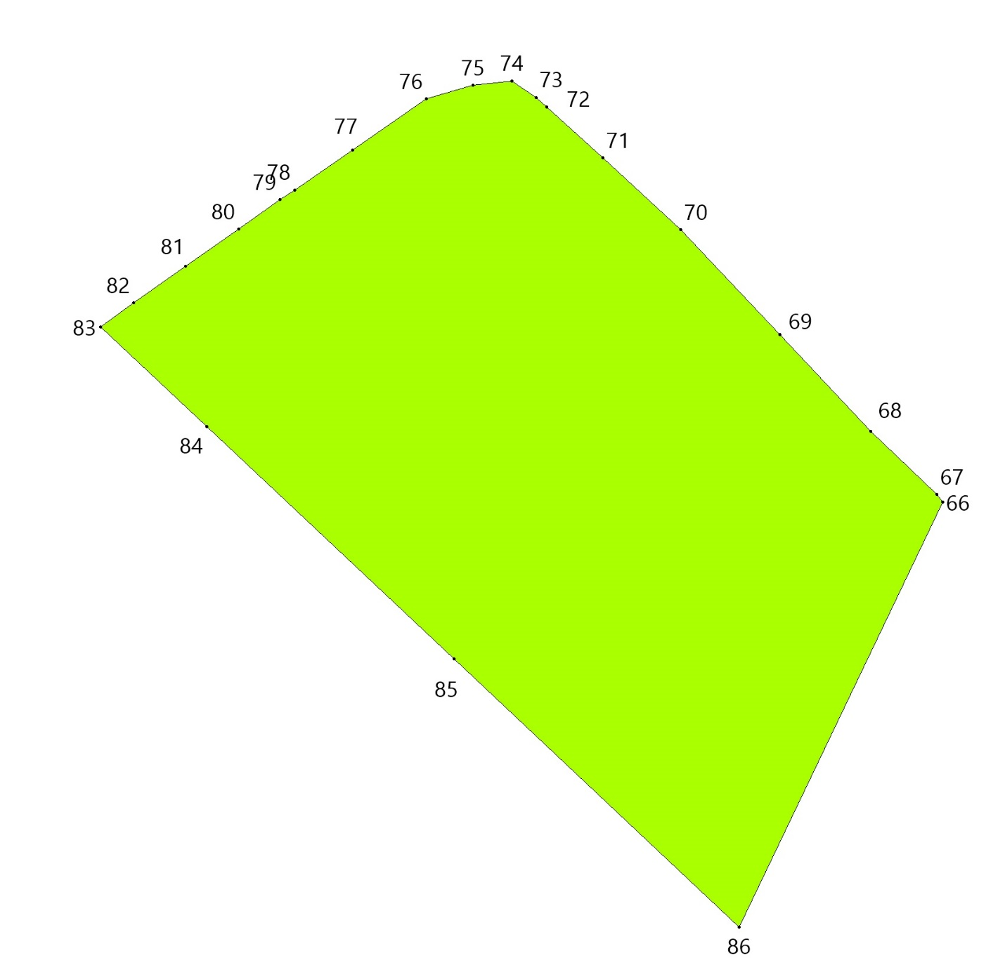
И Территория инженерной инфраструктуры
№№ точек | X | Y
1 | 612375.73 | 2232868.80
2 | 612377.16 | 2232859.77
3 | 612380.73 | 2232845.72
4 | 612371.90 | 2232811.66
5 | 612371.19 | 2232805.82
6 | 612379.26 | 2232748.01
7 | 612384.47 | 2232726.44
8 | 612353.19 | 2232692.51
9 | 612341.60 | 2232658.78
10 | 612371.77 | 2232478.35
11 | 612300.20 | 2232390.37
12 | 612138.65 | 2232388.32
13 | 612116.16 | 2232519.27
14 | 612101.84 | 2232543.82
15 | 612106.99 | 2232732.98
16 | 612103.47 | 2232743.84
17 | 612101.49 | 2232756.25
18 | 612100.53 | 2232762.60
19 | 612091.68 | 2232814.20
20 | 612138.19 | 2232826.86
21 | 612230.26 | 2232838.49
22 | 612270.48 | 2232840.82
23 | 612270.17 | 2232862.70
24 | 612362.76 | 2232868.13
25 | 612367.43 | 2232868.66

Площадь = 113052.27 кв.м
